INSPECTION & SPECIFICATION SERVICES CC.
ISS
CONTROLLED ENGINEERING INSPECTION REPORT
Combined-Product Spillage Audit
Inspection and Engineering Assessment
Report
South32 Wessels Mine · Surface and Underground Conveyor / Process Areas
DRAFT · REVISION 0.1 · FOR REVIEW

Client | South32
Mine / site | Wessels Mine
Area / system | Combined-product handling and processing systems - selected surface and underground sections
Report number | S32WPPSR-01
Revision | 0.1 - Draft
Issue date | 24/08/2026
Inspection date / range | July 2026
Prepared by | [PREPARED BY]
Inspection & Specification Services cc.
Reg. No. 1990/020258/23
24 Jonkershoek Street, Vaalpark, 1947
iss@inspecserv.co.za

Document Control and Metadata
Table 1 - Document control and report metadata
Field | Value
Report title | Combined-Product Spillage Audit Report
Report number | S32WPPSR-01
Revision | 0.1
Issue status | Draft / Working Review
Issue date | 24/08/2026
Client | South32
Mine / site | Wessels Mine
System | Combined-product handling and processing systems
Primary drafting source | Running_Report_Contextual_Spillage_NotesV3.7.docx
Evidence register | Report-Working/evidence_index.md - 23 evidence groups / 197 media files; visual review complete
Template lineage | Adapted from ISS Sheave Inspection Report Master Template v2.1 structure and photographic-evidence-sheet format

Prepared, Reviewed and Approved
Table 2 - Document authorization record
Role | Name | Title / Discipline | Date | Signature
Prepared by | [PREPARED BY] | [TITLE] | [DATE]
Reviewed by | [REVIEWED BY] | [TITLE] | [DATE]
Approved by | [APPROVED BY] | [TITLE] | [DATE]

Revision History
Table 3 - Revision history
Revision | Date | Change description | Prepared by | Approved by
0.1 | 24/08/2026 | Initial populated spillage-audit draft: contextual narrative, reviewed evidence and Section 16 photographic evidence sheets inserted. | [NAME] | [NAME]

Controlled Distribution
Table 4 - Controlled distribution list
Recipient / role | Organisation | Purpose | Controlled copy
[CLIENT CONTACT] | South32 | Review / action tracking | [YES / NO]
[ISS FILE] | ISS | Controlled project record | Yes
Draft document control note
This V0.1 draft is the first evidence-populated combined-product spillage audit report. The engineering narrative and photographic evidence are populated from Contextual Notes V3.7 and the completed evidence review. Controlled placeholders remain for authorisation, final condition/severity/priority ratings, client-specific acceptance criteria and final issue approval.

Table of Contents
1 Purpose
2 Executive Summary
2.1 Executive Dashboard
3 Introduction
4 Scope of Inspection
5 Inspection Limitations
6 Applicable Standards and References
7 Definitions and Abbreviations
8 Responsibilities
9 System and Asset Information
10 Inspection Team and Equipment Used
11 Inspection Methodology
12 Inspection Criteria and Evidence Framework
13 Condition Rating, Finding Severity and Maintenance Priority
14 Engineering Sketches and Reference Arrangements
15 System / Area Descriptions
16 Detailed Inspection Findings
17 Summary of Findings
18 Inspection Observation and Evidence Log
19 Consolidated Engineering Assessment
20 Recommendations
21 Conclusion
22 Technical Review and Report Issue Sign-off
Appendix A - Photographic Register and Evidence Selection
Appendix B - Spillage Audit Checklist
Appendix C - Measurements and Dimensional Records
Appendix D - Video Evidence Register
Appendix E - Drawings, Schematics and Conceptual Engineering References
Appendix F - Supporting Documentation and Source Records
Page numbers and automated cross-references will be refreshed after this evidence-populated V0.1 draft has completed engineering review and final layout consolidation.

List of Figures
50 photographic evidence figures are inserted in Section 16 using the canonical evidence IDs. Formal page-numbered figure indexing will be refreshed during the V0.2 polish/layout pass together with the conceptual engineering illustrations.

List of Tables
Existing table numbering remains provisional in V0.1. Photographic evidence assessment tables are identified directly by evidence ID and will be integrated into the final automated table register during the polish/issue stage.

1 Purpose
This report documents a qualitative engineering inspection and mechanism-focused assessment of combined-product spillage across selected surface and underground product-handling areas at South32 Wessels Mine. The report is intended to identify where spillage occurs, distinguish the principal physical mechanisms, separate confirmed observations from engineering interpretation, and define practical maintenance, operational and engineering actions for further verification and remedial development.
The audit is not intended to calculate total spillage tonnage or volume. Visible extent is used as a qualitative indicator of severity and persistence, while root-cause conclusions are limited to what is supported by the inspection record, photographs/videos, completed questionnaires and subsequent evidence review.

2 Executive Summary
The consolidated evidence indicates that the observed combined-product spillage is not attributable to a single universal cause. The strongest system-wide mechanism is recurring fines carryback, with material progressively detached and redistributed from return belts onto conveyor frames, support structures and surrounding areas. Several localised design, maintenance, alignment, containment and structural conditions materially increase the severity at particular assets.
Direct examples include a non-functional cleaner condition at CV06; a CV09 cleaner arrangement in which removed wet carryback is not effectively contained within the discharge path; product-size and loading-versus-belt-width limitations at the Sample Conveyors; visually verified mistracking at Sample Conveyor 3 and U4; process-water loss of containment at the screening plant; damaged/cut screen supports; and extensive structural deterioration and previous/intermittent belt-to-structure contact at L1.
The evidence therefore supports a combined response: improve source control of carryback; pilot an improved enclosed/self-tensioning cleaner arrangement at CV09; verify cleaner applicability at other head discharges; quantify Sample Conveyor feed, belt capacity and tracking; correct/verify local alignment issues; determine the actual screen-water escape mechanism during safe shutdown; and obtain structural assessment/repair definition for the screen supports and L1. Housekeeping remains necessary but should not be treated as the primary control for recurring source mechanisms.

2.1 Executive Dashboard
Table 5 - Executive dashboard
Theme / system issue | Evidence status | Current working significance | Primary next action
Fines carryback | System-wide recurring condition; visually supported across multiple surface/underground sections | Primary recurring mechanism | Source-control / cleaner effectiveness review
Belt-cleaner condition | Direct defects at CV06; direct cleaner/containment example at CV09; wider similarity partly inferred | Major design + maintenance contributor | CV09 pilot; then applicability survey
Sample Conveyor containment | Product size/volume relative to narrow belts directly supported; Sample 3 mistracking visually supported | Material loss / containment limitation | Feed study + live tracking + secondary side-skirt design
Belt tracking / alignment | Sample 3 and U4 mistracking visually supported; L3 offset supported but causal spillage link unconfirmed | Local contributor | Quantitative alignment/tracking verification
Screen water containment | Active water escape directly verified by video | Wet fines, corrosion, access/housekeeping consequence | Safe-shutdown leak-source investigation
Structural condition | Cut/damaged screen supports; severe L1 concrete/steel deterioration; previous belt-contact wear | Engineering / maintenance concern | Formal structural assessment and repair definition
Housekeeping / restart events | Reactive cleaning and event-driven unloading recorded | Treats consequence rather than source | Confirm procedures and prioritise source control

3 Introduction
Combined product is conveyed through a connected mine-to-surface handling chain that includes the underground crusher and UC conveyor route, secondary plant conveyors, silos/feeders, surface screening conveyors, screens/chutes, loading-station conveyors and narrow sample conveyors. Fines are present from blasting and are further generated during crushing and material handling. Water is also introduced in parts of the process, particularly screening/washing.
The inspection found that the visible location of spilled material is not always the location at which the initiating defect occurs. For example, residual material passing the head discharge can remain on the return belt, be detached later by return rollers and appear as deposits some distance downstream. The report therefore evaluates the relationship between observed spillage, immediate mechanism, contributing condition, probable root cause, consequence and proposed action.

4 Scope of Inspection

4.1 Surface Processing Plant

4.1.1 Screening Processing Section
- W10 Conveyor - Primary Feed
- CV01
- CV02
- CV03
- CV04
- CV06
- CV09
- CV14
- CV15
- Screens / screen-chute assemblies
Excluded from report integration: CV05, CV07, CV08, CV10, CV11, CV12 and CV13.

4.1.2 Loading Station Processing Section
- L1 Conveyor - Primary Feed
- L2 Conveyor
- L3 Conveyor
- L4 Conveyor
- Sample Conveyor 1
- Sample Conveyor 2
- Sample Conveyor 3

4.2 Underground Sections

4.2.1 Central Block
- Crusher
- UC05 / UC04 / UC03 / UC02 / UC01 - treated as one logical continuous conveyor transport system

4.2.2 Secondary Plant
- U3 Conveyor
- U4 Conveyor - Tripper Car

4.2.3 Silos / Feeders
- U5A Conveyor
- U5B Conveyor

5 Inspection Limitations
Table 6 - Inspection limitations register
Limitation / qualification | Report implication
The audit is qualitative and mechanism-focused; total spillage mass/volume was not measured. | Retain as a boundary on interpretation; do not infer unsupported dimensions, operating states or root causes.
Not every belt cleaner/discharge chute was directly accessible. Conclusions about cleaner-design similarity outside verified examples remain engineering inference pending local verification. | Retain as a boundary on interpretation; do not infer unsupported dimensions, operating states or root causes.
Formal maintenance schedules, cleaner replacement criteria, maintenance histories and applicable OEM cleaner standards were not reviewed. | Retain as a boundary on interpretation; do not infer unsupported dimensions, operating states or root causes.
Sample conveyors were not observed live long enough to classify all tracking behaviour as constant, intermittent or load-dependent. | Retain as a boundary on interpretation; do not infer unsupported dimensions, operating states or root causes.
Approximate tracking descriptions in source records are visual estimates and are not surveyed dimensions. | Retain as a boundary on interpretation; do not infer unsupported dimensions, operating states or root causes.
Screen-water escape was observed during operation, but safe access did not permit close identification of the equipment-level leak mechanism. | Retain as a boundary on interpretation; do not infer unsupported dimensions, operating states or root causes.
The reason screen supports were cut is unconfirmed; any installation-clearance explanation remains an inspector working hypothesis only. | Retain as a boundary on interpretation; do not infer unsupported dimensions, operating states or root causes.
Remaining structural capacity of damaged/corroded members cannot be established from photographs and requires formal assessment. | Retain as a boundary on interpretation; do not infer unsupported dimensions, operating states or root causes.
Where a still photograph proves a physical condition but not an operating state (for example a visibly damaged roller versus a seized roller), the report preserves that distinction. | Retain as a boundary on interpretation; do not infer unsupported dimensions, operating states or root causes.
The evidence repository contains 23 evidence groups / 197 media files and all six visual-review batches are complete; remaining uncertainties are engineering verification/design matters rather than unreviewed media. | Retain as a boundary on interpretation; do not infer unsupported dimensions, operating states or root causes.

6 Applicable Standards and References
No project-specific numerical spillage acceptance standard, formal mine belt-cleaner standard, OEM cleaner specification or spillage-volume criterion was supplied as part of the contextual source set. This working draft therefore does not introduce unsupported numerical limits.
Table 7 - Applicable references register
Reference | Status / use in this report
Running_Report_Contextual_Spillage_NotesV3.7.docx | Primary consolidated engineering drafting source after complete visual review.
Running_Report_Contextual_Spillage_Questionnaire_ResponseV1.docx | Primary asset-by-asset baseline for spillage type, location, qualitative extent and original evidence index.
Running_Report_Contextual_Spillage_Questionnaire_ResponseV2.docx | Primary mechanism / contributing-condition / existing-control / remedial-concept source.
Report-Working/evidence_index.md | Consolidated evidence register and first-draft figure candidate plan.
Report-Working/evidence_visual_review_batch_A.md through _F.md | Independent visual-review records and evidence qualifications.
South32 mine procedures / maintenance standards | Not reviewed - obtain where final recommendations depend on formal procedure or acceptance criteria.
OEM conveyor / cleaner / screen information | Not supplied / not reviewed - verify during detailed design or component-specific engineering review.

7 Definitions and Abbreviations
Table 8 - Definitions and abbreviations
Term | Definition
Combined Product | A mixture of lump ore and fines conveyed together as a single material stream.
Fines | Small or finely divided ore particles forming the finer fraction of the conveyed material, including very fine particulate material or ore dust.
Belt Tracking | The lateral alignment of the conveyor belt along its intended travel path. Correct tracking occurs when the belt remains centred across the conveyor structure and does not exhibit excessive lateral drift.
Belt Mistracking | Lateral belt displacement away from the intended centred travel path.
Belt Carryback | Residual fines/product adhering to the belt after discharge and returning on the belt rather than being fully removed at the head/discharge point.
Belt Scraper / Cleaner | A device installed at or near the discharge to remove material adhering to the belt and, ideally, direct that material into the intended process/discharge path.
Wet Fines / Slurry | Moisture-laden fines or slurry-like material produced where fines combine with process or cleaning water.
Conveyor Side Skirt / Side-Containment Skirting System | A material-containment arrangement along the conveyor side. Current working concept for the sample conveyors is a fixed side support with flexible rubber skirting close to, but normally not contacting, the belt.
Direct visual evidence | A photograph/video that independently demonstrates the stated physical condition.
Supporting evidence | Evidence that supports context/extent but does not independently prove the complete causal statement.

8 Responsibilities
Table 9 - Responsibility and interface matrix
Role | Working responsibility in this report
ISS report compiler / inspection team | Record observed conditions, maintain evidence traceability, separate direct observation from interpretation, and develop engineering recommendations within the stated limitations.
South32 responsible engineering authority | Confirm operational risk decisions, approve structural/mechanical modifications and determine site acceptance criteria.
Section Supervisor / Maintenance | Verify asset-specific operating condition, support corrective action and provide post-maintenance confirmation where assigned.
Structural Engineer / competent structural authority | Assess damaged/corroded screen and L1 structural elements; approve repair/replacement or geometry changes.
Mechanical / Conveyor Engineering | Verify alignment, cleaner/chute design, sample-conveyor feed/containment and other mechanical modifications.

9 System and Asset Information
The report covers a connected set of material-handling assets rather than one isolated component. Asset-level findings are organised by plant area to preserve the process relationship while keeping evidence traceable to individual conveyor or process sections.
Table 10 - System and asset grouping
Plant area | Asset / group | Working description
Surface - Screening | W10 | Primary surface feed / enclosed tunnel
Surface - Screening | CV01 | Conveyor / return-side area
Surface - Screening | CV02 | Conveyor / transfer
Surface - Screening | CV03 | Comparator / inspected clean condition
Surface - Screening | CV04 | Wet fines / slurry area
Surface - Screening | CV06 | Cleaner maintenance example
Surface - Screening | CV09 | Cleaner/chute containment example
Surface - Screening | CV14 | Trace/localised carryback
Surface - Screening | CV15 | E-3181 discharge area
Surface - Screening | Screens / Chutes | Wet screening / water containment / structure
Surface - Loading Station | L1 | Primary feed / tunnel / structural condition
Surface - Loading Station | L2 | Comparator / inspected clean condition
Surface - Loading Station | L3 | Tail-end offset / fines
Surface - Loading Station | L4 | Localised product/fines loss
Surface - Loading Station | Sample Conveyor 1 | Extensive mixed accumulation
Surface - Loading Station | Sample Conveyor 2 | Narrow-belt loading/containment
Surface - Loading Station | Sample Conveyor 3 | Narrow-belt loading/containment + mistracking
Underground - Central Block | Crusher | Initial crushing / conveyor interface
Underground - Central Block | UC05-UC01 | Continuous underground conveyor route
Underground - Secondary Plant | U3 | Conveyor
Underground - Secondary Plant | U4 Tripper Car | Travelling tripper / alignment / spillage
Underground - Silos/Feeders | U5A | Conveyor / extensive fines
Underground - Silos/Feeders | U5B | Conveyor / localised fines

10 Inspection Team and Equipment Used

10.1 Inspection Team
Table 11 - Inspection team register
Role | Name | Organisation | Notes
Inspector / report compiler | [NAME] | ISS | [CONFIRM]
Site representative(s) | [NAME / ROLE] | South32 | [CONFIRM]

10.2 Inspection Equipment
Table 12 - Inspection equipment and method register
Equipment / method | Use | Calibration / verification status
Digital photographs / video | Visual condition evidence and operating context | Evidence files retained in repository; camera calibration not applicable for dimensional measurement.
Visual inspection / walkdown | Identify spillage type, location, extent, access and physical condition | Qualitative inspection method.
Measurement / survey equipment | [TO BE ADDED WHERE TARGETED FOLLOW-UP MEASUREMENTS ARE COMPLETED] | Not part of current qualitative evidence base.

11 Inspection Methodology
The audit combined field observations, photographs/videos and two iterative questionnaires. Questionnaire V1 established the asset-by-asset baseline of what was spilling, where it was observed and the qualitative extent. Questionnaire V2 then interrogated mechanisms, contributing conditions, controls, maintenance/operational context and practical remedial concepts. All repository evidence was subsequently inventoried, reconciled and independently visually reviewed in six batches.
Table 13 - Inspection methodology matrix
Step | Method | Output
1 | Field walkdown / visual inspection | Observed spillage type, location, extent and equipment condition
2 | Photo/video evidence capture | Traceable evidence references
3 | Questionnaire V1 | Asset baseline and evidence index
4 | Questionnaire V2 | Mechanism/root-cause/control follow-up
5 | Evidence repository reconciliation | Confirm evidence presence and reference control
6 | Visual-review Batches A-F | Classify evidence as Direct / Supporting / Context and identify report figures
7 | Engineering synthesis | Separate confirmed mechanisms from probable / unresolved causes and develop working actions

12 Inspection Criteria and Evidence Framework
The report applies a cause-and-effect chain rather than treating every visible pile as a standalone defect. The governing sequence is: Observed Spillage -> Spillage Type -> Immediate Mechanism -> Contributing Condition(s) -> Root Cause -> Consequence -> Existing Control -> Recommended Action.
Table 14 - Inspection criteria and evidence requirements
Assessment element | Working criteria / evidence requirement
Spillage category | Water-related/leakage; fines/carryback; solid or mixed combined product.
Location | Feed, carry side, return side, discharge/transfer, below belt, structure, access area or surrounding plant.
Extent | Qualitative: trace/minor, localised/moderate, extensive/widespread; do not convert to mass/volume.
Evidence | Direct visual, supporting/context, source-recorded inspection observation, engineering interpretation or unverified hypothesis.
Cause | Do not equate the observed deposit location with the initiating root-cause location.
Action | Prioritise source control; housekeeping remains necessary but should not substitute for recurring source correction.

13 Condition Rating, Finding Severity and Maintenance Priority
The following inherited ISS rating framework is retained as a report-control tool. Formal site risk decisions remain with South32. Ratings in this working draft are intentionally left unassigned unless already supported by project-specific decision criteria.
Table 15 - Condition rating
Rating | Definition
Excellent | No material defect observed within inspection scope
Good | Minor condition observations only
Fair | Defect or deterioration requiring planned attention
Poor | Defect requiring priority engineering or maintenance review
Critical | Condition requiring immediate responsible-site review
Table 16 - Finding severity classification
Level | Severity | Definition
Level 1 | Minor | Low-severity observation requiring monitoring or routine correction
Level 2 | Moderate | Defect requiring planned corrective action
Level 3 | Significant | Defect requiring priority engineering review and corrective action
Level 4 | Critical | Potentially critical condition requiring immediate responsible-site review
Table 17 - Maintenance priority guidance
Priority | Meaning | Typical response
P1 | Immediate | Escalate to responsible site authority
P2 | Urgent | Short-term planned correction at earliest practical opportunity
P3 | Planned | Include in maintenance / engineering planning cycle
P4 | Monitor | Verify during routine inspection / trend condition

14 Engineering Sketches and Reference Arrangements
This section is reserved for system and remedial-concept illustrations. The first working report should insert only drawings that materially assist interpretation of the photographed evidence.
Table 18 - Planned engineering sketches and reference arrangements
Planned figure | Purpose | Status
Overall combined-product process / inspection-scope flow | Orient the reader from underground crusher/UC route to surface screening/loading sections | To be developed / inserted
CV09 existing cleaner/chute versus proposed contained pilot concept | Explain why removed wet carryback currently becomes spillage and the intended pilot function | Concept to be developed from reviewed geometry
Sample Conveyor side-containment concept | Illustrate fixed side support + flexible rubber skirt with non-contact belt clearance | Concept to be developed from reviewed Sample 2/3 geometry
U4 Tripper Car tracking / alignment context | Explain source-recorded tail-pulley misalignment, visually verified mistracking and one-side product loss | Optional contextual figure

15 System / Area Descriptions

15.1 General Spillage Mechanisms
Three broad categories are used throughout the report: water-related spillage/leakage, fines/carryback, and solid/mixed combined-product spillage. These categories interact: water can mobilise fines into slurry, poor cleaning leaves carryback on the return belt, and belt mistracking or inadequate local containment can produce lateral solid-product loss.

15.2 Surface Screening Section
The surface screening section includes the primary W10 feed, selected CV conveyors and water-based screen/chute equipment. The strongest recurring themes are carryback, wet fines/slurry, cleaner effectiveness and process-water containment. CV03 provides a useful inspected-condition baseline with no significant visible spillage.

15.3 Loading Station Section
The loading station contains L1-L4 and three sample conveyors. L1 combines extensive spillage with structural deterioration and evidence of previous/intermittent belt contact. Sample Conveyors 2 and 3 have limited carrying width relative to observed product size/volume; Sample Conveyor 3 also shows visually supported mistracking.

15.4 Underground Sections
The underground scope covers the Crusher, the continuous UC05-UC01 route, U3, U4 Tripper Car and U5A/U5B. Carryback/fines accumulation is common. U4 additionally shows visually verified mistracking with one-side product loss, while U5A has extensive/widespread longitudinal fines accumulation.

16 Detailed Inspection Findings
Section 16 presents the asset-by-asset inspection findings. Each asset contains a consolidated finding table followed by sheave-template-style Photographic Evidence Sheets. Each evidence sheet records the canonical Photo ID, finding ID, location, caption, direct observation, engineering assessment and recommended action. Final condition/severity/priority values remain controlled placeholders pending engineering review.

16.1 Surface Processing Plant - Screening Section

16.1.1 W10 Conveyor - Primary Feed
Location / system | Surface screening - primary feed / enclosed tunnel
Observed condition | Substantial dry lump/mixed-product and fines accumulation within the enclosed tunnel; deposits occur beneath/adjacent to the conveyor and along restricted access routes. Overall extent retained as localised to moderate, with locally severe piles.
Primary evidence | W10-REF-001 to W10-REF-012. First-draft candidates: W10-REF-002; W10-REF-010 or -011; optional -006/-009.
Mechanism / cause assessment | Mixed spillage is directly verified. Fines coating and return-side deposits are consistent with carryback, but individual deposits should not all be attributed to carryback without qualification.
Evidence qualification / limitation | Restricted access materially affects inspection and cleanup. No mass/volume quantification.
Working action / next step | Review source control and cleaner effectiveness applicable to the W10 discharge/return path; retain access/housekeeping constraints in any maintenance plan.
Condition / severity / priority | [TO BE RATED] | [TO BE CLASSIFIED] | [TO BE ASSIGNED]

16.1.1.1 Photographic Evidence Sheet
Photo ID | W10-REF-002
Finding ID | FND-001
Asset | W10 Conveyor - Primary Feed
Component / location | Enclosed W10 tunnel / conveyor access route
View / direction | Contextual view along restricted side-access route
Date / time | July 2026 (inspection period)
Caption | Large dry lump and mixed-size product accumulation within the enclosed W10 conveyor tunnel.
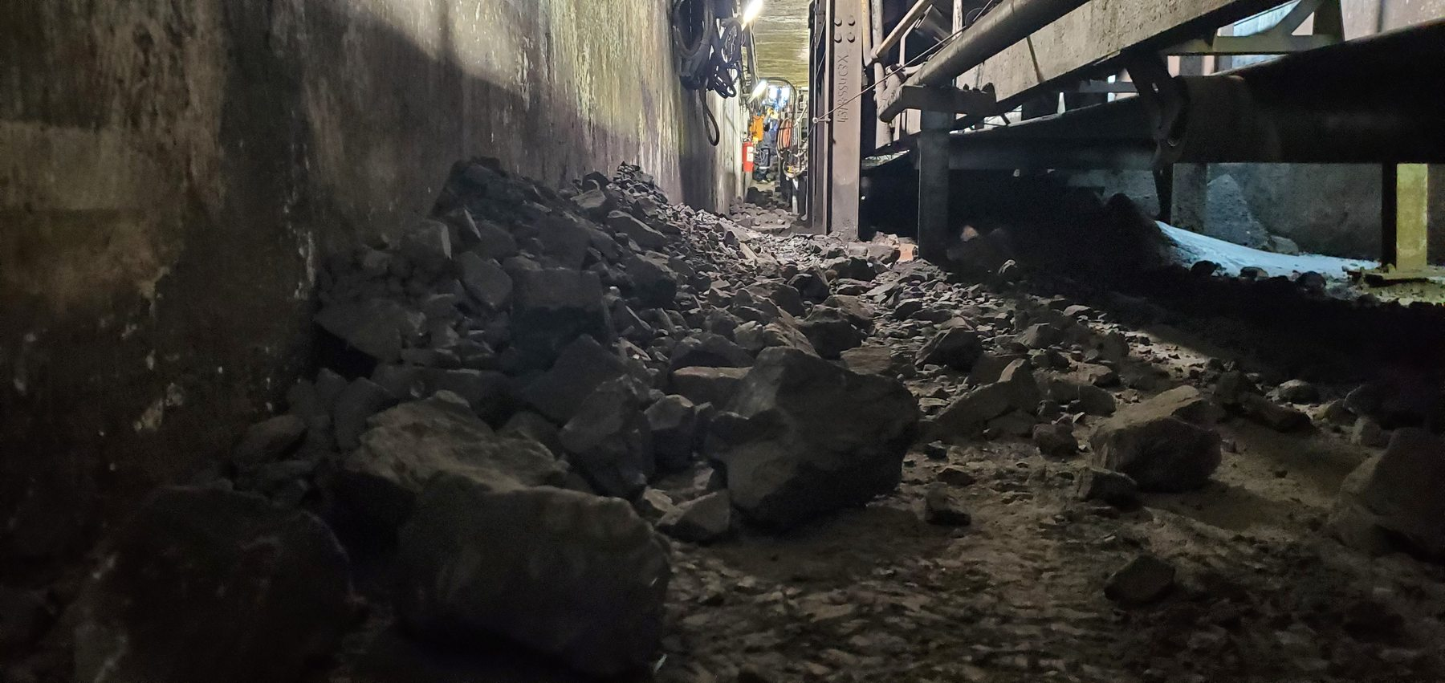
Figure 1 - W10 Conveyor - Primary Feed evidence - W10-REF-002 / FND-001
Photographic evidence assessment - W10-REF-002
Observation | Engineering assessment | Recommended action
Large dry lump and mixed-size product is visibly accumulated along a substantial part of the narrow tunnel access path beside the conveyor. | Direct evidence of solid/mixed-product spillage and the restricted-access consequence. The image demonstrates local severity but does not quantify total system spillage volume. | Review source control and cleaner effectiveness at W10; retain access constraints in the housekeeping and maintenance plan.

16.1.1.2 Photographic Evidence Sheet
Photo ID | W10-REF-010
Finding ID | FND-001
Asset | W10 Conveyor - Primary Feed
Component / location | Enclosed W10 tunnel / conveyor access route
View / direction | Longitudinal contextual view of tunnel and access route
Date / time | July 2026 (inspection period)
Caption | W10 enclosed tunnel showing restricted access and product accumulated along the conveyor-side route.
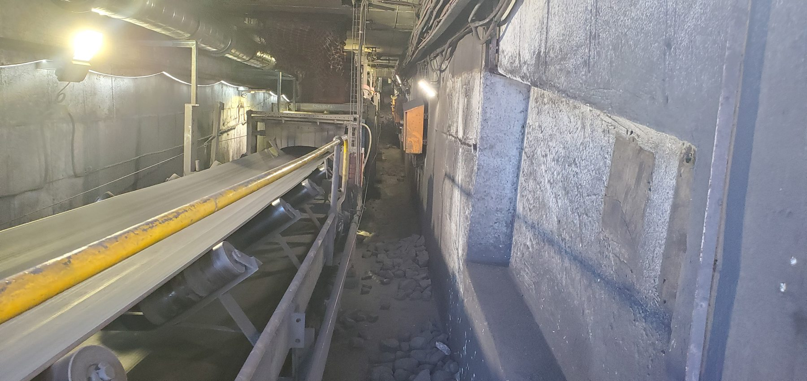
Figure 2 - W10 Conveyor - Primary Feed evidence - W10-REF-010 / FND-001
Photographic evidence assessment - W10-REF-010
Observation | Engineering assessment | Recommended action
The photograph shows the narrow enclosed conveyor corridor with product accumulated along the side-access route. | Supports the recorded confined/restricted-access condition and demonstrates why deposited material has an immediate housekeeping and access consequence. | Maintain access as part of any corrective plan and reduce recurring source spillage before relying on repeated manual clean-up.

16.1.2 CV01
Location / system | Surface screening conveyor
Observed condition | Wet fines/slurry and pooled water below the conveyor; severe visible surface damage/abrasion on the identified return support roller.
Primary evidence | CV01-REF-001 to -004. Preferred: REF-001 plus REF-003 or REF-004.
Mechanism / cause assessment | Wet fines/slurry condition is direct. Roller physical damage is direct; the recorded seized condition is an inspection observation not dynamically proven by the still image.
Evidence qualification / limitation | Do not state “seized” as visually proven unless mechanical/dynamic verification is added.
Working action / next step | Repair/replace damaged return roller as required; verify roller free rotation/function. Investigate and control local wet-fines/carryback source.
Condition / severity / priority | [TO BE RATED] | [TO BE CLASSIFIED] | [TO BE ASSIGNED]

16.1.2.1 Photographic Evidence Sheet
Photo ID | CV01-REF-001
Finding ID | FND-002
Asset | CV01
Component / location | Return support roller
View / direction | Close view of identified return support roller
Date / time | July 2026 (inspection period)
Caption | CV01 return support roller showing severe visible surface damage/abrasion.
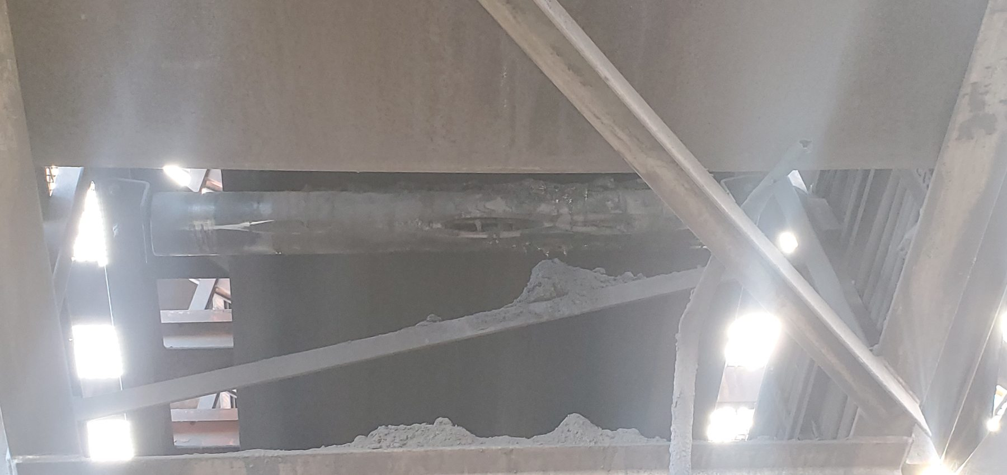
Figure 3 - CV01 evidence - CV01-REF-001 / FND-002
Photographic evidence assessment - CV01-REF-001
Observation | Engineering assessment | Recommended action
The return support roller surface is visibly damaged and heavily abraded. | Physical roller damage is directly verified. The previously recorded seized condition is a source-recorded inspection observation and cannot be established from the still image alone. | Repair/replace the damaged roller and mechanically verify free rotation and return-side function.

16.1.2.2 Photographic Evidence Sheet
Photo ID | CV01-REF-003
Finding ID | FND-002
Asset | CV01
Component / location | Below conveyor / return-side area
View / direction | Floor-level view beneath conveyor
Date / time | July 2026 (inspection period)
Caption | Wet fines/slurry and pooled water beneath the CV01 conveyor.
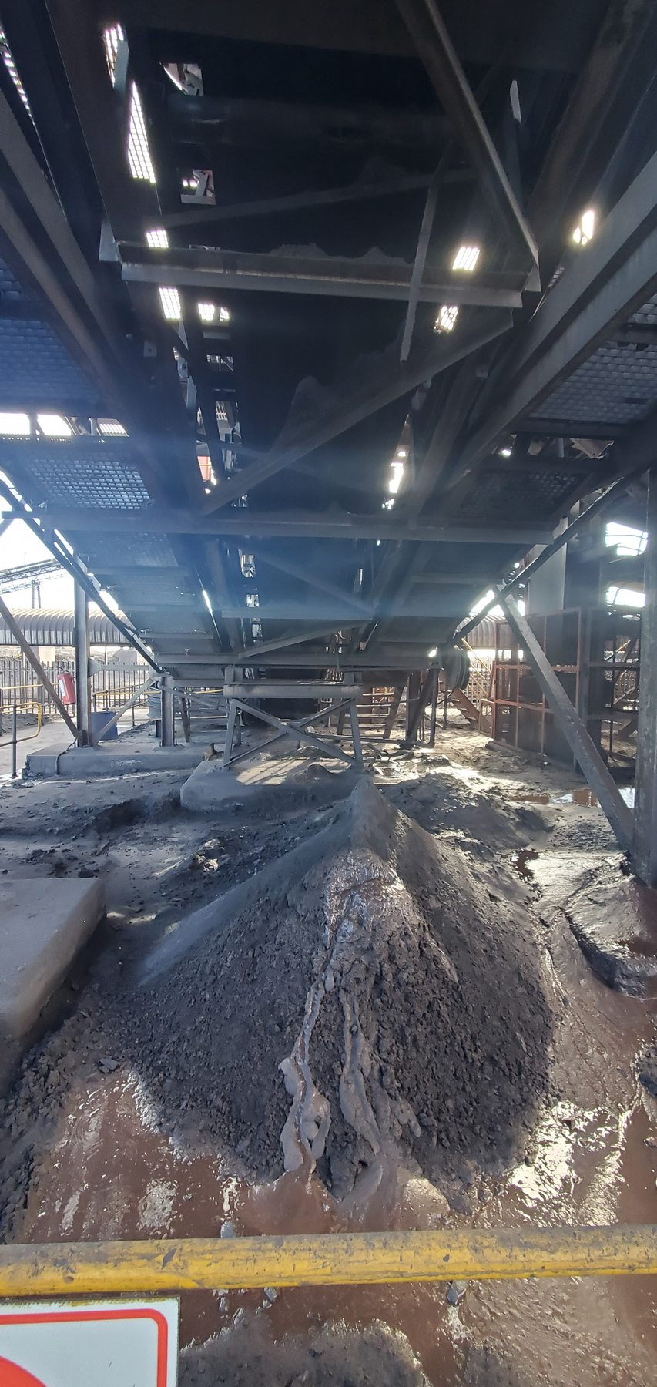
Figure 4 - CV01 evidence - CV01-REF-003 / FND-002
Photographic evidence assessment - CV01-REF-003
Observation | Engineering assessment | Recommended action
A large wet/damp fines deposit with visible pooled water/slurry is present beneath the conveyor. | Direct evidence of the recorded wet-fines/slurry condition. The image does not isolate the initiating water or carryback source. | Investigate local wet-material/carryback source and improve source containment in conjunction with roller correction and housekeeping.

16.1.3 CV02
Location / system | Surface screening conveyor / transfer
Observed condition | Dry fines and mixed-size/lump-product accumulation around transfer and return-side/support areas; localised to moderate extent.
Primary evidence | CV02-REF-001 to -004. Preferred: REF-001 and REF-003.
Mechanism / cause assessment | Physical accumulation is direct. Carryback remains a supported mechanism for fines but is not independently demonstrated as the sole source of every deposit.
Evidence qualification / limitation | None additional beyond Section 5 and Section 21 limitations.
Working action / next step | Include in wider cleaner/carryback applicability review; maintain local containment and housekeeping while source controls are assessed.
Condition / severity / priority | [TO BE RATED] | [TO BE CLASSIFIED] | [TO BE ASSIGNED]

16.1.3.1 Photographic Evidence Sheet
Photo ID | CV02-REF-001
Finding ID | FND-003
Asset | CV02
Component / location | Transfer / lower conveyor area
View / direction | Contextual view below transfer structure
Date / time | July 2026 (inspection period)
Caption | CV02 dry fines and mixed-size lump-product accumulation below the transfer area.
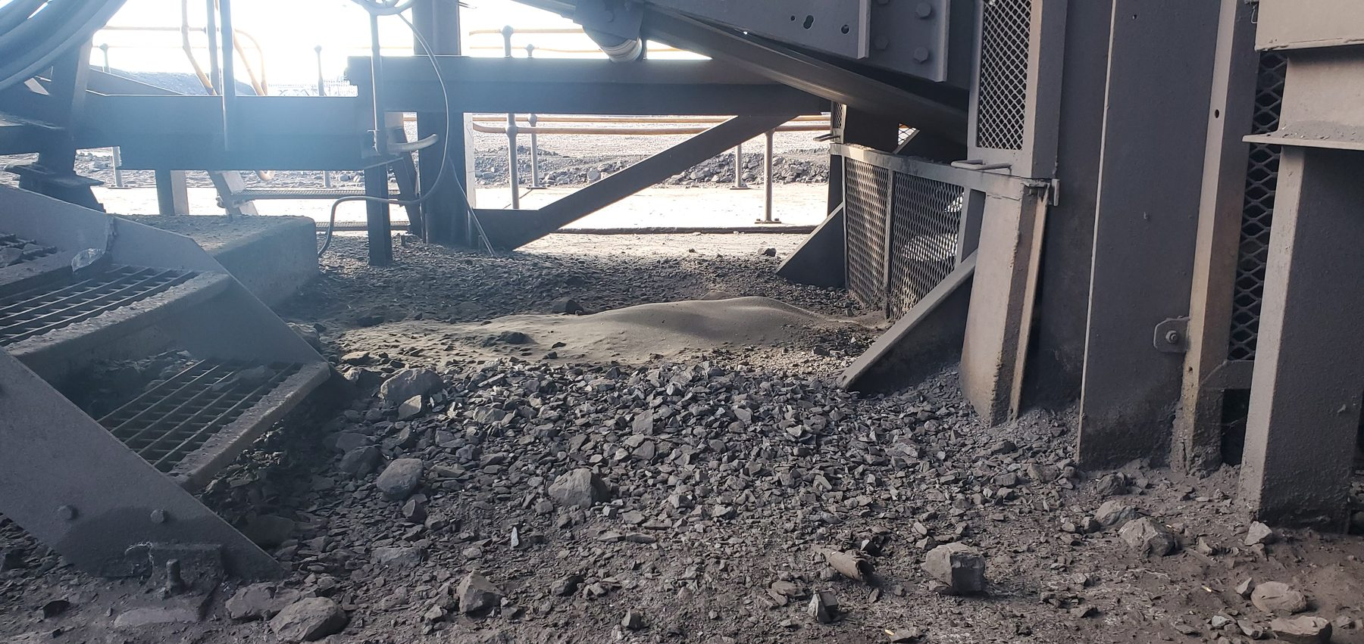
Figure 5 - CV02 evidence - CV02-REF-001 / FND-003
Photographic evidence assessment - CV02-REF-001
Observation | Engineering assessment | Recommended action
Dry fines and coarse/mixed-size product are visibly accumulated below and adjacent to the conveyor/transfer structure. | Direct evidence of dry combined-product spillage. The still image does not establish a single initiating mechanism for all material. | Include CV02 in the wider carryback/cleaner review and maintain local transfer containment and housekeeping.

16.1.3.2 Photographic Evidence Sheet
Photo ID | CV02-REF-003
Finding ID | FND-003
Asset | CV02
Component / location | Return-side / support-roller area
View / direction | Close contextual view of lower support region
Date / time | July 2026 (inspection period)
Caption | Dry lump product and fines accumulated around the CV02 return-side/support-roller area.
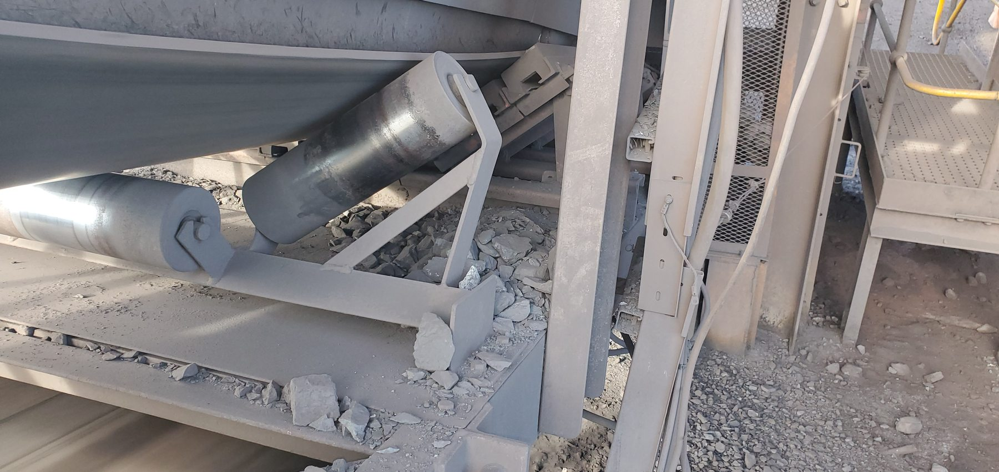
Figure 6 - CV02 evidence - CV02-REF-003 / FND-003
Photographic evidence assessment - CV02-REF-003
Observation | Engineering assessment | Recommended action
Coarse fragments and fines are visibly deposited around the lower return-side/support components. | Direct evidence that material reaches the lower conveyor structure. Return-side fines are consistent with carryback, but the origin of every coarse fragment is not independently proven by the photograph. | Verify return-side cleaner performance and local containment; remove deposits while source controls are assessed.

16.1.4 CV03
Location / system | Surface screening conveyor / transfer
Observed condition | No significant spillage observed in the supplied inspected-condition views.
Primary evidence | CV03-REF-001 to -003. Optional clean comparator: REF-002 or -003.
Mechanism / cause assessment | Baseline/comparator only. Demonstrates that not every inspected conveyor was classified as a spillage problem.
Evidence qualification / limitation | Time-specific inspection condition; does not prove spillage can never occur.
Working action / next step | No immediate spillage-specific action from the current evidence; continue routine inspection and monitoring.
Condition / severity / priority | [TO BE RATED] | [TO BE CLASSIFIED] | [TO BE ASSIGNED]

16.1.4.1 Photographic Evidence Sheet
Photo ID | CV03-REF-002
Finding ID | FND-004
Asset | CV03
Component / location | Conveyor / transfer area
View / direction | Inspected-condition contextual view
Date / time | July 2026 (inspection period)
Caption | CV03 inspected condition with no significant visible spillage in the photographed area.
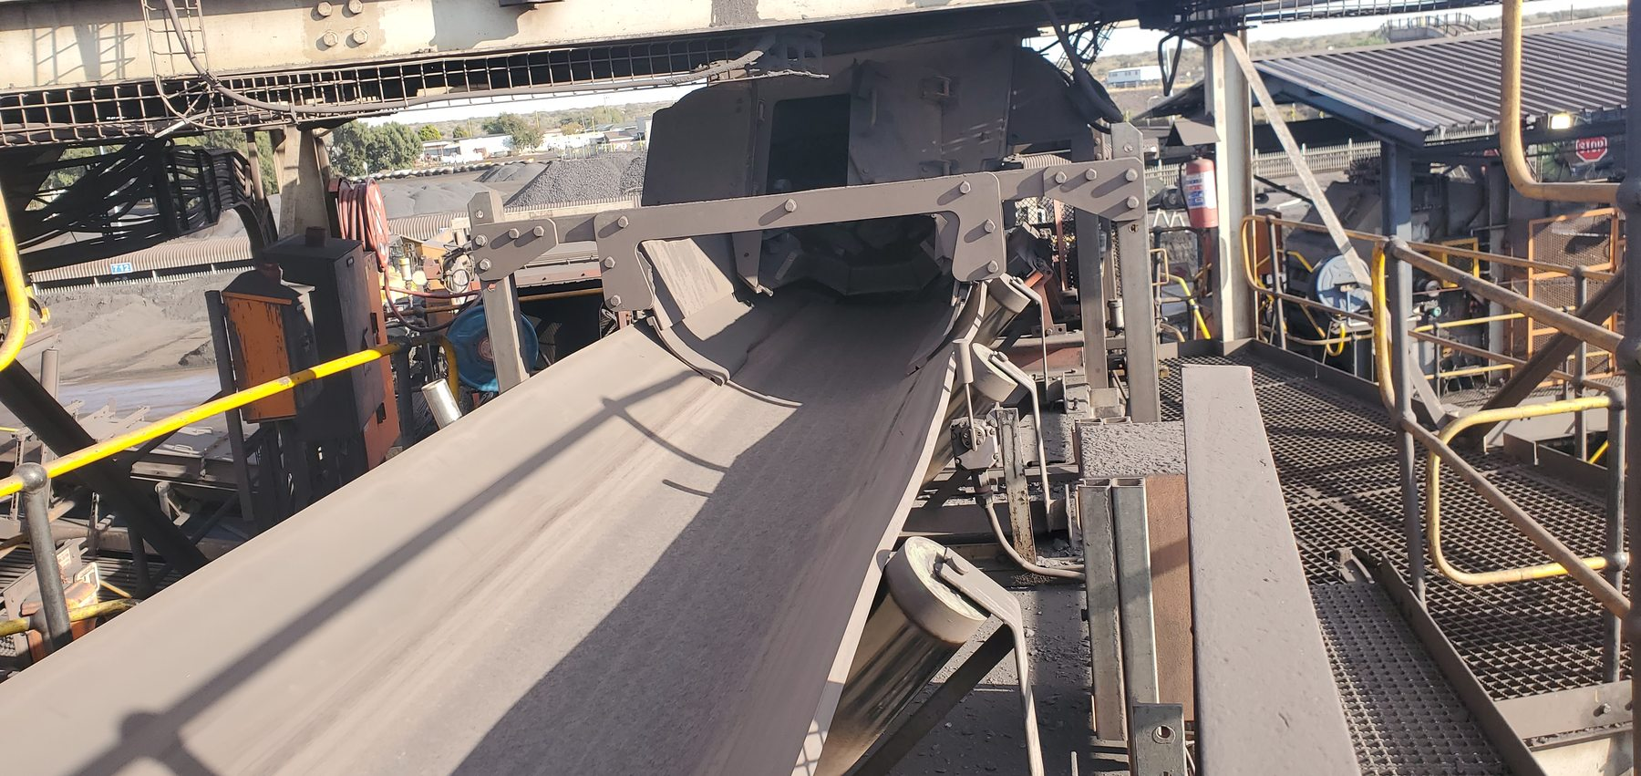
Figure 7 - CV03 evidence - CV03-REF-002 / FND-004
Photographic evidence assessment - CV03-REF-002
Observation | Engineering assessment | Recommended action
The conveyor/transfer area appears comparatively clean with no significant accumulated spillage visible. | Useful direct inspected-condition baseline showing that the audit did not classify every conveyor as a spillage location. The condition is time-specific. | No immediate spillage-specific action from this evidence; retain routine inspection and monitoring.

16.1.5 CV04
Location / system | Surface screening conveyor
Observed condition | Saturated wet-fines/slurry and multiple accumulated fines piles below/around the conveyor; extensive/widespread condition.
Primary evidence | CV04-REF-001 to -005. Preferred: REF-002, REF-005; optional REF-004.
Mechanism / cause assessment | Wet fines/slurry is directly verified, including visible droplets/wet fallout in REF-002. Source may include carryback and local water exposure; exact contribution requires site-specific review.
Evidence qualification / limitation | None additional beyond Section 5 and Section 21 limitations.
Working action / next step | Identify/limit water entry and carryback source; assess cleaner/containment condition and drainage/housekeeping interface without assuming a drainage defect.
Condition / severity / priority | [TO BE RATED] | [TO BE CLASSIFIED] | [TO BE ASSIGNED]

16.1.5.1 Photographic Evidence Sheet
Photo ID | CV04-REF-002
Finding ID | FND-005
Asset | CV04
Component / location | Below conveyor / wet-spillage area
View / direction | Close view of saturated deposit
Date / time | July 2026 (inspection period)
Caption | CV04 saturated wet-fines/slurry accumulation with visible wet fallout.
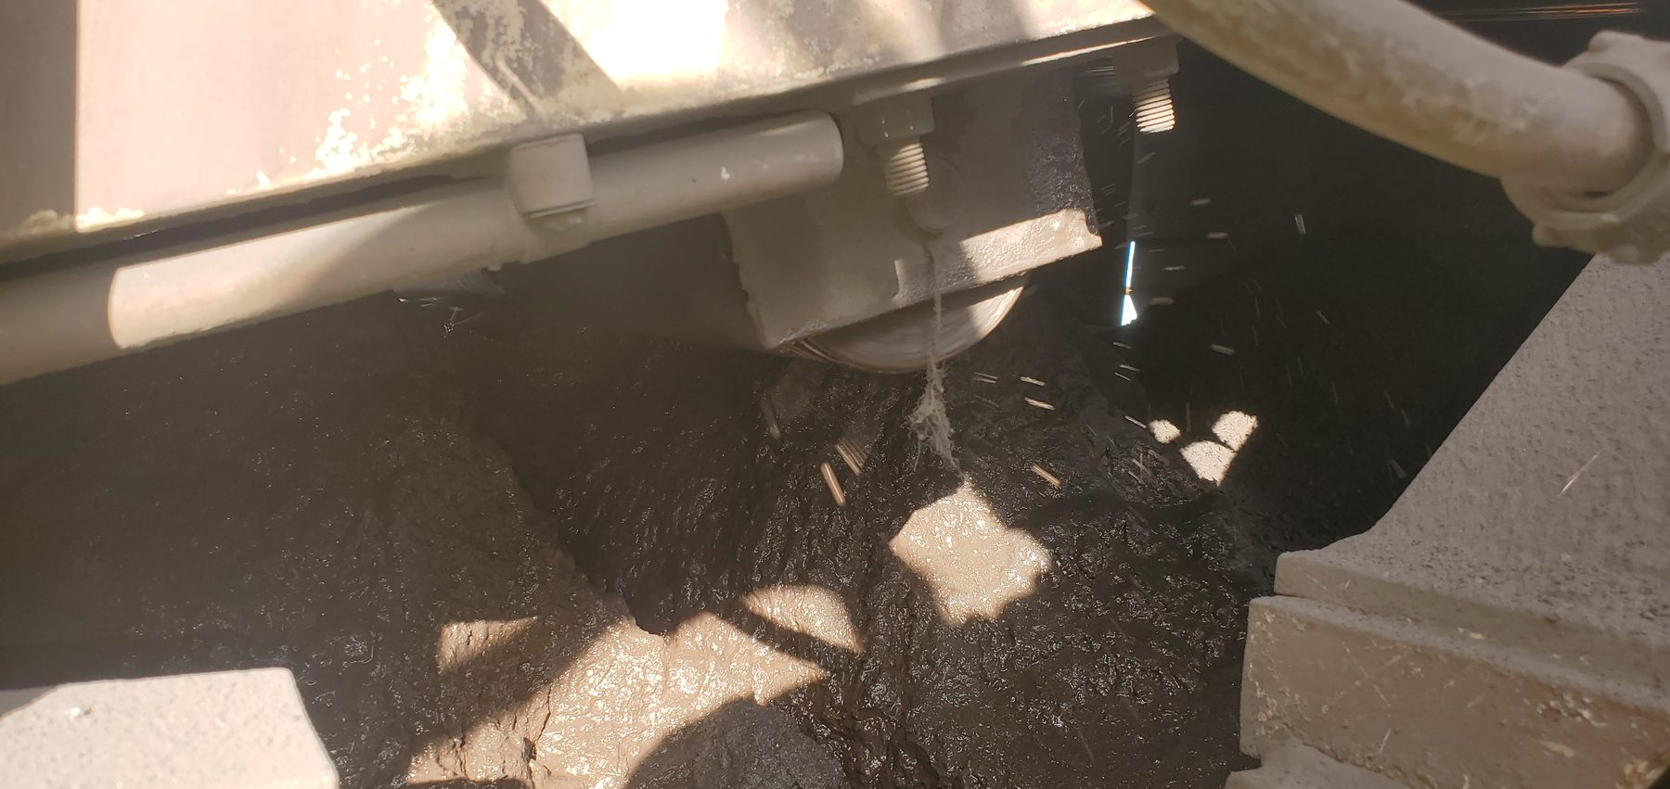
Figure 8 - CV04 evidence - CV04-REF-002 / FND-005
Photographic evidence assessment - CV04-REF-002
Observation | Engineering assessment | Recommended action
Saturated fines/slurry is visibly accumulated beneath the conveyor and wet droplets/fallout are visible in the photographed area. | Direct evidence of active or recently active wet-material loss. The still does not isolate whether the initiating source is carryback, process water, or a combination. | Identify and control water entry and carryback source; review cleaner/containment and drainage/housekeeping interfaces.

16.1.5.2 Photographic Evidence Sheet
Photo ID | CV04-REF-005
Finding ID | FND-005
Asset | CV04
Component / location | Below conveyor / surrounding floor area
View / direction | Wider extent view
Date / time | July 2026 (inspection period)
Caption | Multiple accumulated fines piles beneath CV04 demonstrating the wider spillage extent.
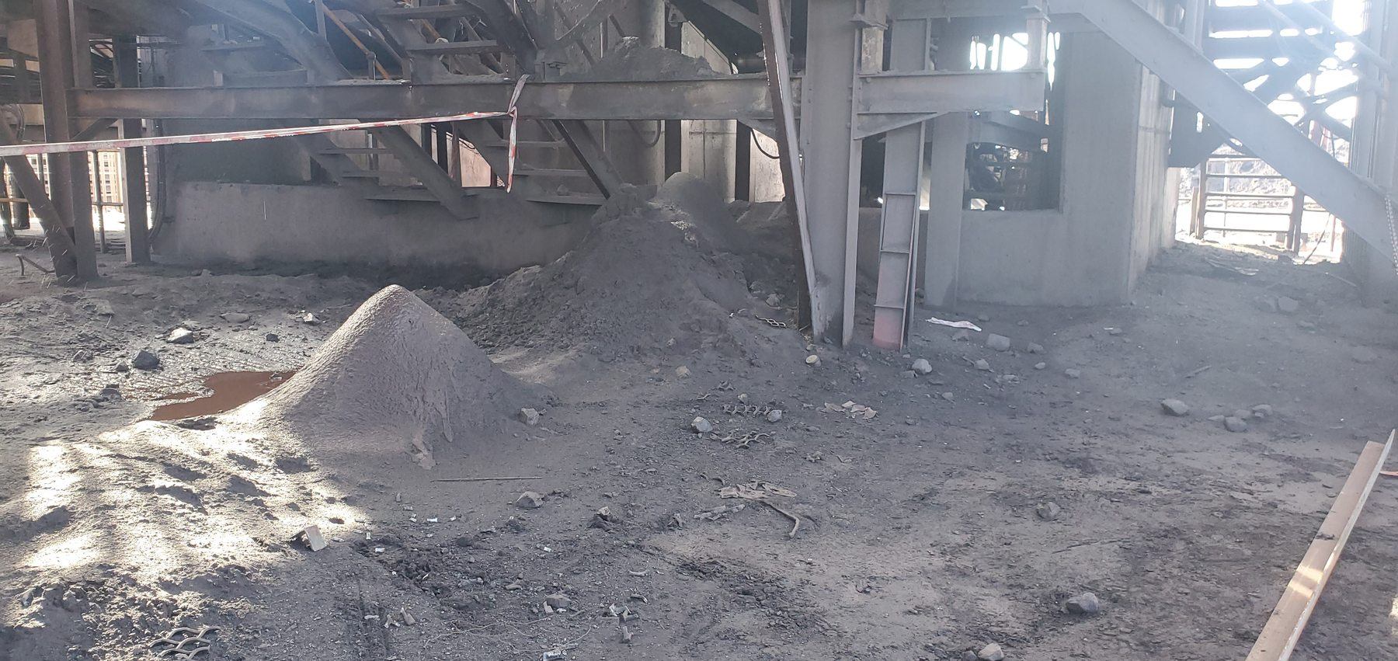
Figure 9 - CV04 evidence - CV04-REF-005 / FND-005
Photographic evidence assessment - CV04-REF-005
Observation | Engineering assessment | Recommended action
Multiple fines piles are distributed beneath and around the conveyor over a wider area. | Direct evidence supporting the existing extensive/widespread qualitative classification. | Prioritise source control and local recovery/clean-up after correcting the initiating wet-fines/carryback mechanism.

16.1.6 CV06
Location / system | Surface screening conveyor - head cleaner
Observed condition | Cleaner support bush/insert displaced from housing and scraper blades absent from the working belt width; dry fines/carryback deposits present.
Primary evidence | CV06-REF-004 (displaced bush); CV06-REF-005 (missing blades).
Mechanism / cause assessment | The cleaner was non-functional/materially compromised at inspection. Poor housing design is a working assessment for the bush displacement; reason/history for blade absence remains unknown.
Evidence qualification / limitation | Do not present the housing-design explanation or blade-loss history as proven fact.
Working action / next step | Restore functional cleaner condition. Use CV09 pilot development rather than a separate CV06 redesign at this stage; verify maintenance/replacement history and support arrangement.
Condition / severity / priority | [TO BE RATED] | [TO BE CLASSIFIED] | [TO BE ASSIGNED]

16.1.6.1 Photographic Evidence Sheet
Photo ID | CV06-REF-004
Finding ID | FND-006
Asset | CV06
Component / location | Head-cleaner support assembly
View / direction | Close view of support housing / bush
Date / time | July 2026 (inspection period)
Caption | CV06 scraper support bush displaced from its housing.
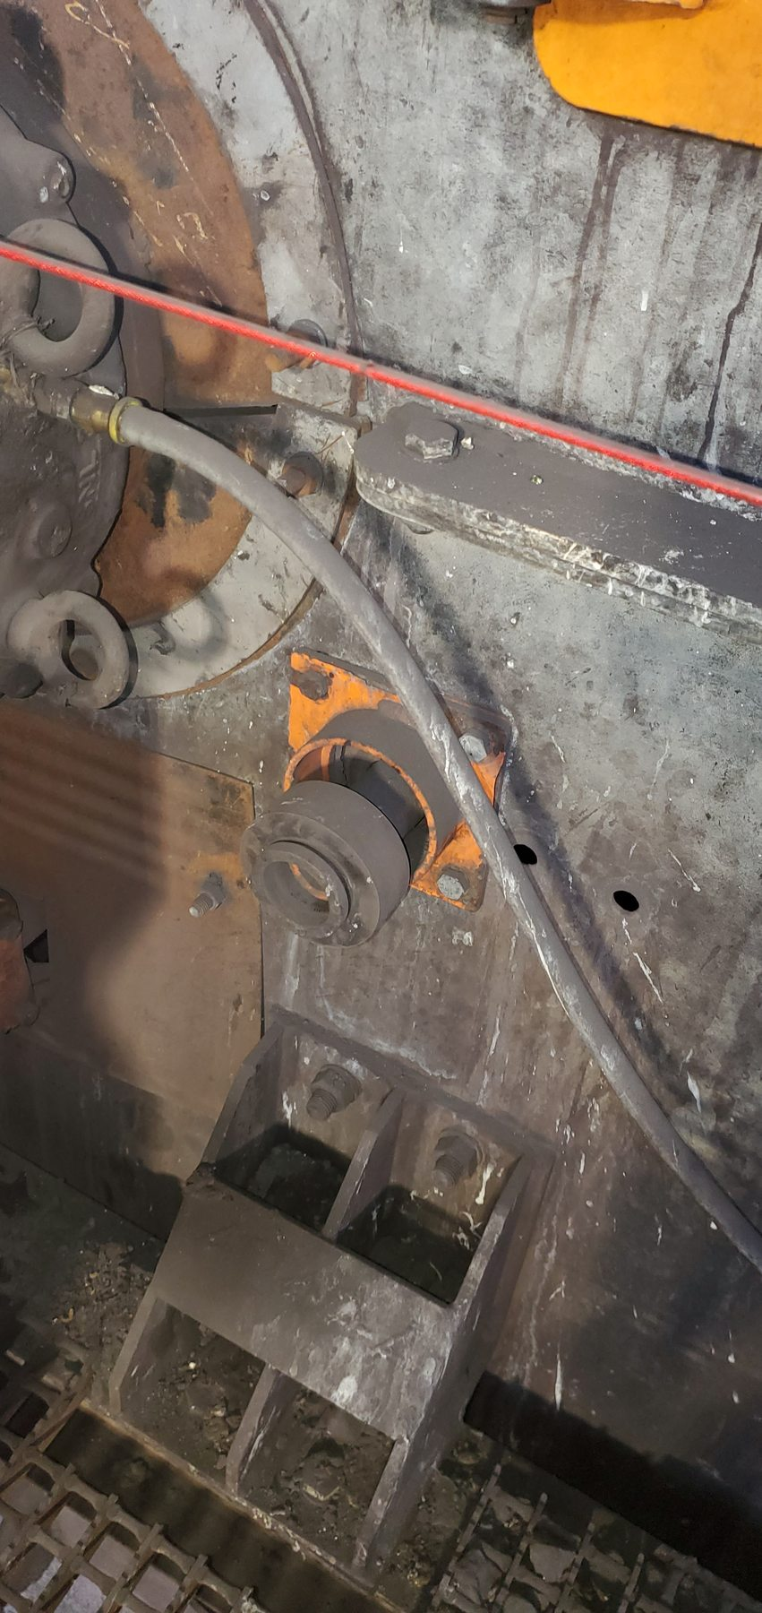
Figure 10 - CV06 evidence - CV06-REF-004 / FND-006
Photographic evidence assessment - CV06-REF-004
Observation | Engineering assessment | Recommended action
The dark cylindrical bush/insert is visibly displaced and protruding outboard relative to the support housing. | Direct evidence that the cleaner support arrangement was mechanically compromised at inspection. The photograph does not prove why the bush displaced. | Restore the support assembly to a serviceable condition, verify retention/geometry and review the housing design as a probable contributor rather than a proven cause.

16.1.6.2 Photographic Evidence Sheet
Photo ID | CV06-REF-005
Finding ID | FND-006
Asset | CV06
Component / location | Head-cleaner support beam / working belt width
View / direction | Contextual underside view of cleaner position
Date / time | July 2026 (inspection period)
Caption | CV06 head-cleaner support arrangement with scraper blades absent from the working belt width.
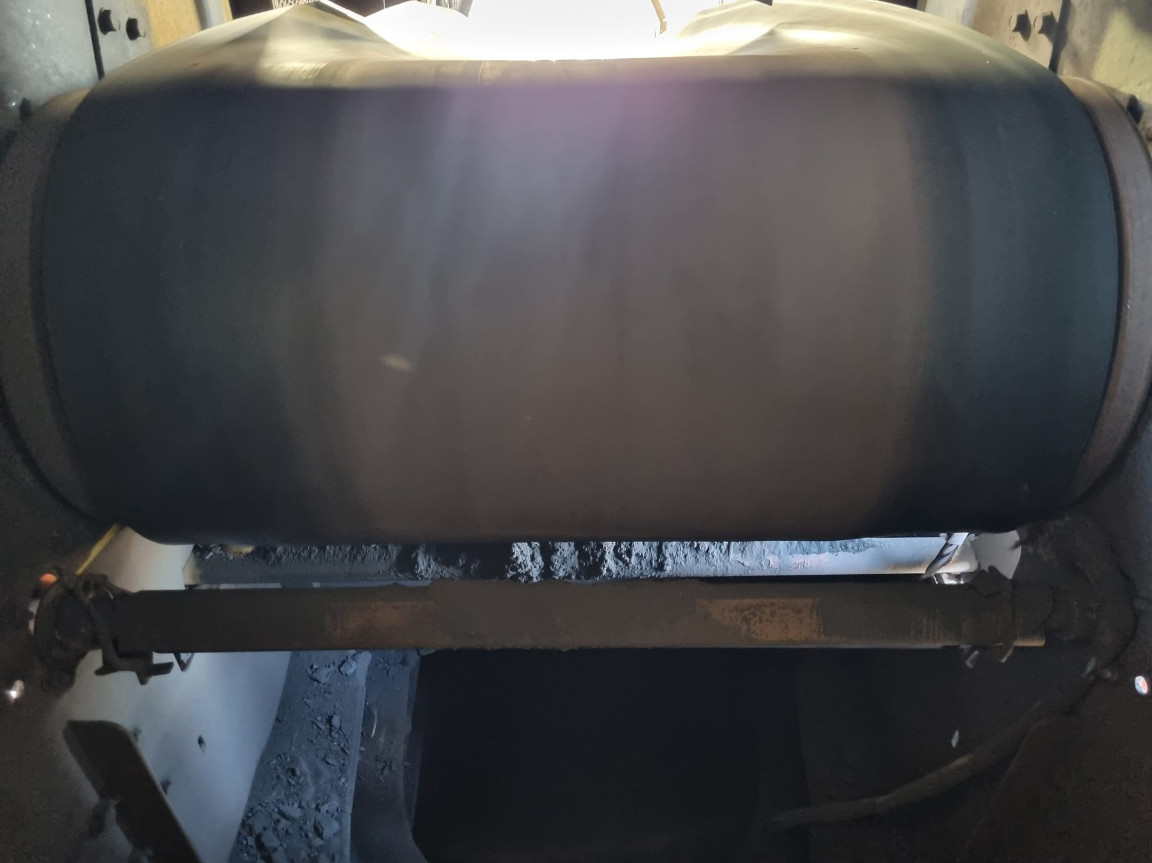
Figure 11 - CV06 evidence - CV06-REF-005 / FND-006
Photographic evidence assessment - CV06-REF-005
Observation | Engineering assessment | Recommended action
The cleaner support beam/cross-shaft is present below the belt, while scraper blade elements are not visible across the working belt width. | Direct evidence that the cleaner was not functioning as intended in the photographed condition. The image does not establish when or why the blades were removed/lost. | Restore a complete functional cleaner assembly and verify blade coverage/contact; use the CV09 pilot to inform any wider design standardisation.

16.1.7 CV09
Location / system | Surface screening conveyor - discharge / cleaner area
Observed condition | Wet-fines/slurry accumulation, heavily contaminated cleaner region and active wet-material fallout below the conveyor/transfer area. Cleaner operates in an open/non-contained local arrangement in the reviewed evidence.
Primary evidence | CV09-REF-002/-003; video CV09-REF-006; supplementary video CV09-REF-008.
Mechanism / cause assessment | Direct evidence supports the cleaner/chute containment mechanism: removed wet carryback can become environmental spillage, while residual carryback continues downstream. Detailed final geometry is not yet verified.
Evidence qualification / limitation | Final chute dimensions, cleaner selection and spring/travel design require measurement and detailed engineering.
Working action / next step | Use CV09 as pilot: extend/revise chute containment, keep removed fines within the intended fines discharge, apply self-tensioning cleaner concept with wear/travel limits, assess primary/secondary stages, retain safe access.
Condition / severity / priority | [TO BE RATED] | [TO BE CLASSIFIED] | [TO BE ASSIGNED]

16.1.7.1 Photographic Evidence Sheet
Photo ID | CV09-REF-003
Finding ID | FND-007
Asset | CV09
Component / location | Discharge / belt-cleaner area
View / direction | Close view beneath belt at cleaner
Date / time | July 2026 (inspection period)
Caption | CV09 cleaner assembly showing heavy wet-fines build-up and an open, non-contained local discharge arrangement.
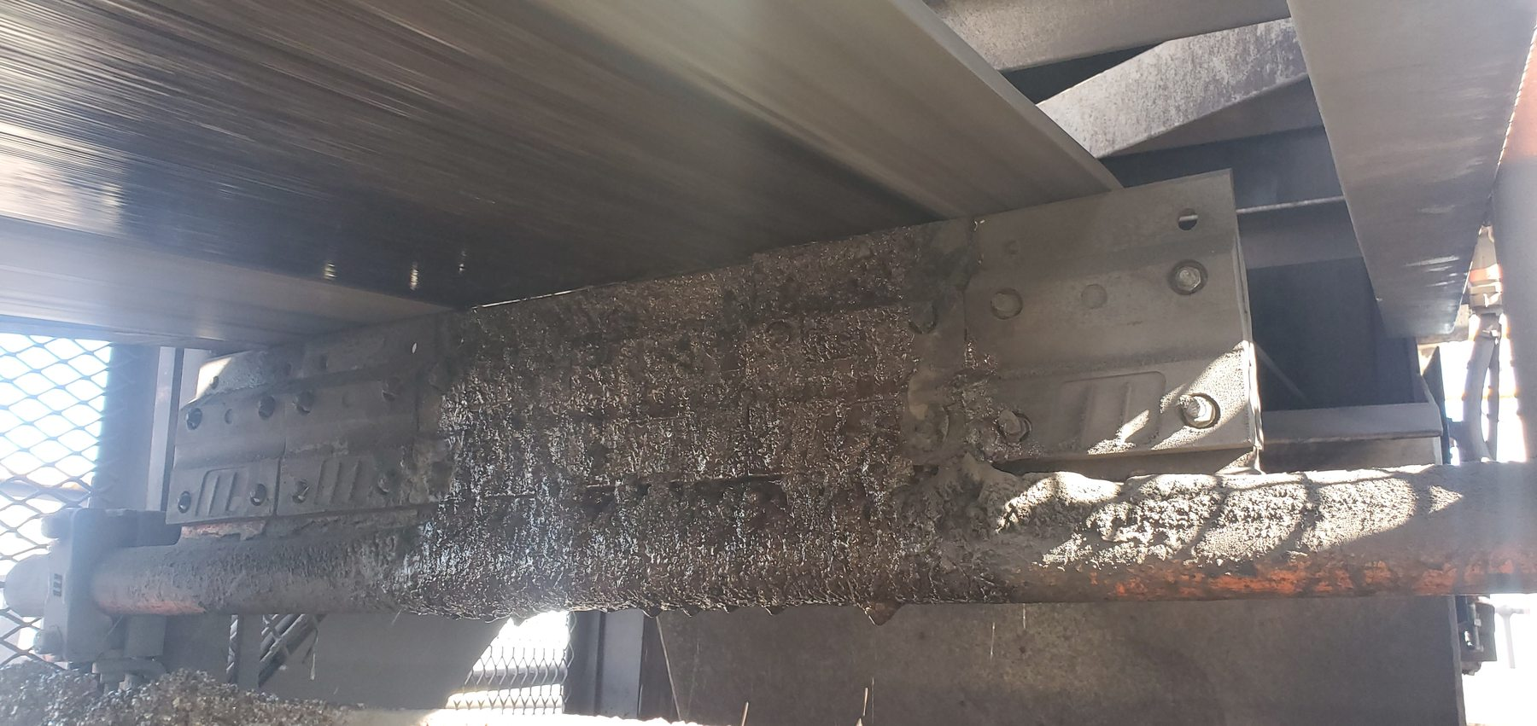
Figure 12 - CV09 evidence - CV09-REF-003 / FND-007
Photographic evidence assessment - CV09-REF-003
Observation | Engineering assessment | Recommended action
The cleaner/scraper assembly is visibly coated with wet fines/carryback and the surrounding cleaner region is open to the plant area in the supplied view. | Direct evidence supporting the cleaner/chute containment mechanism: removed material can fall outside the intended discharge path. Final extension geometry still requires measurement. | Develop the CV09 pilot with revised chute containment so removed fines remain within the intended fines-discharge path; retain safe maintenance access.

16.1.7.2 Photographic Evidence Sheet
Photo ID | CV09-REF-002
Finding ID | FND-007
Asset | CV09
Component / location | Floor below CV09 discharge / cleaner area
View / direction | Floor-level consequence view
Date / time | July 2026 (inspection period)
Caption | Wet fines/slurry accumulated beneath the CV09 conveyor discharge/cleaner area.
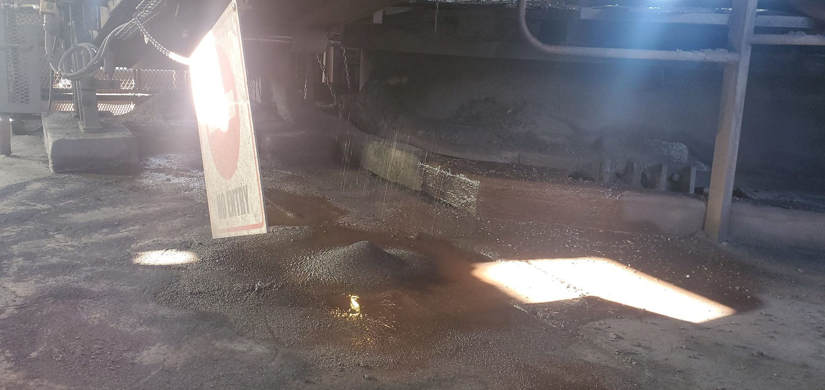
Figure 13 - CV09 evidence - CV09-REF-002 / FND-007
Photographic evidence assessment - CV09-REF-002
Observation | Engineering assessment | Recommended action
Wet fines/slurry and standing wet material are visibly accumulated below the conveyor/cleaner region. | Direct consequence evidence showing that wet material reaches the surrounding plant environment rather than remaining contained within the discharge system. | Combine source containment with cleaner effectiveness improvements; remove accumulated wet material after source controls are implemented.

16.1.7.3 Photographic Evidence Sheet
Photo ID | CV09-REF-006
Finding ID | FND-007
Asset | CV09
Component / location | Below CV09 conveyor / transfer region
View / direction | Representative still extracted from operational video CV09-REF-006
Date / time | July 2026 (inspection period)
Caption | Representative video still showing active wet-material fallout beneath the CV09 conveyor/transfer area.
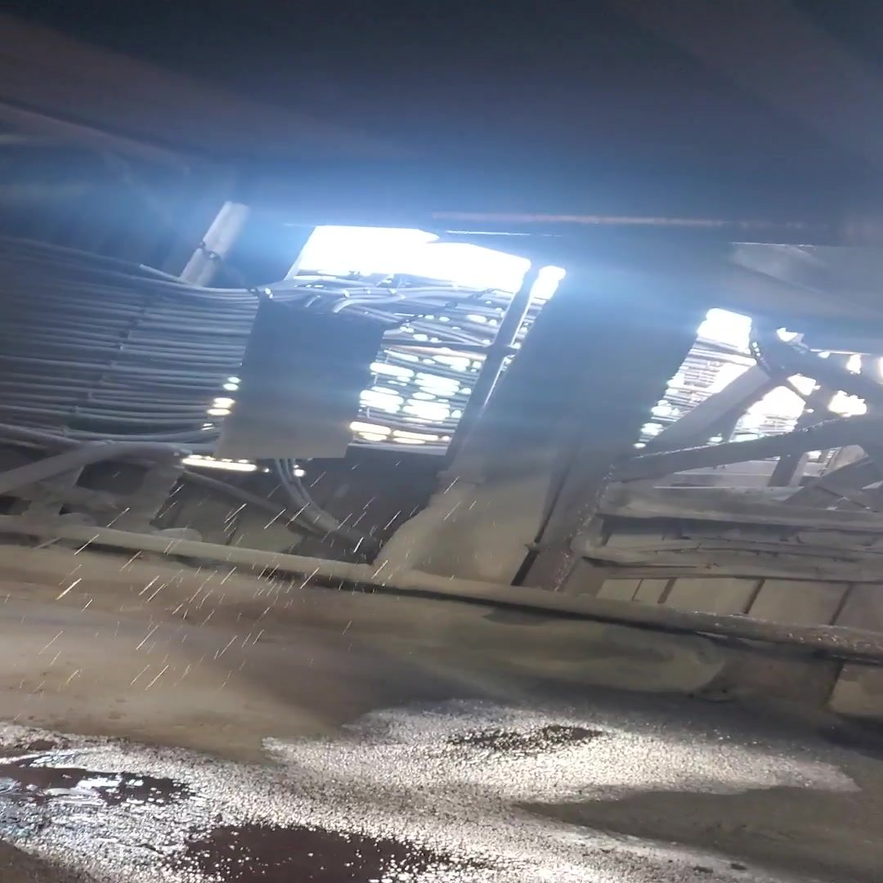
Figure 14 - CV09 evidence - CV09-REF-006 / FND-007
Photographic evidence assessment - CV09-REF-006
Observation | Engineering assessment | Recommended action
Multiple droplets/streams of wet material are visibly falling from the overhead conveyor/transfer region to the wet floor below. | Direct dynamic evidence that the wet-spillage condition was active during the recorded operating period. The frame does not isolate the exact origin of every droplet. | Use the video evidence to inform the CV09 containment pilot and verify the post-modification condition under representative operation.

16.1.8 CV14
Location / system | Surface screening conveyor
Observed condition | Trace/localised dry fines/carryback deposits, including a local mound beneath the return-side structure.
Primary evidence | CV14-REF-001/-002. Preferred: REF-002.
Mechanism / cause assessment | Condition is consistent with recurring carryback but does not support escalation to widespread accumulation.
Evidence qualification / limitation | None additional beyond Section 5 and Section 21 limitations.
Working action / next step | Routine cleaner/return-side inspection and housekeeping; include in system carryback trend review.
Condition / severity / priority | [TO BE RATED] | [TO BE CLASSIFIED] | [TO BE ASSIGNED]

16.1.8.1 Photographic Evidence Sheet
Photo ID | CV14-REF-002
Finding ID | FND-008
Asset | CV14
Component / location | Return-side / below conveyor
View / direction | Localised deposit below return-side structure
Date / time | July 2026 (inspection period)
Caption | CV14 localised fines/carryback mound beneath the conveyor return-side structure.
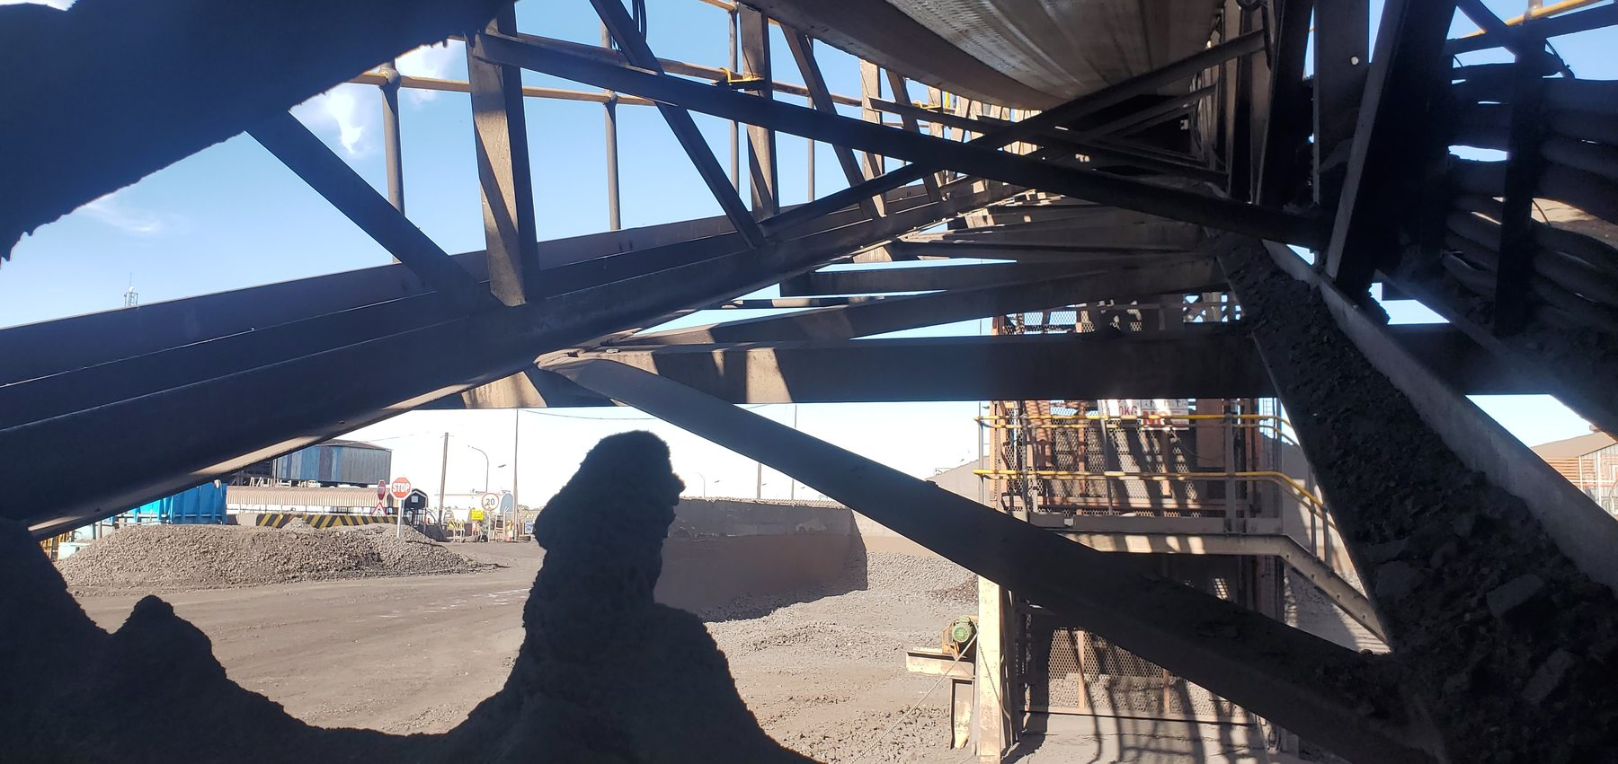
Figure 15 - CV14 evidence - CV14-REF-002 / FND-008
Photographic evidence assessment - CV14-REF-002
Observation | Engineering assessment | Recommended action
A localised mound of dry fines is visibly present below the return-side conveyor structure. | Direct evidence of a trace/localised fines condition consistent with recurring carryback; the image does not support escalation to widespread accumulation. | Continue routine cleaner/return-side inspection, housekeeping and condition trending.

16.1.9 CV15 - E-3181 Area
Location / system | Surface screening discharge / chute area
Observed condition | Extensive distributed fines/carryback accumulation on grating, cross-bracing and structural members around chute E-3181.
Primary evidence | CV15-REF-003 identifies E-3181; REF-004 or -006 for extent; optional REF-008.
Mechanism / cause assessment | Dry/dried fines accumulation is direct. Wet-fines condition and cleaner operational effectiveness remain source-recorded inspection observations rather than directly proven by this still set.
Evidence qualification / limitation | Do not overstate wetness or cleaner performance based solely on still photographs.
Working action / next step | Review local cleaner effectiveness and discharge containment; include in wider cleaner applicability survey following CV09 pilot.
Condition / severity / priority | [TO BE RATED] | [TO BE CLASSIFIED] | [TO BE ASSIGNED]

16.1.9.1 Photographic Evidence Sheet
Photo ID | CV15-REF-003
Finding ID | FND-009
Asset | CV15 - E-3181 Area
Component / location | Chute E-3181 area
View / direction | Asset/location identification view
Date / time | July 2026 (inspection period)
Caption | CV15 chute identification confirming the E-3181 spillage reference area.
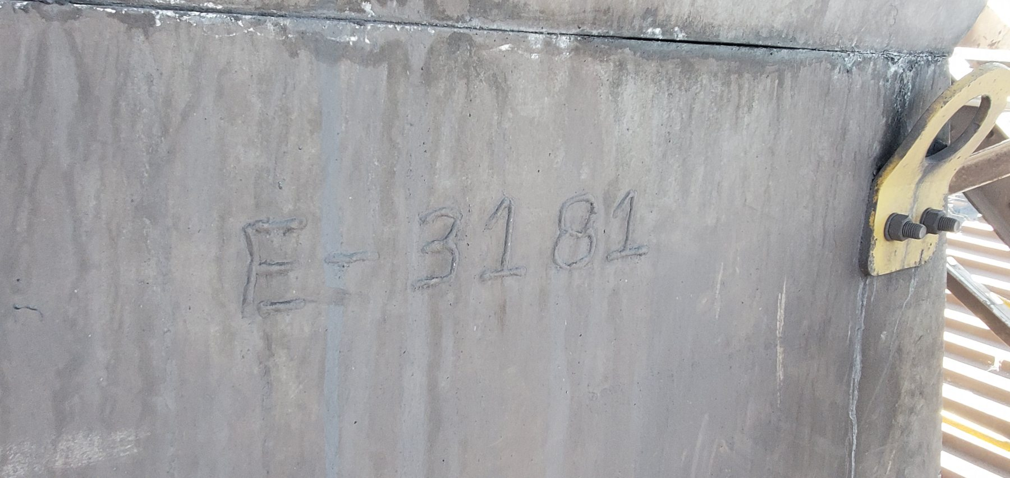
Figure 16 - CV15 - E-3181 Area evidence - CV15-REF-003 / FND-009
Photographic evidence assessment - CV15-REF-003
Observation | Engineering assessment | Recommended action
The chute marking E-3181 is visible and provides direct traceability for the photographed CV15 spillage location. | Contextual identification evidence linking the wider CV15 fines/carryback record to the E-3181 area. | Use E-3181 as the local reference for cleaner/containment inspection and corrective-action tracking.

16.1.9.2 Photographic Evidence Sheet
Photo ID | CV15-REF-006
Finding ID | FND-009
Asset | CV15 - E-3181 Area
Component / location | Structure beneath/around E-3181
View / direction | Wider structural accumulation view
Date / time | July 2026 (inspection period)
Caption | Extensive fines/carryback build-up distributed across CV15 support members and cross-bracing.
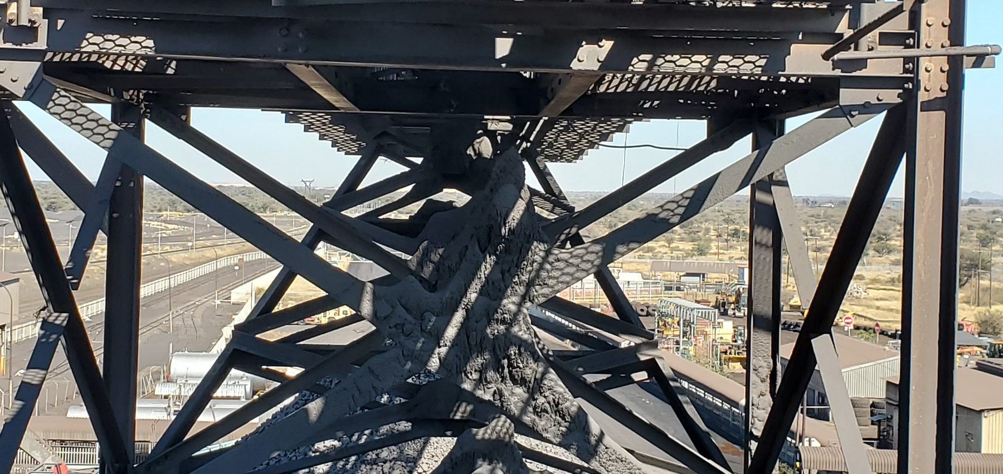
Figure 17 - CV15 - E-3181 Area evidence - CV15-REF-006 / FND-009
Photographic evidence assessment - CV15-REF-006
Observation | Engineering assessment | Recommended action
Large dry/dried-fines deposits coat and accumulate on multiple cross-braces and structural members beneath/around the conveyor. | Direct evidence that the CV15 condition is distributed through the structure rather than limited to a single floor-level pile. Wetness and cleaner performance are not established by this still alone. | Review local cleaner effectiveness and discharge containment and include CV15 in the post-CV09 cleaner applicability survey.

16.1.10 Screens and Screen Chutes
Location / system | Surface screening / washing equipment
Observed condition | Active process-water loss of containment; severe corrosion/deterioration at screen/deck-support interfaces; multiple cut-outs/notches in support members identified in the inspection context as load-bearing.
Primary evidence | Video Screen-REF-016 or -017; corrosion REF-004 or -008; support damage REF-006 or -010; optional context REF-003/-014.
Mechanism / cause assessment | Water loss of containment is direct; equipment-level cause unresolved. Physical support damage is direct, while load path/capacity and reason for cuts require engineering verification.
Evidence qualification / limitation | Do not present installation-clearance hypothesis as established cause. Remaining structural capacity cannot be determined photographically.
Working action / next step | Inspect during safe shutdown to identify leak source; formally assess damaged/corroded supports; define repair/replacement; structurally approve any revised geometry.
Condition / severity / priority | [TO BE RATED] | [TO BE CLASSIFIED] | [TO BE ASSIGNED]

16.1.10.1 Photographic Evidence Sheet
Photo ID | Screen-REF-017
Finding ID | FND-010
Asset | Screens and Screen Chutes
Component / location | Operating screen/chute containment envelope
View / direction | Representative still extracted from Screen-REF-017 video
Date / time | July 2026 (inspection period)
Caption | Operational video still showing substantial process-water spray/runoff escaping around the screen/chute structure.
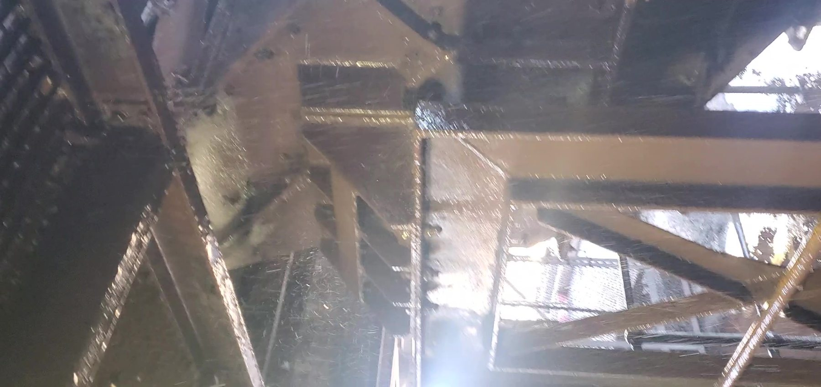
Figure 18 - Screens and Screen Chutes evidence - Screen-REF-017 / FND-010
Photographic evidence assessment - Screen-REF-017
Observation | Engineering assessment | Recommended action
Water spray/runoff is visibly escaping the operating screen/chute region and wetting surrounding steelwork. | Direct dynamic evidence of process-water loss of containment. The frame does not establish the internal defect or exact leak source. | Perform a safe-shutdown close inspection to locate the actual leak mechanism before finalising containment modifications.

16.1.10.2 Photographic Evidence Sheet
Photo ID | Screen-REF-004
Finding ID | FND-010
Asset | Screens and Screen Chutes
Component / location | Screen support / deck interface
View / direction | Close corrosion view
Date / time | July 2026 (inspection period)
Caption | Screen support/deck interface showing severe corrosion and local material deterioration in the wet screening environment.
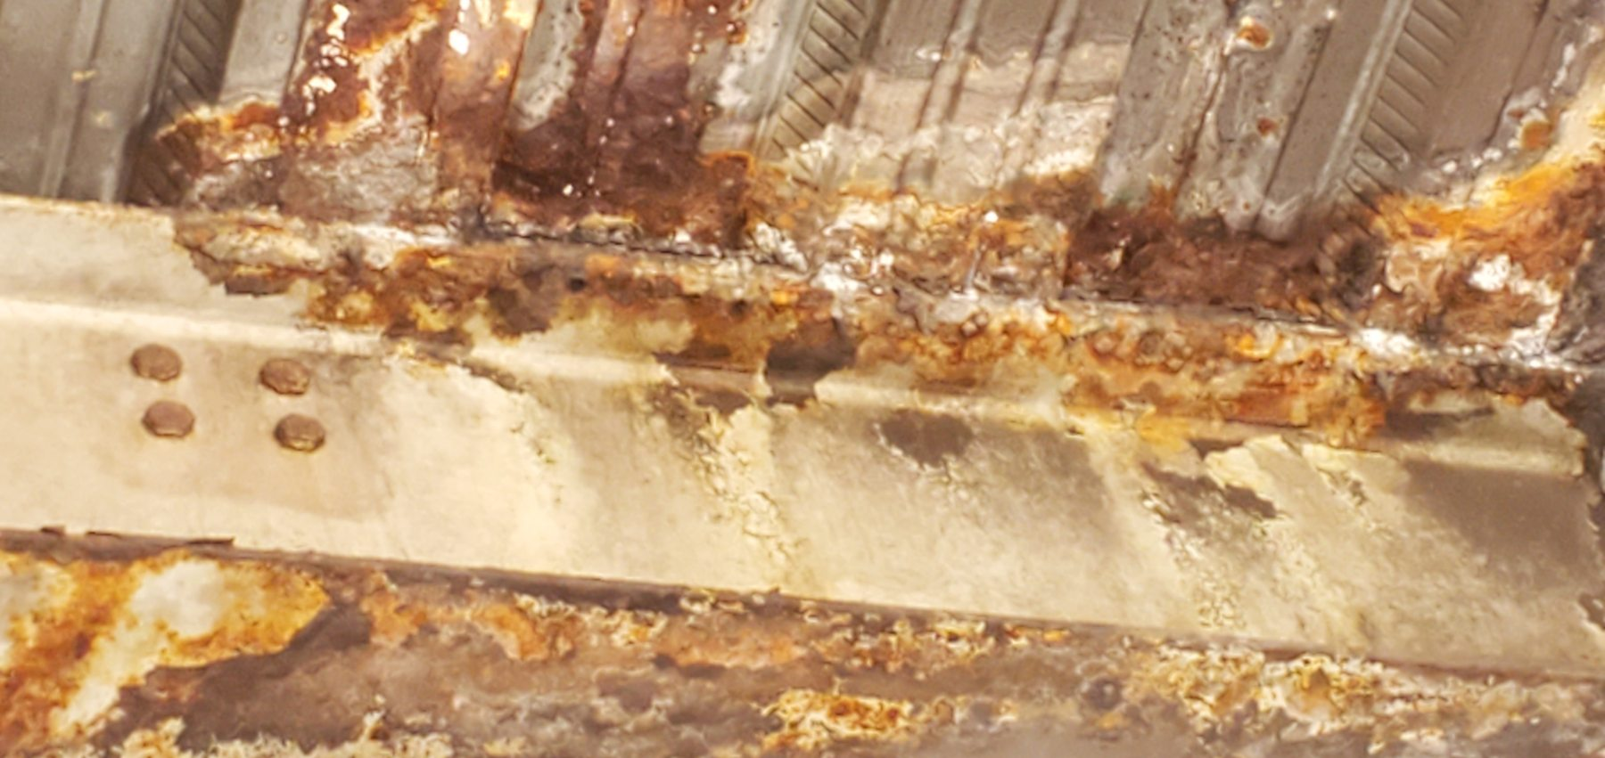
Figure 19 - Screens and Screen Chutes evidence - Screen-REF-004 / FND-010
Photographic evidence assessment - Screen-REF-004
Observation | Engineering assessment | Recommended action
Extensive corrosion products and local steel/material deterioration are visible at the support/deck interface. | Direct evidence of severe deterioration consistent with repeated wet exposure. Remaining structural capacity cannot be determined visually. | Complete a competent structural assessment and develop an approved repair/replacement scope based on measured condition and load path.

16.1.10.3 Photographic Evidence Sheet
Photo ID | Screen-REF-006
Finding ID | FND-010
Asset | Screens and Screen Chutes
Component / location | Screen support member
View / direction | Close view of physical cut-out/notch
Date / time | July 2026 (inspection period)
Caption | Physical cut-out/notch through a screen support member.
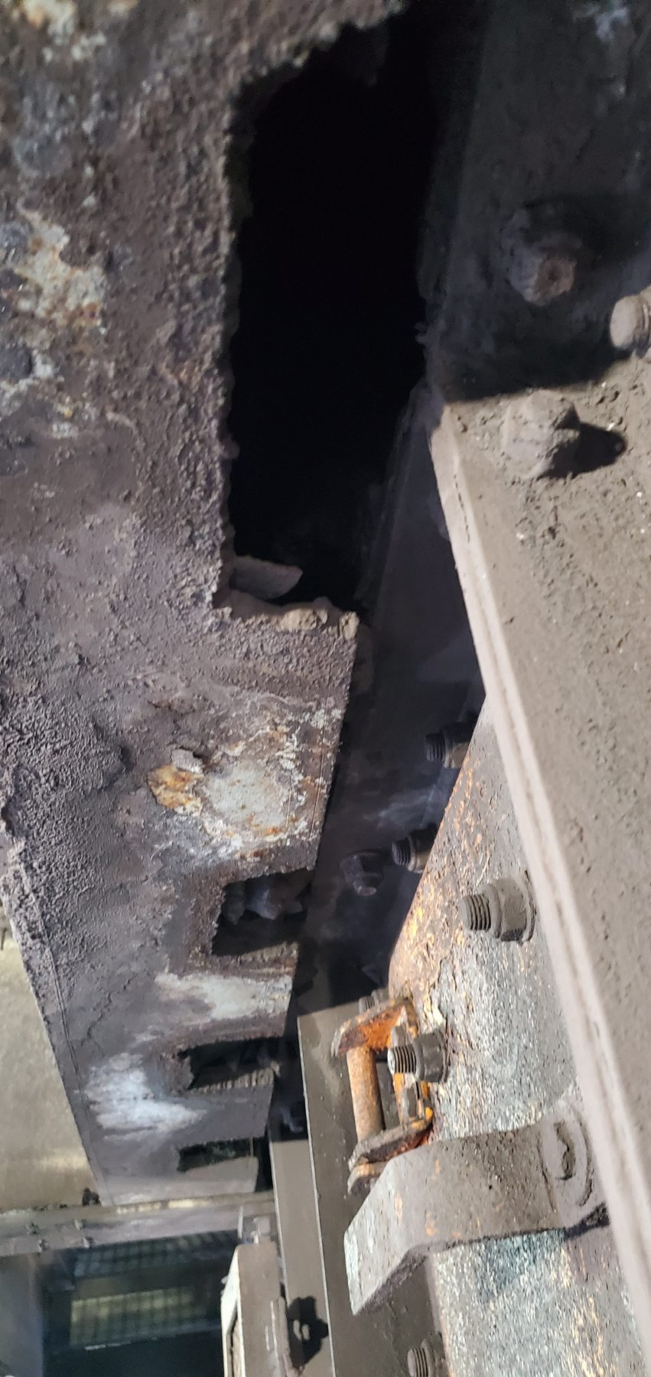
Figure 20 - Screens and Screen Chutes evidence - Screen-REF-006 / FND-010
Photographic evidence assessment - Screen-REF-006
Observation | Engineering assessment | Recommended action
A substantial irregular cut-out/opening is visibly present through the identified support member. | Direct evidence of physical member alteration/damage. The reason for the cut and the remaining load-carrying capacity are not established by the photograph. | Treat the member as requiring structural engineering review; do not rely on the installation-clearance hypothesis unless independently confirmed.

16.2 Surface Processing Plant - Loading Station

16.2.1 L1 Conveyor - Primary Feed
Location / system | Loading Station tunnel / primary feed
Observed condition | Extensive fines and solid/mixed-product accumulation; severe concrete spalling with exposed reinforcement; severe local steel corrosion/section loss; wear slots in angular supports adjacent to belt path consistent with previous/intermittent belt contact.
Primary evidence | Preferred: LoadoutStationL1-REF-007; REF-003 or -005; REF-008; REF-013; optional REF-017.
Mechanism / cause assessment | Previous/intermittent belt contact is strongly supported; belt is clear of supports in the captured image. Mistracking is the probable historical mechanism but not dynamically proven by the still. Corrosion is treated as a separate degradation mechanism.
Evidence qualification / limitation | Do not claim continuous present belt contact or quantify remaining structural capacity from photos.
Working action / next step | Obtain structural assessment/repair definition; continue tracking monitoring; address fines/moisture accumulation around support interfaces.
Condition / severity / priority | [TO BE RATED] | [TO BE CLASSIFIED] | [TO BE ASSIGNED]

16.2.1.1 Photographic Evidence Sheet
Photo ID | LoadoutStationL1-REF-007
Finding ID | FND-011
Asset | L1 Conveyor - Primary Feed
Component / location | Running belt and adjacent angular supports
View / direction | Operating belt / side-support relationship
Date / time | July 2026 (inspection period)
Caption | L1 running belt and adjacent angular supports showing wear slots consistent with previous/intermittent belt contact.
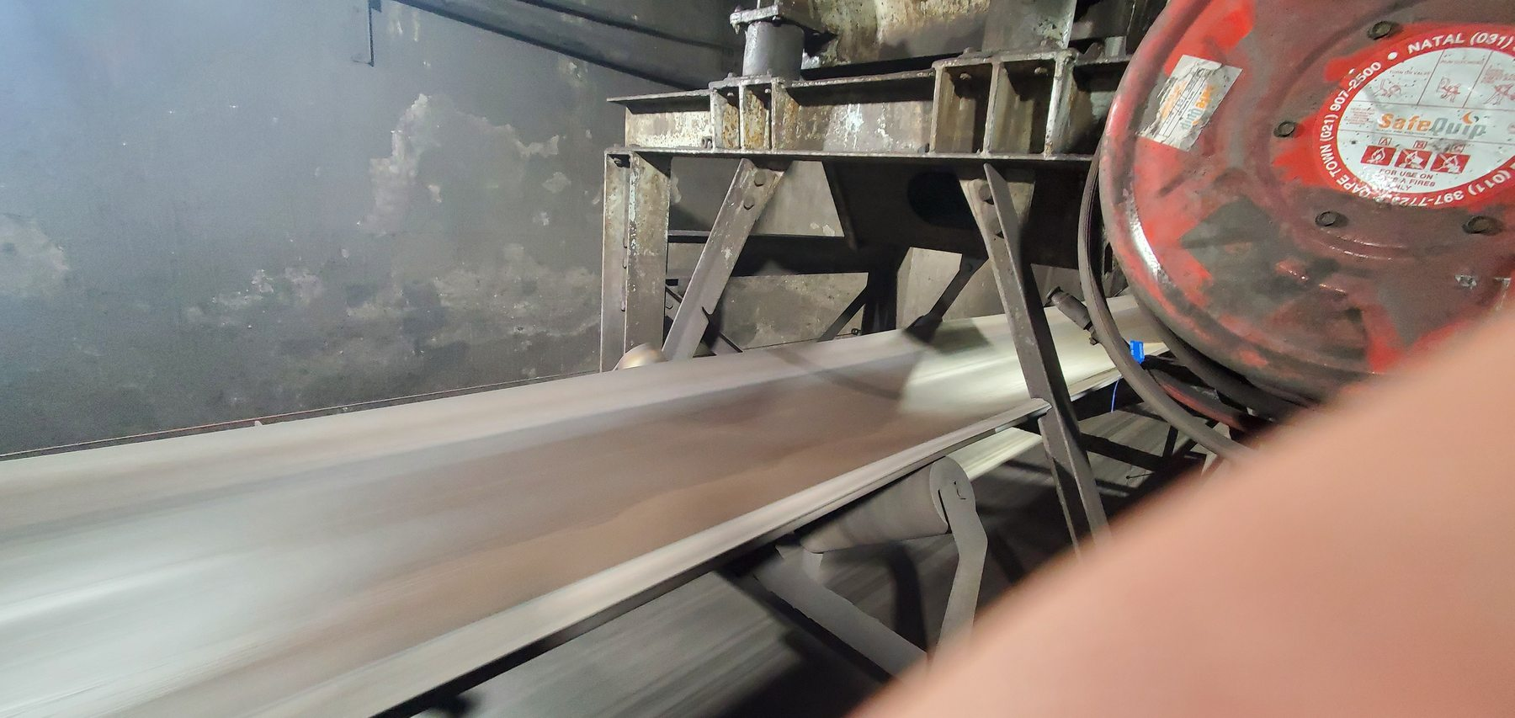
Figure 21 - L1 Conveyor - Primary Feed evidence - LoadoutStationL1-REF-007 / FND-011
Photographic evidence assessment - LoadoutStationL1-REF-007
Observation | Engineering assessment | Recommended action
Distinct smooth wear slots/notches are visible in the angular supports adjacent to the belt path; the running belt is clear of the supports at the photographed instant. | Direct evidence of previous/intermittent belt-to-structure contact while also supporting the qualification that continuous present contact should not be claimed. Mistracking remains the probable mechanism. | Verify belt tracking dynamically, correct contributing alignment/tension issues and structurally assess/repair damaged support steel as required.

16.2.1.2 Photographic Evidence Sheet
Photo ID | LoadoutStationL1-REF-003
Finding ID | FND-011
Asset | L1 Conveyor - Primary Feed
Component / location | L1 tunnel wall/ceiling junction
View / direction | Close structural deterioration view
Date / time | July 2026 (inspection period)
Caption | L1 tunnel structural deterioration showing concrete spalling, exposed reinforcement and corrosion staining.
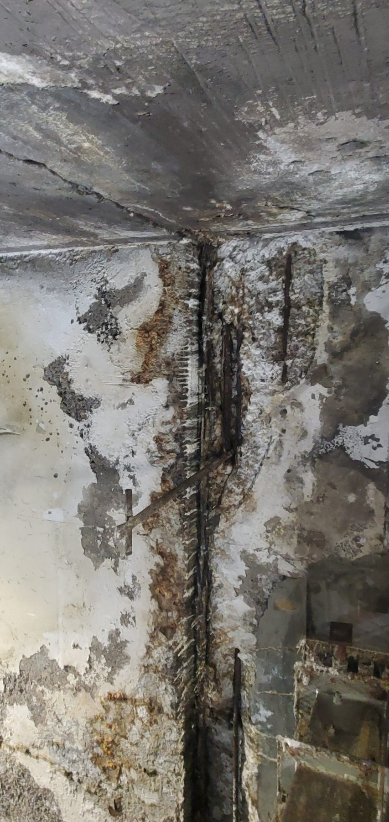
Figure 22 - L1 Conveyor - Primary Feed evidence - LoadoutStationL1-REF-003 / FND-011
Photographic evidence assessment - LoadoutStationL1-REF-003
Observation | Engineering assessment | Recommended action
Severe concrete spalling/loss, exposed reinforcement and corrosion staining are visibly present at the tunnel structure. | Direct evidence of significant structural deterioration. The photograph does not establish residual structural capacity. | Obtain competent structural assessment, define repair scope and address recurring moisture/fines accumulation contributing to deterioration.

16.2.1.3 Photographic Evidence Sheet
Photo ID | LoadoutStationL1-REF-008
Finding ID | FND-011
Asset | L1 Conveyor - Primary Feed
Component / location | Steel support member
View / direction | Close corrosion / section-loss view
Date / time | July 2026 (inspection period)
Caption | L1 support member showing severe corrosion-related section loss/perforation.
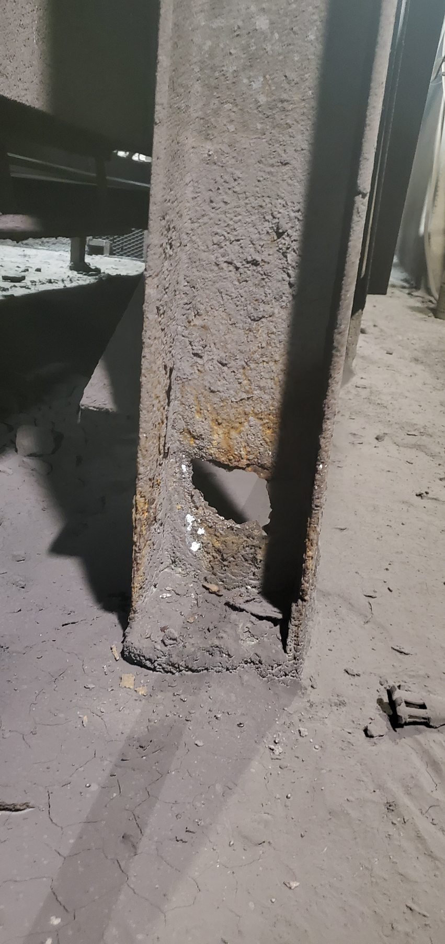
Figure 23 - L1 Conveyor - Primary Feed evidence - LoadoutStationL1-REF-008 / FND-011
Photographic evidence assessment - LoadoutStationL1-REF-008
Observation | Engineering assessment | Recommended action
The steel member shows severe local material loss/perforation with heavy corrosion products. | Direct evidence of substantial section deterioration. Remaining capacity and repairability require engineering assessment. | Include the member in the formal L1 structural survey and approved repair/replacement plan.

16.2.2 L2 Conveyor
Location / system | Loading Station conveyor
Observed condition | No significant spillage observed in the reviewed photos/video; access and transfer areas comparatively clean during the captured condition.
Primary evidence | LoadoutStationL2-REF-001 to -006 plus LoadoutStationL2-REF-005.mp4. Optional comparator REF-004.jpg or REF-005.jpg.
Mechanism / cause assessment | Inspected-condition baseline only.
Evidence qualification / limitation | REF-005 exists as both photo and video; cite exact media type/path. Clean condition is time-specific.
Working action / next step | No spillage-specific corrective action from current evidence; maintain routine inspection.
Condition / severity / priority | [TO BE RATED] | [TO BE CLASSIFIED] | [TO BE ASSIGNED]

16.2.2.1 Photographic Evidence Sheet
Photo ID | LoadoutStationL2-REF-004
Finding ID | FND-012
Asset | L2 Conveyor
Component / location | L2 conveyor / transfer area
View / direction | Inspected-condition contextual view
Date / time | July 2026 (inspection period)
Caption | L2 inspected condition showing a comparatively clean conveyor/transfer area.
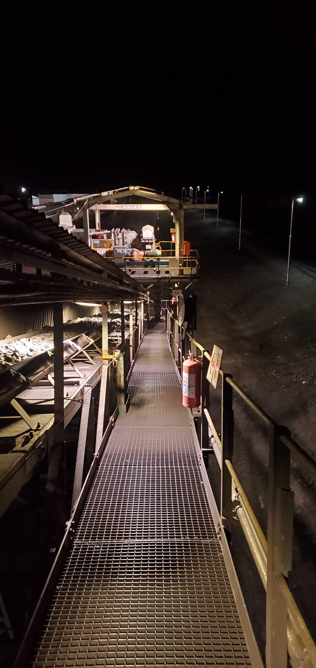
Figure 24 - L2 Conveyor evidence - LoadoutStationL2-REF-004 / FND-012
Photographic evidence assessment - LoadoutStationL2-REF-004
Observation | Engineering assessment | Recommended action
No significant accumulated spillage is visible in the photographed L2 area. | Direct time-specific baseline evidence consistent with Questionnaire V1. It does not prove that L2 cannot spill under other operating states. | No immediate spillage-specific action from the current evidence; continue routine inspection and monitoring.

16.2.3 L3 Conveyor
Location / system | Loading Station conveyor - tail end
Observed condition | Dry fines/carryback and visually supported tail-end belt/pulley offset. Significant solid-product loss is not established by the visual evidence.
Primary evidence | LoadoutStationL3-REF-001 (offset); REF-007; optional REF-008.
Mechanism / cause assessment | Offset/mistracking concern is supported but unmeasured. Direct causal contribution to solid-product spillage remains unconfirmed.
Evidence qualification / limitation | V2 text previously referenced Sample Conveyor 3 images in error; use only L3 evidence set.
Working action / next step | Complete physical alignment check using fixed references; determine source/magnitude of offset and whether it contributes to active spillage before assigning a root cause.
Condition / severity / priority | [TO BE RATED] | [TO BE CLASSIFIED] | [TO BE ASSIGNED]

16.2.3.1 Photographic Evidence Sheet
Photo ID | LoadoutStationL3-REF-001
Finding ID | FND-013
Asset | L3 Conveyor
Component / location | L3 tail-end belt/pulley area
View / direction | Tail-end alignment context
Date / time | July 2026 (inspection period)
Caption | L3 tail-end view supporting an apparent belt/pulley offset condition.
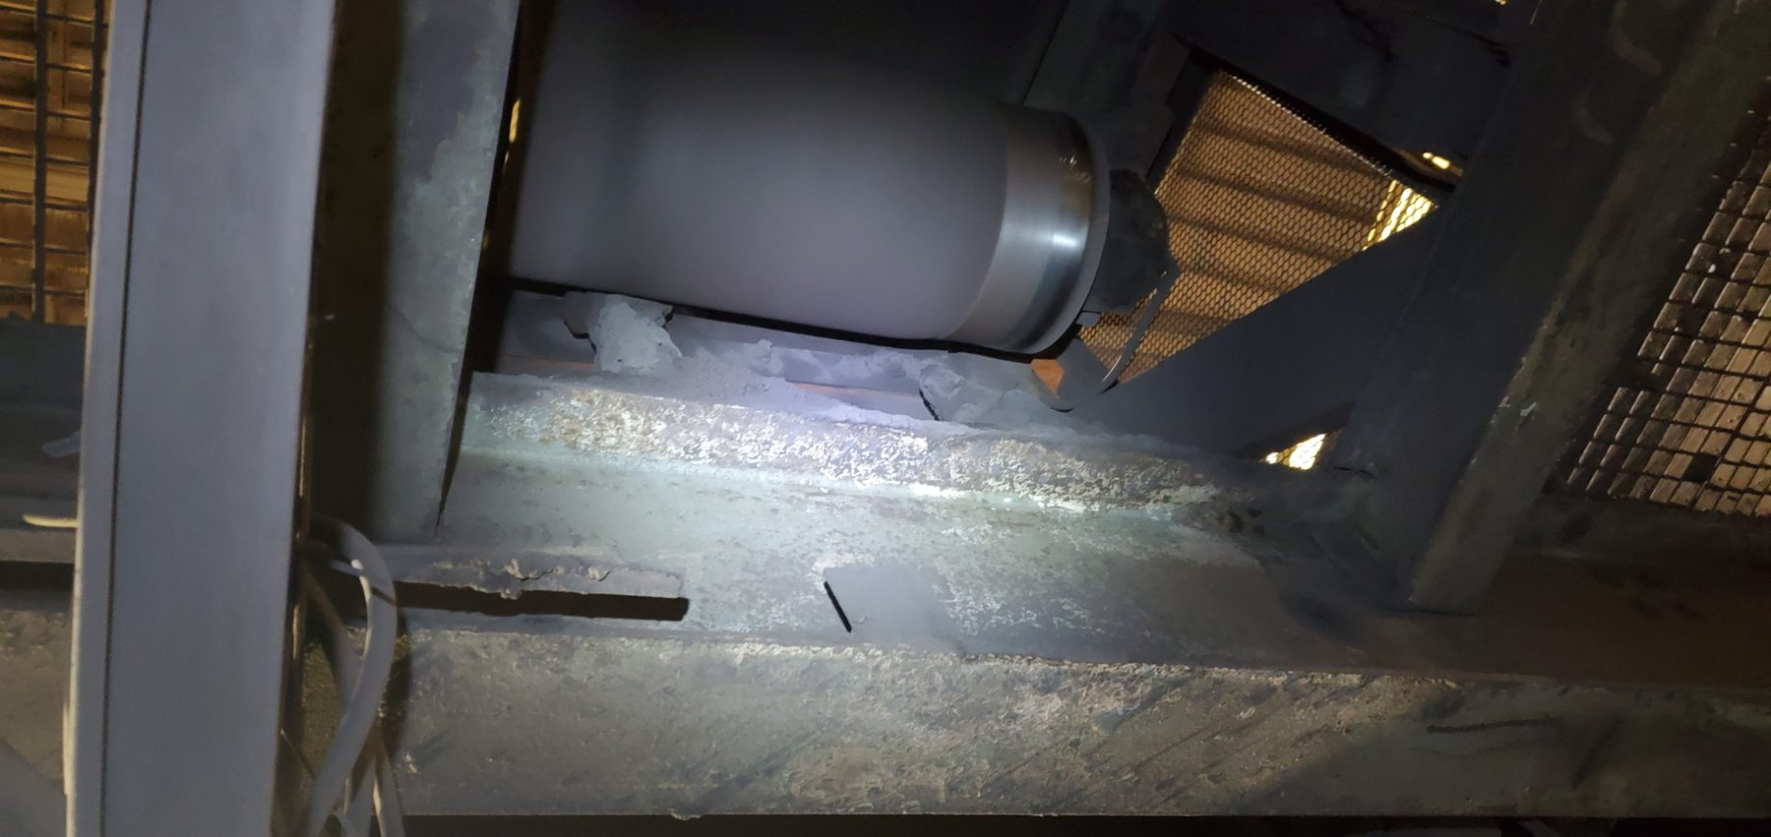
Figure 25 - L3 Conveyor evidence - LoadoutStationL3-REF-001 / FND-013
Photographic evidence assessment - LoadoutStationL3-REF-001
Observation | Engineering assessment | Recommended action
The photographed tail-end area shows an asymmetric belt/pulley relationship consistent with the inspector-recorded offset. | Supporting visual evidence of a tracking/alignment concern. Perspective and absence of a fixed datum prevent reliable dimensional quantification. | Measure the tail-end geometry relative to a repeatable datum and verify whether the offset causes material loss under representative operation.

16.2.3.2 Photographic Evidence Sheet
Photo ID | LoadoutStationL3-REF-007
Finding ID | FND-013
Asset | L3 Conveyor
Component / location | L3 side guarding / adjacent structure
View / direction | Local fines/carryback contamination view
Date / time | July 2026 (inspection period)
Caption | L3 fines/material coating and accumulation on side guarding and adjacent structure.
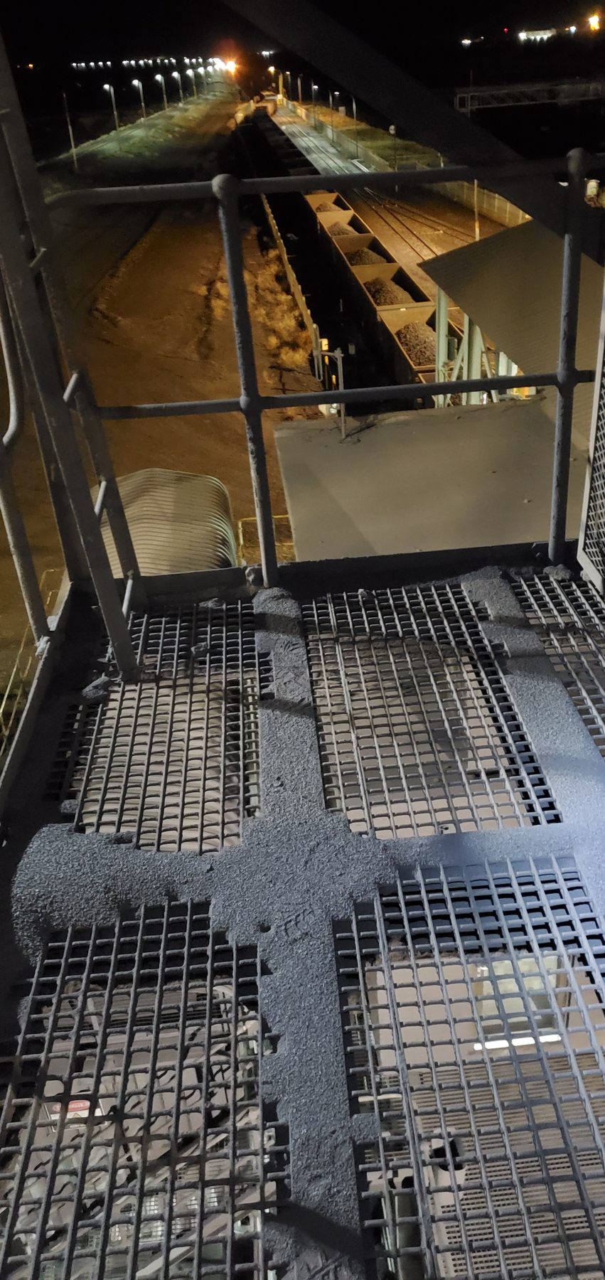
Figure 26 - L3 Conveyor evidence - LoadoutStationL3-REF-007 / FND-013
Photographic evidence assessment - LoadoutStationL3-REF-007
Observation | Engineering assessment | Recommended action
Fine material is visibly coating and accumulating on the conveyor-side guarding/structure. | Direct evidence of fines/carryback contamination. The image does not establish a solid-product-spillage causal chain from the tail-end offset. | Correct/verify tracking as a maintenance item and separately manage recurring fines/carryback source and housekeeping.

16.2.4 L4 Conveyor
Location / system | Loading Station conveyor
Observed condition | Localised dry fines and coarse/lump-product accumulation in lower channels/support areas; wider access walkway comparatively clean.
Primary evidence | LoadoutStationL4-REF-003 or -004; optional operating context REF-007/-008.
Mechanism / cause assessment | Accumulated local spillage is direct. No still captures the instantaneous material-fall mechanism.
Evidence qualification / limitation | Retain trace-to-localised overall classification.
Working action / next step | Maintain local containment/housekeeping and inspect transfer/loading condition to determine the active loss path if recurrence warrants action.
Condition / severity / priority | [TO BE RATED] | [TO BE CLASSIFIED] | [TO BE ASSIGNED]

16.2.4.1 Photographic Evidence Sheet
Photo ID | LoadoutStationL4-REF-003
Finding ID | FND-014
Asset | L4 Conveyor
Component / location | Lower channel / structure beside conveyor
View / direction | Close localised accumulation view
Date / time | July 2026 (inspection period)
Caption | L4 localised dry fines and coarse/lump-product accumulation beside the conveyor.
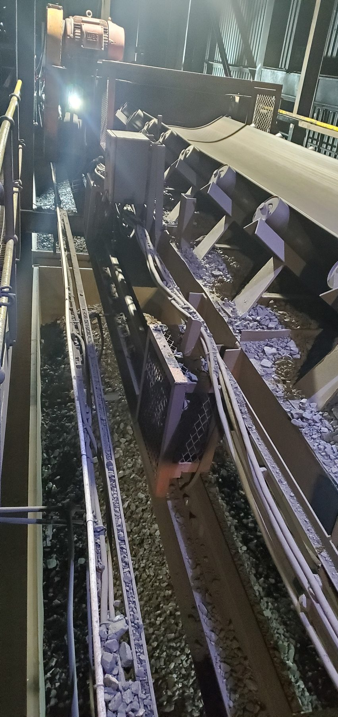
Figure 27 - L4 Conveyor evidence - LoadoutStationL4-REF-003 / FND-014
Photographic evidence assessment - LoadoutStationL4-REF-003
Observation | Engineering assessment | Recommended action
Dry fines and coarse product are visibly accumulated in the lower channel/support area immediately adjacent to the conveyor. | Direct evidence of localised accumulated spillage. No active material-fall event is captured, so the instantaneous loss mechanism remains unproven by the still. | Maintain local containment and housekeeping and inspect the transfer/belt interfaces for the source of recurring local loss.

16.2.4.2 Photographic Evidence Sheet
Photo ID | LoadoutStationL4-REF-007
Finding ID | FND-014
Asset | L4 Conveyor
Component / location | Loaded L4 belt
View / direction | Operating belt context
Date / time | July 2026 (inspection period)
Caption | L4 operating view showing coarse product generally contained within the belt trough.
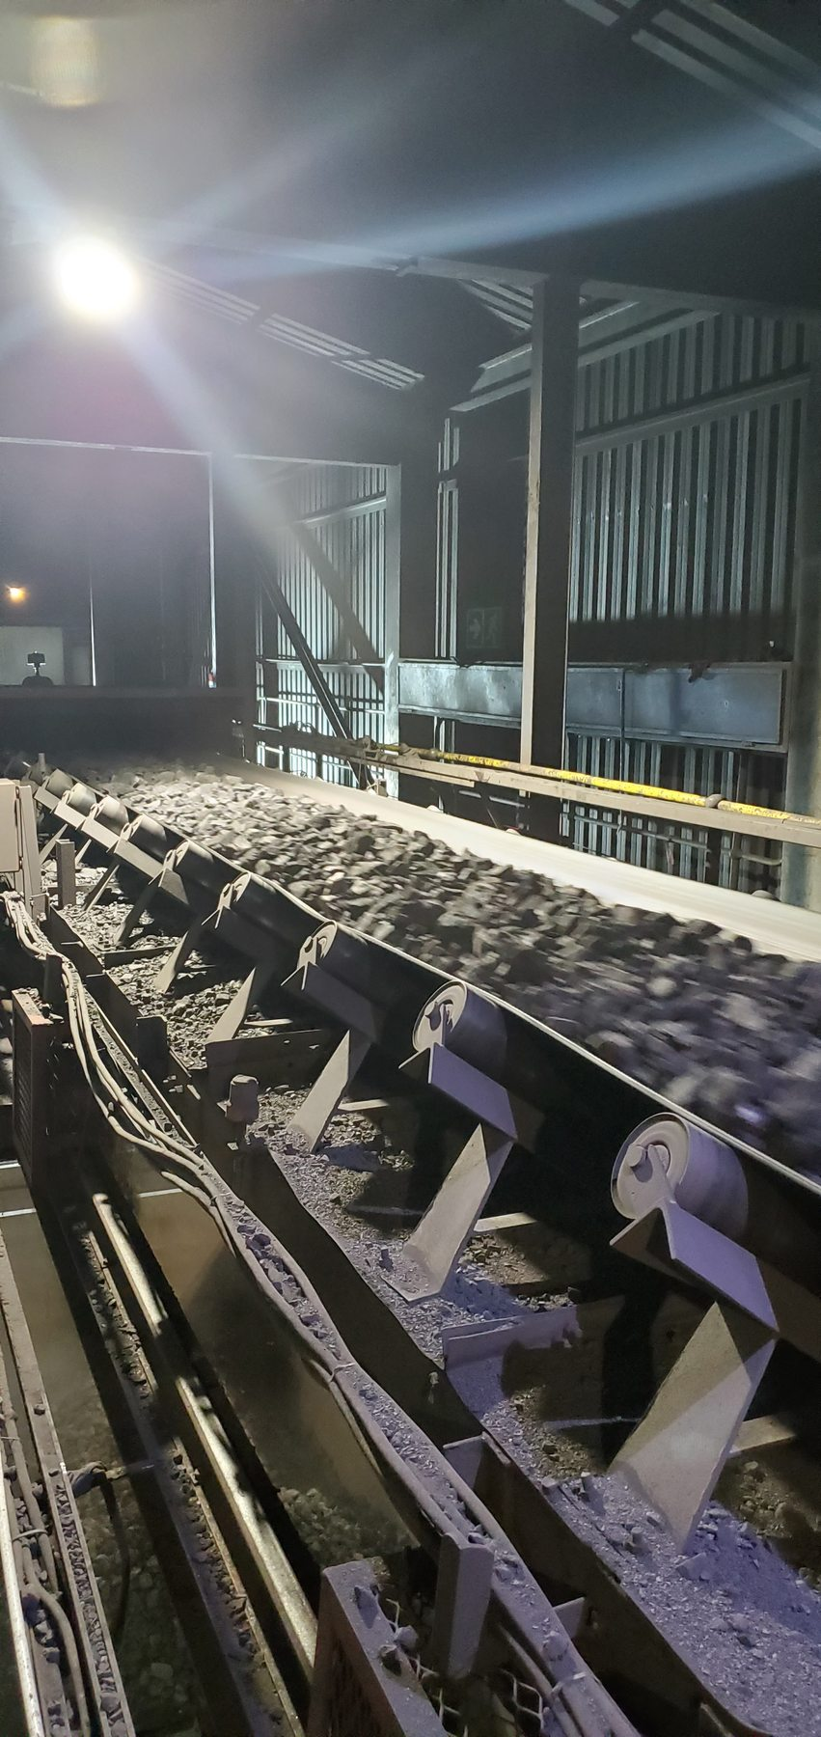
Figure 28 - L4 Conveyor evidence - LoadoutStationL4-REF-007 / FND-014
Photographic evidence assessment - LoadoutStationL4-REF-007
Observation | Engineering assessment | Recommended action
Coarse product is visible on the operating belt and is generally contained within the belt trough in the captured condition. | Useful operating context showing that the photographed belt condition itself is not an obvious gross-overflow event; accumulated spillage remains the verified issue. | Use live observation to identify the intermittent/local loss mechanism before considering any major containment modification.

16.2.5 Sample Conveyor 1
Location / system | Loading Station sample conveyor
Observed condition | Extensive/widespread dry/dried fines and coarse/lump-product accumulation on floors, stairs, grating, platforms and structure at multiple levels.
Primary evidence | Preferred: LoadoutStationSample1-REF-011; REF-008; REF-005 or -006; REF-007 or -010.
Mechanism / cause assessment | Distributed accumulation is direct. Adhered run/drip-like deposits support a history of sticky/moist material deposition; active wet material and moisture source are not proven by the stills.
Evidence qualification / limitation | Do not attribute every deposit specifically to carryback or claim active wet fines solely from still photographs.
Working action / next step | Include in sample-conveyor containment/housekeeping review; determine whether feed/containment improvements similar to Sample 2/3 are physically applicable after local verification.
Condition / severity / priority | [TO BE RATED] | [TO BE CLASSIFIED] | [TO BE ASSIGNED]

16.2.5.1 Photographic Evidence Sheet
Photo ID | LoadoutStationSample1-REF-011
Finding ID | FND-015
Asset | Sample Conveyor 1
Component / location | Sample Conveyor 1 surrounding structure
View / direction | Severe accumulation view
Date / time | July 2026 (inspection period)
Caption | Major coarse/lump-product accumulation retained on and within the Sample Conveyor 1 structure.
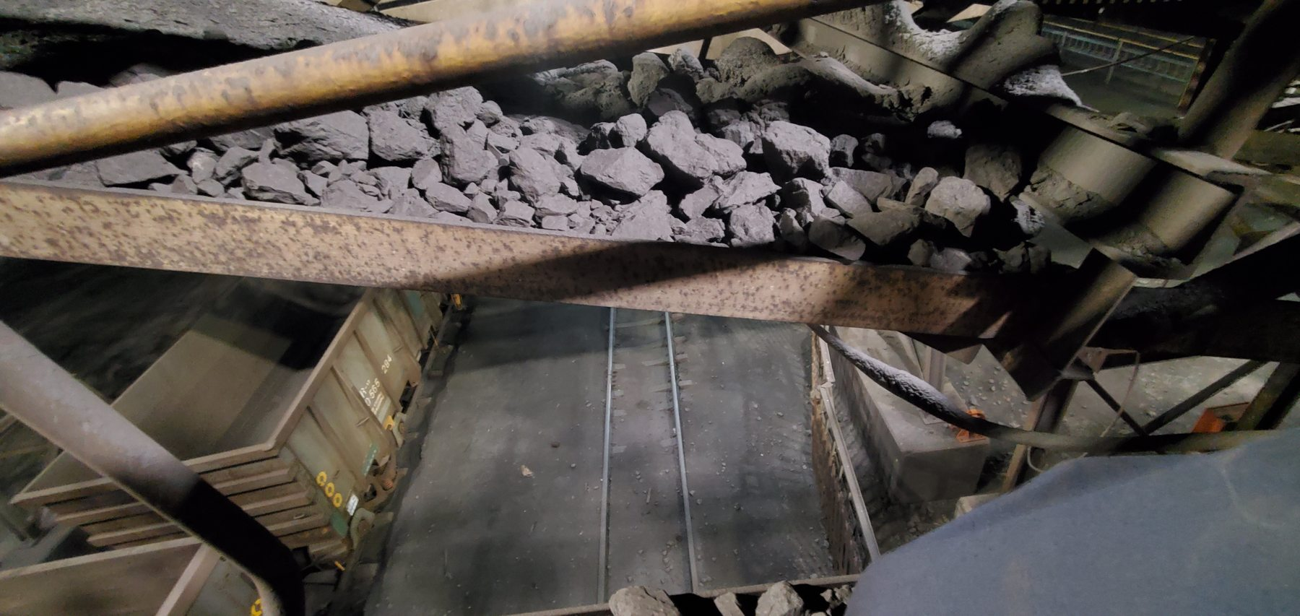
Figure 29 - Sample Conveyor 1 evidence - LoadoutStationSample1-REF-011 / FND-015
Photographic evidence assessment - LoadoutStationSample1-REF-011
Observation | Engineering assessment | Recommended action
Large coarse/lump product and fines are visibly retained on and within surrounding structural members. | Direct evidence of extensive/widespread spillage distributed beyond the belt and floor level. | Prioritise source containment and recovery; review cleaner/transfer interfaces and remove accumulated material once source controls are addressed.

16.2.5.2 Photographic Evidence Sheet
Photo ID | LoadoutStationSample1-REF-008
Finding ID | FND-015
Asset | Sample Conveyor 1
Component / location | Access grating beside Sample Conveyor 1
View / direction | Access-area consequence view
Date / time | July 2026 (inspection period)
Caption | Coarse/lump-product spillage distributed across the Sample Conveyor 1 access grating.
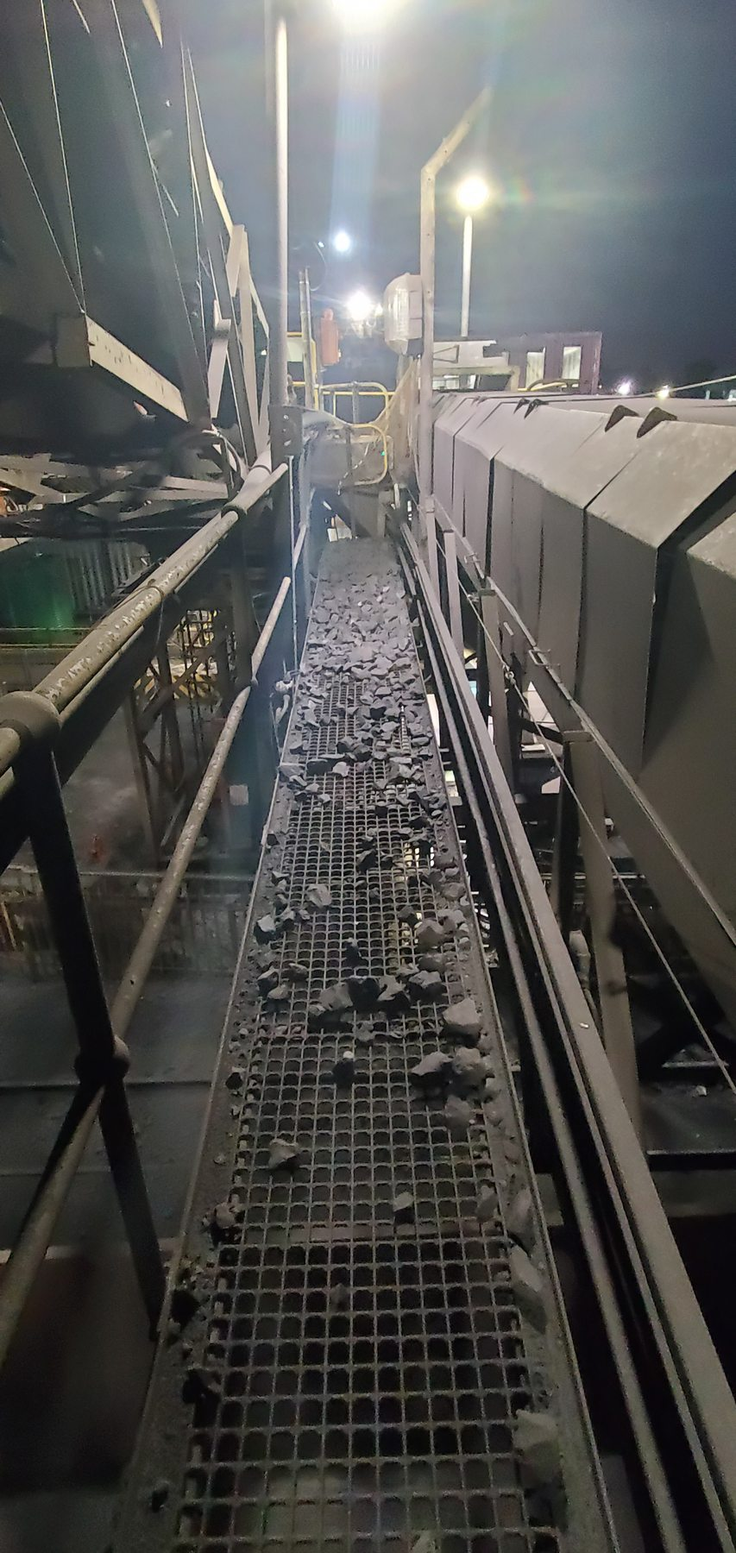
Figure 30 - Sample Conveyor 1 evidence - LoadoutStationSample1-REF-008 / FND-015
Photographic evidence assessment - LoadoutStationSample1-REF-008
Observation | Engineering assessment | Recommended action
Coarse/lump material is visibly spread across the access grating beside the conveyor. | Direct evidence of loss of material containment and a consequential access/housekeeping burden. | Reduce source spillage before relying on repeated manual recovery; keep access routes clear and safe.

16.2.5.3 Photographic Evidence Sheet
Photo ID | LoadoutStationSample1-REF-005
Finding ID | FND-015
Asset | Sample Conveyor 1
Component / location | Sample Conveyor 1 structural members
View / direction | Close adhered-deposit view
Date / time | July 2026 (inspection period)
Caption | Thick adhered/dried fines deposits with pronounced run/drip-like morphology on Sample Conveyor 1 structure.
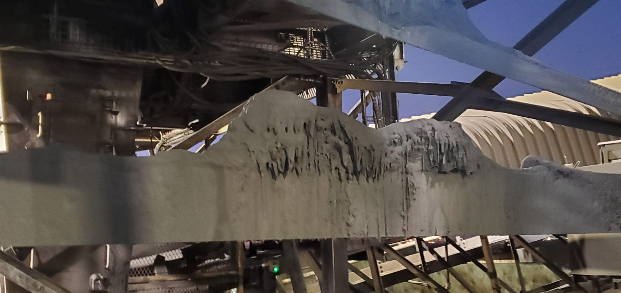
Figure 31 - Sample Conveyor 1 evidence - LoadoutStationSample1-REF-005 / FND-015
Photographic evidence assessment - LoadoutStationSample1-REF-005
Observation | Engineering assessment | Recommended action
Thick fines deposits adhere to the steel with downward run/drip-like streaking. | Direct evidence of adhered/dried material and qualitative support for a history of sticky/moist deposition. Active wetness and the moisture source are not proven by the still. | Include moisture/sticky-material behaviour when evaluating cleaner/containment improvements and housekeeping method.

16.2.6 Sample Conveyor 2
Location / system | Loading Station narrow sample conveyor
Observed condition | Coarse/lump product occupies a substantial proportion of the narrow belt width with visible containment loss. Significant mistracking is not visually established.
Primary evidence | LoadoutStationSample2-REF-004; REF-006 or -007; REF-001 or -003.
Mechanism / cause assessment | Product size/volume relative to practical belt containment is a confirmed concern. Quantitative design-capacity overload and exact upstream control mechanism remain unverified.
Evidence qualification / limitation | Approx. 250 mm side-support height and 5-10 mm clearance are preliminary conceptual values only.
Working action / next step | Inspect actual feed-control arrangement; quantify product size versus usable belt width/capacity; determine throttling/metering control; verify alignment/tracking; develop side-skirt containment as secondary control.
Condition / severity / priority | [TO BE RATED] | [TO BE CLASSIFIED] | [TO BE ASSIGNED]

16.2.6.1 Photographic Evidence Sheet
Photo ID | LoadoutStationSample2-REF-004
Finding ID | FND-016
Asset | Sample Conveyor 2
Component / location | Sample Conveyor 2 loaded belt
View / direction | Close view of product size relative to belt width
Date / time | July 2026 (inspection period)
Caption | Coarse/lump product occupying a substantial proportion of the narrow Sample Conveyor 2 carrying width.
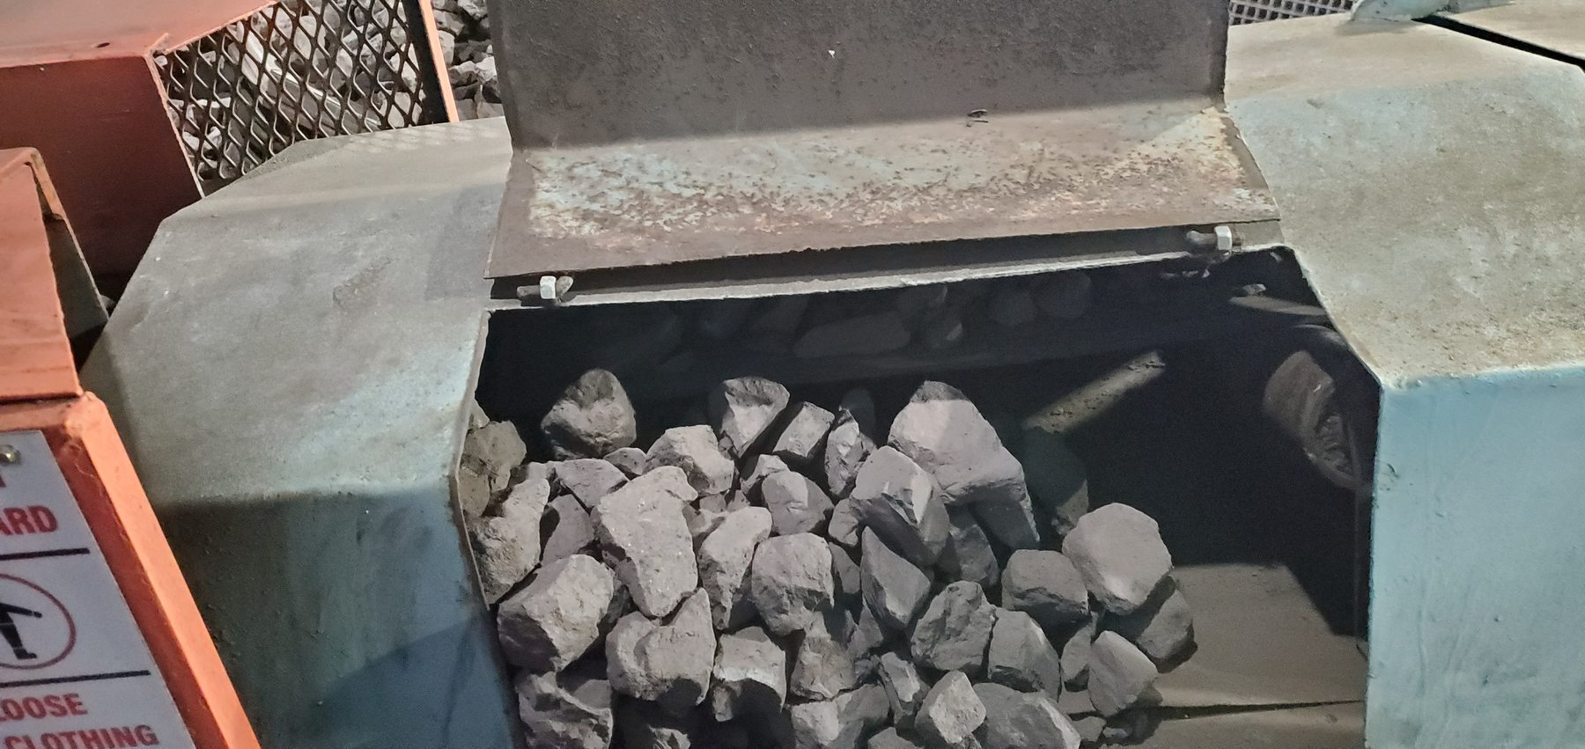
Figure 32 - Sample Conveyor 2 evidence - LoadoutStationSample2-REF-004 / FND-016
Photographic evidence assessment - LoadoutStationSample2-REF-004
Observation | Engineering assessment | Recommended action
Large coarse/lump product is visibly carried on a relatively narrow belt and occupies a substantial proportion of the available carrying width. | Direct evidence supporting the product-size/loading-versus-belt-width containment concern. The photograph does not establish the design-capacity limit or measured overload. | Measure usable belt width, representative product size and feed geometry/rate; evaluate upstream throttling/metering before finalising side containment.

16.2.6.2 Photographic Evidence Sheet
Photo ID | LoadoutStationSample2-REF-006
Finding ID | FND-016
Asset | Sample Conveyor 2
Component / location | Sample Conveyor 2 enclosure / belt side
View / direction | Close containment-loss view
Date / time | July 2026 (inspection period)
Caption | Sample Conveyor 2 local containment loss with coarse product outside the intended belt carrying path.
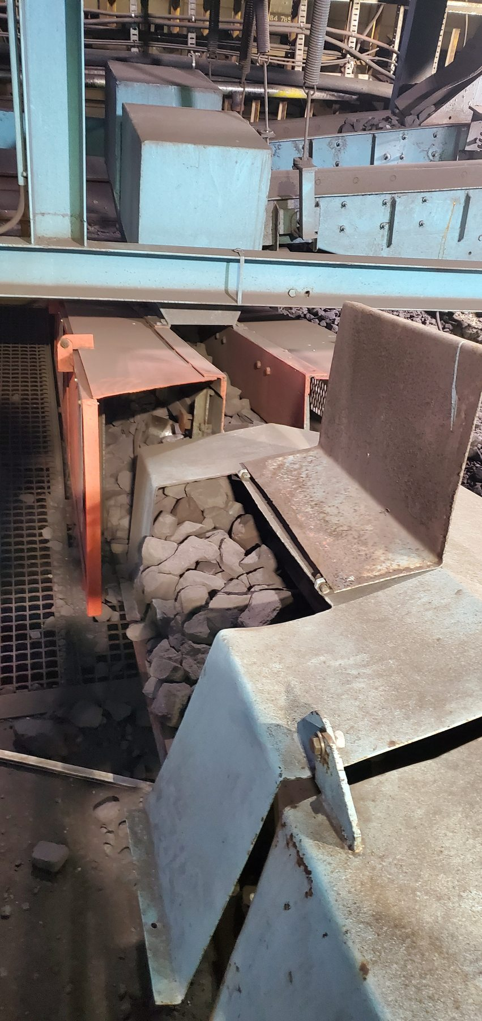
Figure 33 - Sample Conveyor 2 evidence - LoadoutStationSample2-REF-006 / FND-016
Photographic evidence assessment - LoadoutStationSample2-REF-006
Observation | Engineering assessment | Recommended action
Coarse product is visibly present outside the intended belt carrying path within/around the local conveyor enclosure. | Direct evidence of containment loss. Significant belt mistracking is not independently established by the supplied Sample Conveyor 2 photographs. | Address feed quantity/trajectory first, verify live tracking/alignment and then develop non-contact side-skirt containment as a secondary control.

16.2.7 Sample Conveyor 3
Location / system | Loading Station narrow sample conveyor
Observed condition | Substantial solid/lump-product spillage, coarse product occupying much of the narrow belt width, and visually supported lateral offset/mistracking.
Primary evidence | LoadoutStationSample3-REF-013 (tracking); REF-005 or -006 (product size/loading); REF-002; REF-012.
Mechanism / cause assessment | Mistracking is visually supported but unmeasured. Root cause may involve alignment, tensioning and/or trapped spillage; these remain hypotheses. Product-size/volume versus belt containment is a confirmed concern.
Evidence qualification / limitation | Any “about 50% usable belt width” description remains a qualitative inspector estimate, not a measured dimension.
Working action / next step | Clear trapped product; inspect head/tail alignment and tension; observe live tracking under representative load; evaluate feed control; then finalise side-skirt containment geometry.
Condition / severity / priority | [TO BE RATED] | [TO BE CLASSIFIED] | [TO BE ASSIGNED]

16.2.7.1 Photographic Evidence Sheet
Photo ID | LoadoutStationSample3-REF-013
Finding ID | FND-017
Asset | Sample Conveyor 3
Component / location | Sample Conveyor 3 belt / training-roller area
View / direction | Tracking relationship view
Date / time | July 2026 (inspection period)
Caption | Sample Conveyor 3 showing lateral belt asymmetry relative to the side/training-roller arrangement.
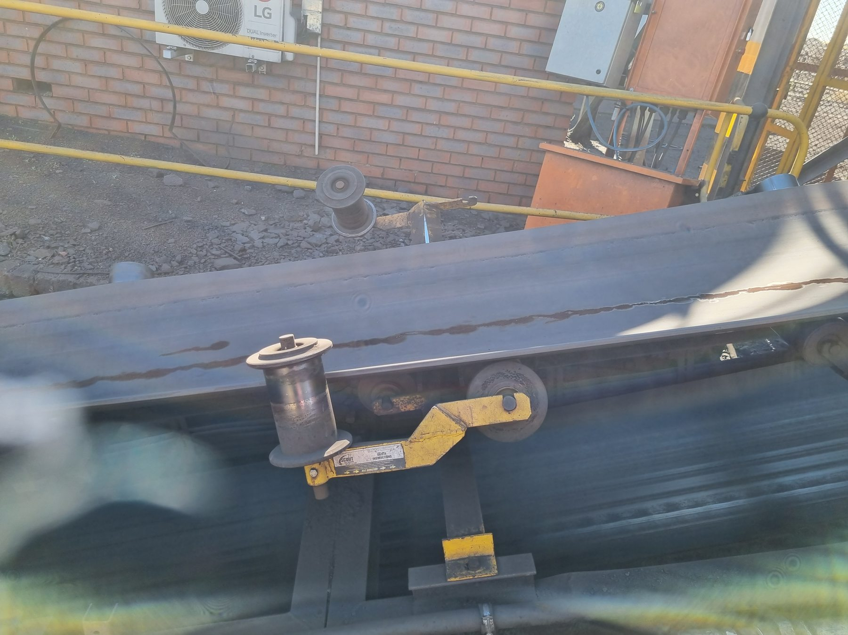
Figure 34 - Sample Conveyor 3 evidence - LoadoutStationSample3-REF-013 / FND-017
Photographic evidence assessment - LoadoutStationSample3-REF-013
Observation | Engineering assessment | Recommended action
The belt is visibly asymmetric relative to adjacent side/training hardware, with one edge operating close to the lower guide/training region and greater clearance on the opposite side. | Direct/supporting evidence of lateral offset/mistracking. No measured percentage or millimetre offset can be assigned from the photograph alone. | Clear trapped product, inspect head/tail alignment and tension, and perform live tracking verification under representative load.

16.2.7.2 Photographic Evidence Sheet
Photo ID | LoadoutStationSample3-REF-005
Finding ID | FND-017
Asset | Sample Conveyor 3
Component / location | Sample Conveyor 3 loaded belt
View / direction | Close product-size / belt-width view
Date / time | July 2026 (inspection period)
Caption | Coarse/lump product occupying a substantial proportion of the narrow Sample Conveyor 3 belt width.
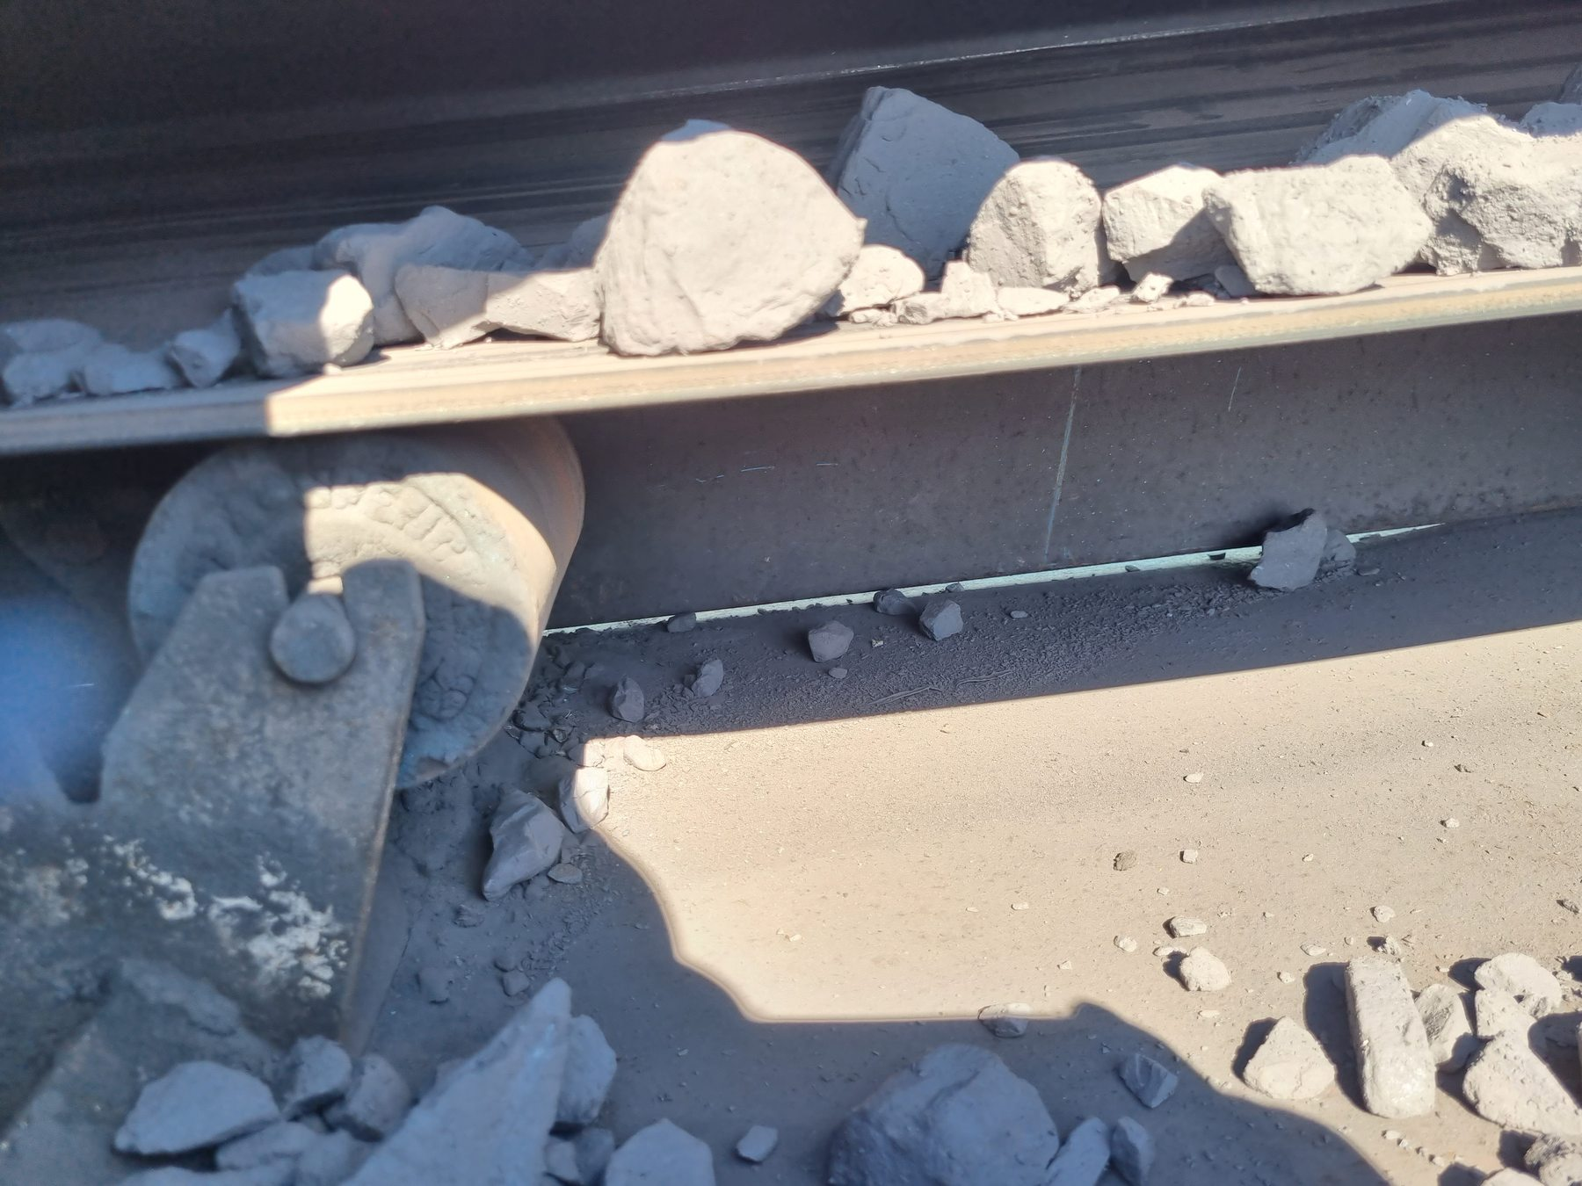
Figure 35 - Sample Conveyor 3 evidence - LoadoutStationSample3-REF-005 / FND-017
Photographic evidence assessment - LoadoutStationSample3-REF-005
Observation | Engineering assessment | Recommended action
Large lump product is visibly carried on a narrow belt and occupies a substantial portion of the available carrying width. | Direct evidence supporting the loading/containment concern. The still does not establish a numerical design-capacity exceedance. | Quantify representative lump size, belt width and feed rate/geometry; integrate findings with the tracking correction and containment design.

16.2.7.3 Photographic Evidence Sheet
Photo ID | LoadoutStationSample3-REF-012
Finding ID | FND-017
Asset | Sample Conveyor 3
Component / location | Sample Conveyor 3 surrounding structure / access area
View / direction | Wider spillage consequence view
Date / time | July 2026 (inspection period)
Caption | Widespread Sample Conveyor 3 product accumulation on surrounding structure/access areas.
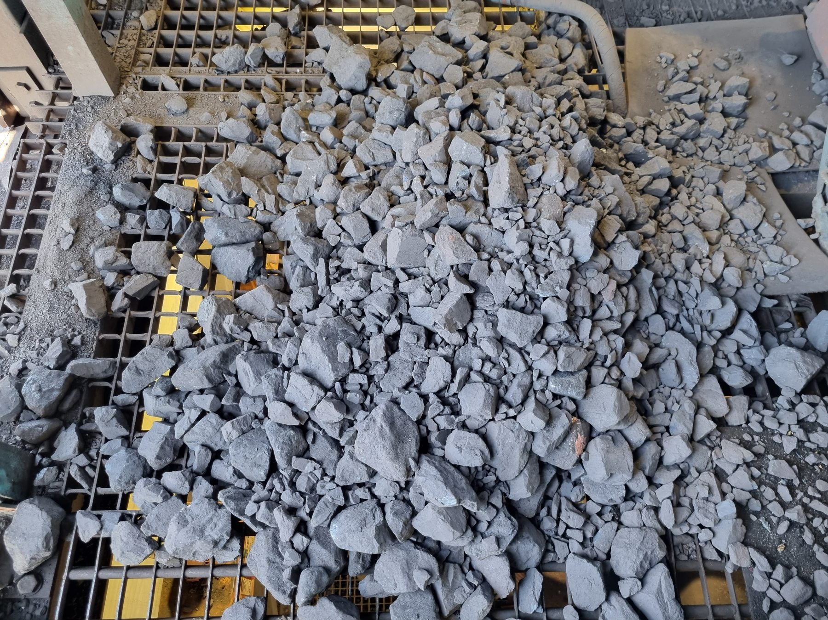
Figure 36 - Sample Conveyor 3 evidence - LoadoutStationSample3-REF-012 / FND-017
Photographic evidence assessment - LoadoutStationSample3-REF-012
Observation | Engineering assessment | Recommended action
Substantial coarse product and fines are visibly accumulated outside the belt path and across surrounding structure/access surfaces. | Direct consequence evidence of significant containment loss and recurring housekeeping burden. | Combine feed control, tracking correction and secondary side-skirt containment; remove trapped/accumulated product before final tracking assessment.

16.3 Underground - Central Block

16.3.1 Underground Crusher
Location / system | Central Block crusher / conveyor interface
Observed condition | Mixed coarse/lump material and fines accumulated around/beneath the crusher-conveyor area. Local standing water is visible in one evidence view.
Primary evidence | UGCrusher-REF-001; REF-002 or -003.
Mechanism / cause assessment | Physical accumulation is direct. Carryback is consistent with fine deposits beneath/adjacent to belt areas but is not proven as the sole source. Standing-water source is unresolved.
Evidence qualification / limitation | Retain trace-to-moderate asset-level classification despite locally significant piles.
Working action / next step | Review local carryback/source control and housekeeping; identify water source if relevant to recurring wet-material accumulation.
Condition / severity / priority | [TO BE RATED] | [TO BE CLASSIFIED] | [TO BE ASSIGNED]

16.3.1.1 Photographic Evidence Sheet
Photo ID | UGCrusher-REF-001
Finding ID | FND-018
Asset | Underground Crusher
Component / location | Underground crusher / adjacent conveyor area
View / direction | Mixed spillage and floor-condition view
Date / time | July 2026 (inspection period)
Caption | Underground Crusher mixed lump/fines accumulation with local standing water.
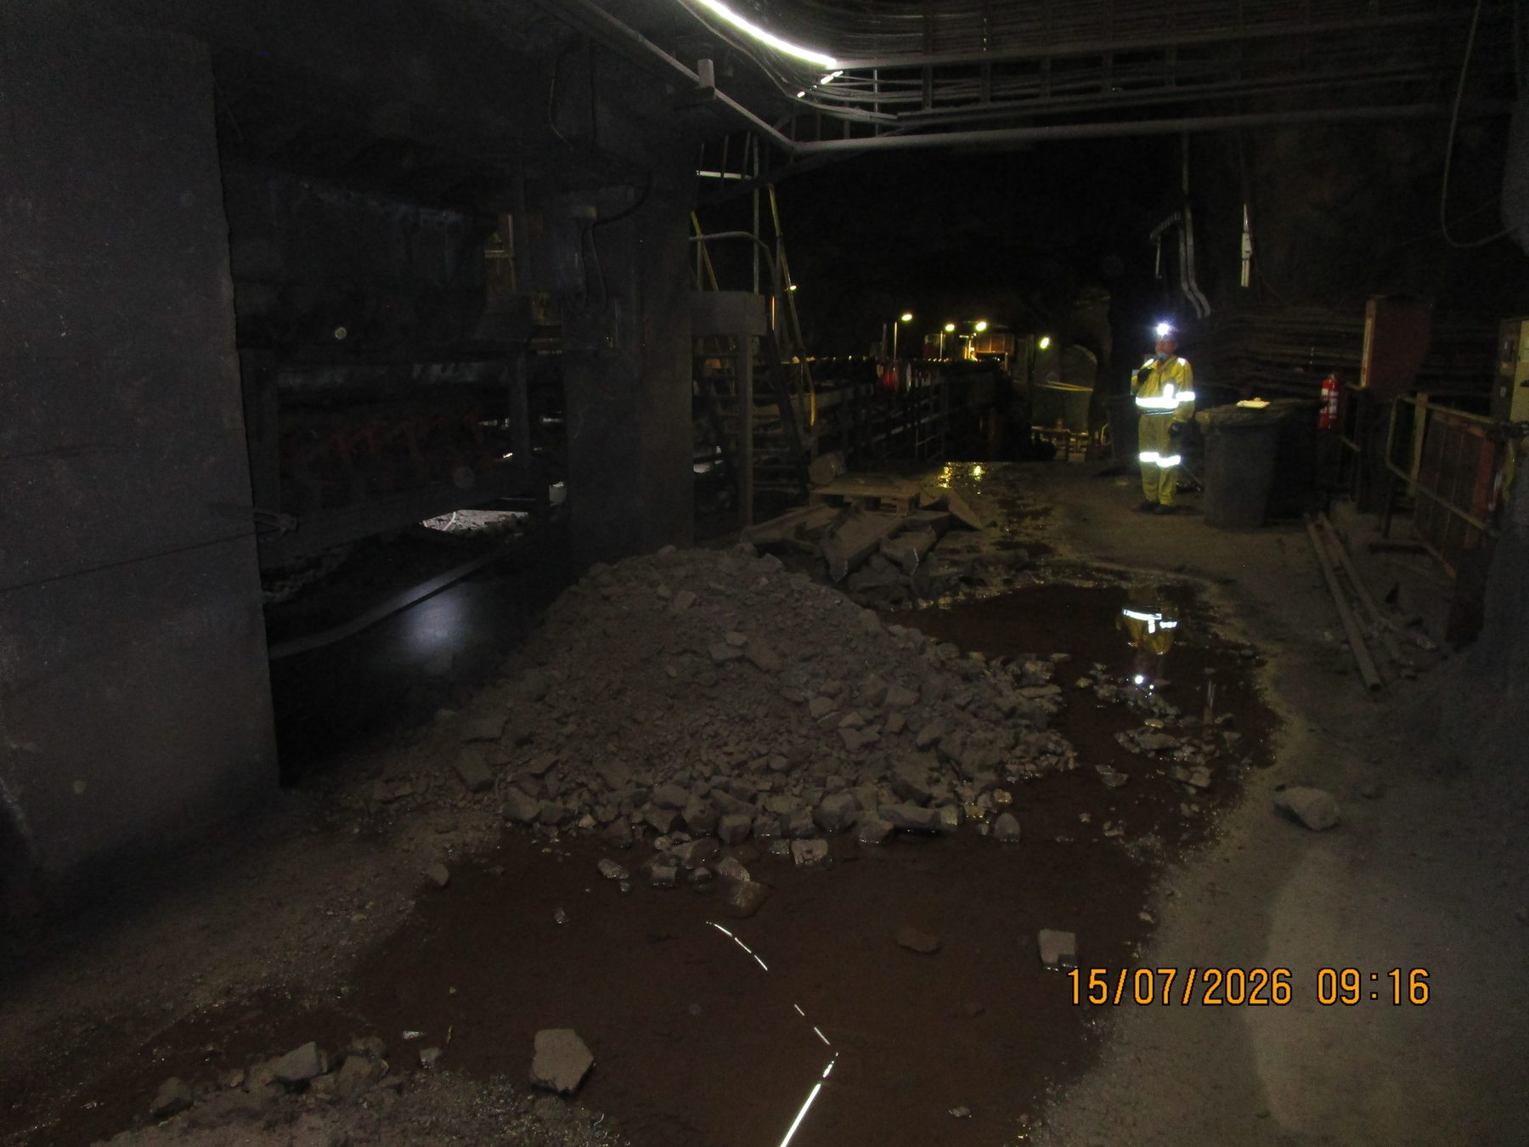
Figure 37 - Underground Crusher evidence - UGCrusher-REF-001 / FND-018
Photographic evidence assessment - UGCrusher-REF-001
Observation | Engineering assessment | Recommended action
A sizeable mixed lump/fines deposit is visibly accumulated beside the crusher/conveyor area with local standing water/puddling. | Direct evidence of mixed spillage and water presence. The photograph does not establish the source of the water. | Control recurring material loss/carryback and investigate the local water source before determining whether drainage or process-water controls are required.

16.3.1.2 Photographic Evidence Sheet
Photo ID | UGCrusher-REF-002
Finding ID | FND-018
Asset | Underground Crusher
Component / location | Below crusher/conveyor structure
View / direction | Under-conveyor accumulation view
Date / time | July 2026 (inspection period)
Caption | Mixed coarse fragments and fines accumulated beneath the Underground Crusher conveyor structure.
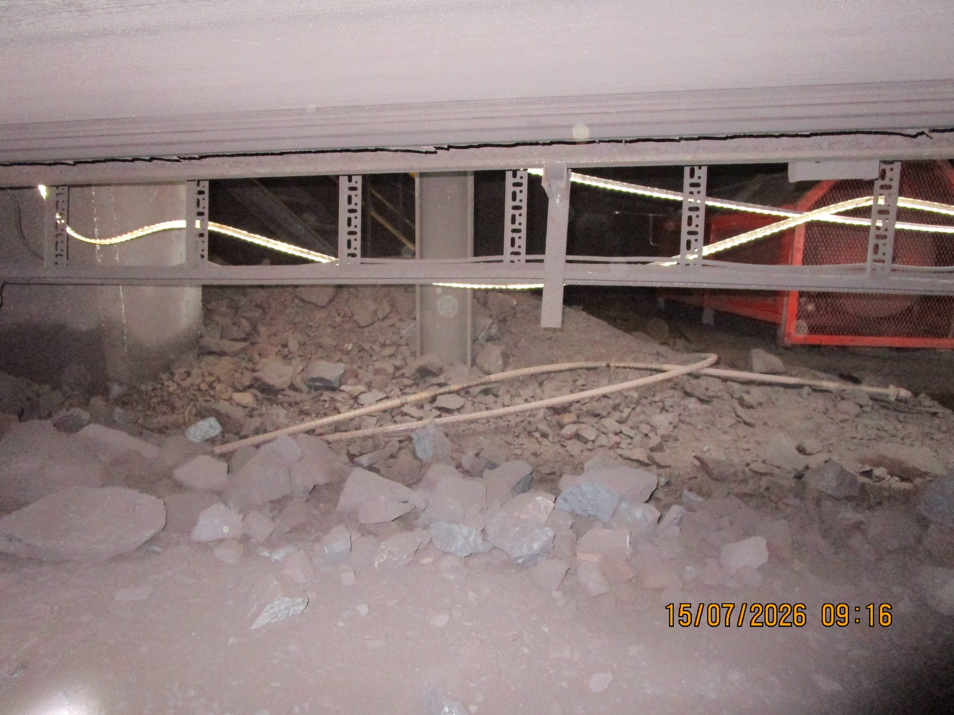
Figure 38 - Underground Crusher evidence - UGCrusher-REF-002 / FND-018
Photographic evidence assessment - UGCrusher-REF-002
Observation | Engineering assessment | Recommended action
Mixed coarse fragments and fines are visibly deposited beneath the conveyor/underside structure. | Direct evidence of local spillage. Fine material location is consistent with carryback, but the origin of every deposit is not independently proven. | Include the crusher in the underground carryback/source-control review and maintain targeted housekeeping after source correction.

16.3.2 UC05 / UC04 / UC03 / UC02 / UC01 Continuous System
Location / system | Central Block continuous conveyor route
Observed condition | Distributed dry-fines accumulation with mixed coarse fragments in some areas. Several local mounds are large, while other sections are comparatively clear.
Primary evidence | Preferred: UGUC05_04_03_02_01-REF-006 or -008; REF-015 or -016; REF-005; optional REF-007 comparator.
Mechanism / cause assessment | Deposit geometry is consistent with carryback redistribution. Recent cleaning between UC05 and UC03 is source-recorded; REF-007 only proves a comparatively clear inspected condition.
Evidence qualification / limitation | Overall classification remains moderate/distributed; do not infer cleaning history from photograph alone.
Working action / next step | Include in system cleaner/carryback review; use recurrence after housekeeping to prioritise source-control improvements.
Condition / severity / priority | [TO BE RATED] | [TO BE CLASSIFIED] | [TO BE ASSIGNED]

16.3.2.1 Photographic Evidence Sheet
Photo ID | UGUC05_04_03_02_01-REF-006
Finding ID | FND-019
Asset | UC05 / UC04 / UC03 / UC02 / UC01 Continuous System
Component / location | UC05-UC01 continuous route / beneath conveyor
View / direction | Severe local fines accumulation view
Date / time | July 2026 (inspection period)
Caption | Large fines mound beneath/adjacent to the UC05-UC01 continuous conveyor route.
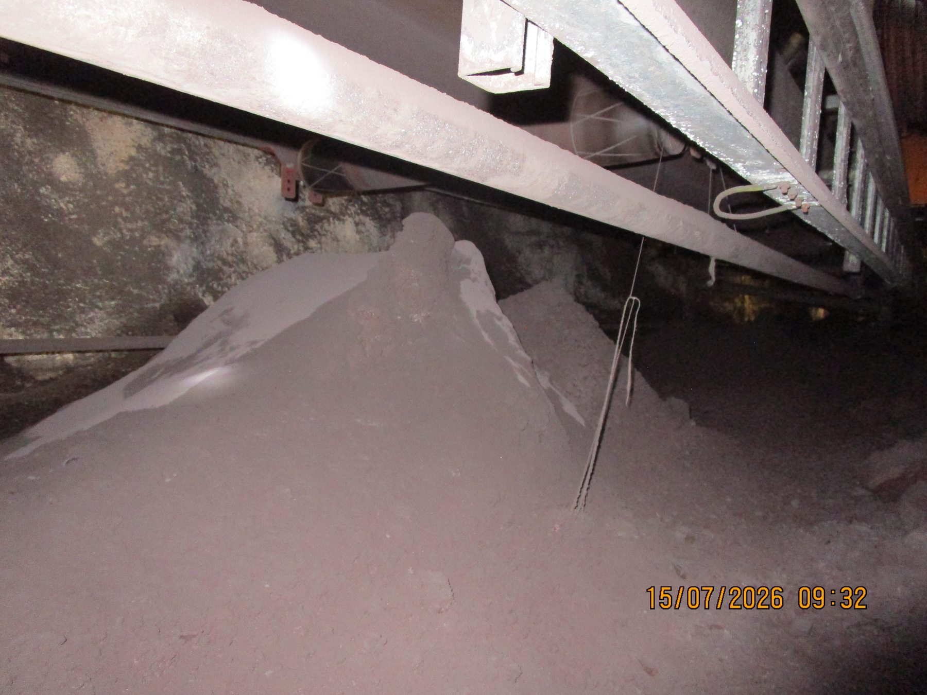
Figure 39 - UC05 / UC04 / UC03 / UC02 / UC01 Continuous System evidence - UGUC05_04_03_02_01-REF-006 / FND-019
Photographic evidence assessment - UGUC05_04_03_02_01-REF-006
Observation | Engineering assessment | Recommended action
A very large fines mound is visibly accumulated directly beneath/alongside the conveyor structure. | Direct evidence of severe local fines accumulation within the wider moderate distributed route condition. Geometry is consistent with carryback redistribution. | Review return-side cleaner/source control through the UC route and schedule recovery of accumulated fines after source correction.

16.3.2.2 Photographic Evidence Sheet
Photo ID | UGUC05_04_03_02_01-REF-015
Finding ID | FND-019
Asset | UC05 / UC04 / UC03 / UC02 / UC01 Continuous System
Component / location | UC05-UC01 continuous route
View / direction | Wider longitudinal accumulation view
Date / time | July 2026 (inspection period)
Caption | Wider UC-system view showing extensive local longitudinal fines accumulation along the conveyor route.
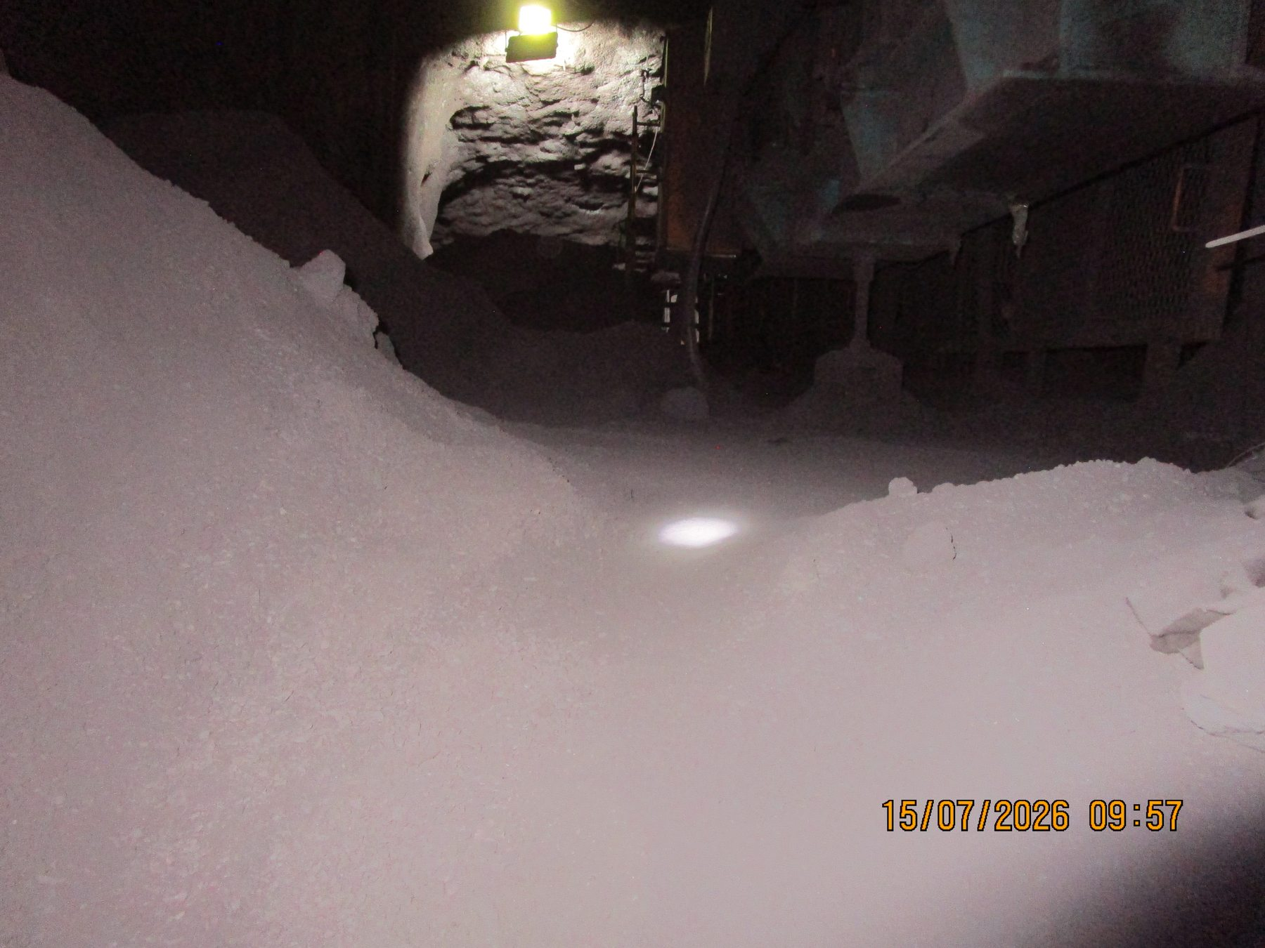
Figure 40 - UC05 / UC04 / UC03 / UC02 / UC01 Continuous System evidence - UGUC05_04_03_02_01-REF-015 / FND-019
Photographic evidence assessment - UGUC05_04_03_02_01-REF-015
Observation | Engineering assessment | Recommended action
Large longitudinal deposits of fines are visibly distributed along the side/beneath the conveyor. | Direct evidence that the condition recurs at multiple route locations rather than being a single isolated pile. | Treat the UC05-UC01 route as one continuous carryback/source-control system for inspection and corrective planning.

16.3.2.3 Photographic Evidence Sheet
Photo ID | UGUC05_04_03_02_01-REF-007
Finding ID | FND-019
Asset | UC05 / UC04 / UC03 / UC02 / UC01 Continuous System
Component / location | UC05-UC03 portion of continuous route
View / direction | Comparatively clear inspected-condition view
Date / time | July 2026 (inspection period)
Caption | Comparatively clear UC-route section retained as a source-qualified inspection comparator.
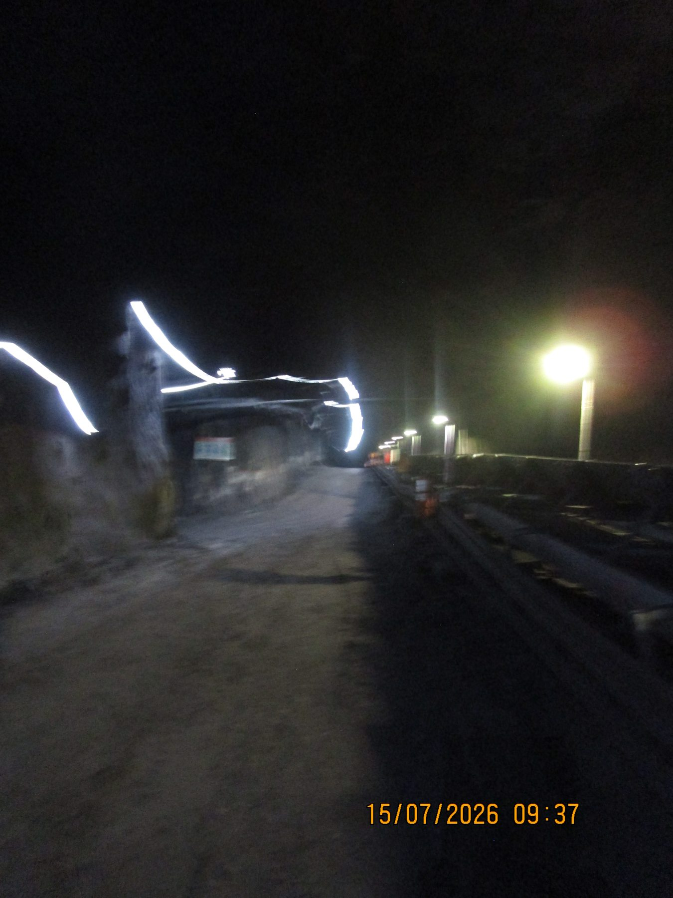
Figure 41 - UC05 / UC04 / UC03 / UC02 / UC01 Continuous System evidence - UGUC05_04_03_02_01-REF-007 / FND-019
Photographic evidence assessment - UGUC05_04_03_02_01-REF-007
Observation | Engineering assessment | Recommended action
The photographed conveyor-side access route is comparatively clear of major fines accumulation. | Direct evidence of the inspected condition only. The explanation that this area had recently been cleared remains source-recorded and is not proven by the photograph. | Use the clear section as a future comparison point and confirm housekeeping history/recurrence when trending the route condition.

16.4 Underground - Secondary Plant

16.4.1 U3 Conveyor
Location / system | Secondary Plant conveyor
Observed condition | Local fines/mixed-material accumulation beneath/adjacent to conveyor structures; coarse broken rock also present along the excavated roadway.
Primary evidence | Preferred: UGU3-REF-007 plus REF-004 or -005.
Mechanism / cause assessment | Direct conveyor-adjacent fines are verified. Coarse roadway rock cannot automatically be attributed to conveyor spillage from still photographs alone.
Evidence qualification / limitation | Trip/restart clearing condition remains Unknown for U3.
Working action / next step | Address confirmed conveyor-adjacent accumulation through carryback/housekeeping review; verify any coarse-product spillage mechanism before assigning roadway rock to the conveyor.
Condition / severity / priority | [TO BE RATED] | [TO BE CLASSIFIED] | [TO BE ASSIGNED]

16.4.1.1 Photographic Evidence Sheet
Photo ID | UGU3-REF-007
Finding ID | FND-020
Asset | U3 Conveyor
Component / location | U3 conveyor / immediately adjacent structure
View / direction | Direct conveyor-adjacent accumulation view
Date / time | July 2026 (inspection period)
Caption | U3 fines/mixed-material accumulation immediately beneath and adjacent to the conveyor structure.
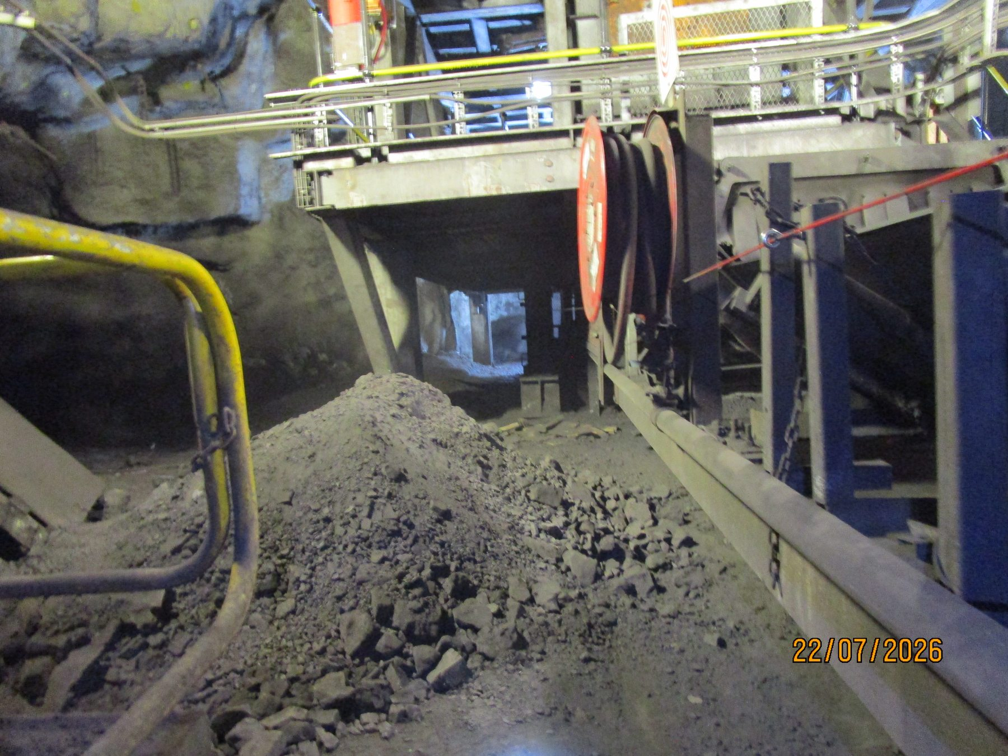
Figure 42 - U3 Conveyor evidence - UGU3-REF-007 / FND-020
Photographic evidence assessment - UGU3-REF-007
Observation | Engineering assessment | Recommended action
Fine and mixed material is visibly accumulated immediately below/adjacent to conveyor components. | Direct evidence of localised conveyor-related accumulation and a stronger evidentiary basis than roadway rock located farther from the belt. | Inspect carryback/cleaner condition and remove conveyor-adjacent deposits while retaining the localised-to-moderate classification.

16.4.1.2 Photographic Evidence Sheet
Photo ID | UGU3-REF-005
Finding ID | FND-020
Asset | U3 Conveyor
Component / location | U3 lower conveyor area
View / direction | Supporting local deposit view
Date / time | July 2026 (inspection period)
Caption | Additional local fines/mixed-material accumulation below the U3 conveyor.
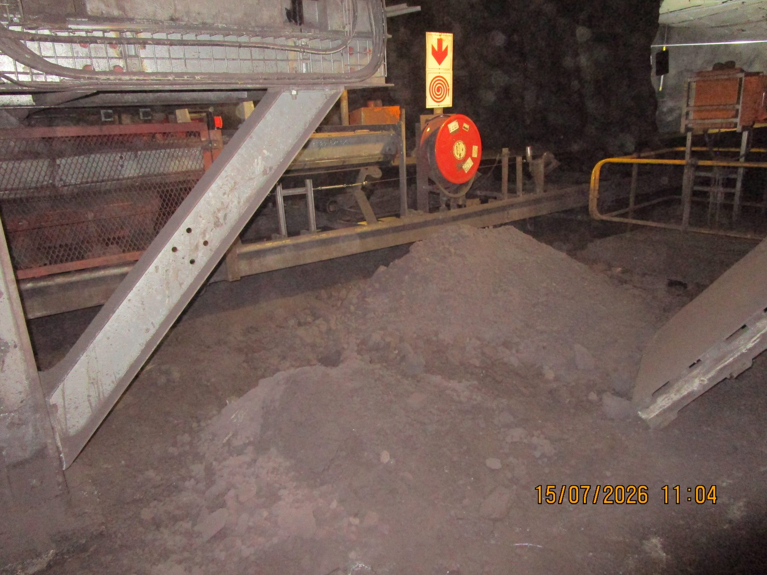
Figure 43 - U3 Conveyor evidence - UGU3-REF-005 / FND-020
Photographic evidence assessment - UGU3-REF-005
Observation | Engineering assessment | Recommended action
Local fines/mixed material is visibly present below the conveyor structure. | Supporting evidence of recurring local accumulation. Broader roadway rock should not automatically be attributed to conveyor spillage. | Focus corrective assessment on material demonstrably related to the conveyor path and verify trip/restart practices separately if required.

16.4.2 U4 Conveyor - Tripper Car
Location / system | Secondary Plant travelling tripper
Observed condition | Extensive fines and solid/mixed-product accumulation; concentrated one-side product loss; visible lateral belt mistracking. U4 has a distinct/custom cleaner arrangement.
Primary evidence | UGU4-REF-009 (mistracking); REF-007 (one-side product); optional REF-006 (fines severity); video REF-010; REF-011 or -012 (custom cleaner).
Mechanism / cause assessment | Belt mistracking and one-side spillage are direct. Tail-pulley misalignment is a source-recorded direct inspection observation visually supported but not quantitatively proven by the supplied media.
Evidence qualification / limitation | Underlying mechanical source of pulley misalignment remains unresolved; use fixed/repeatable references for verification.
Working action / next step | Mechanically realign tail pulley using verified adjustment provisions; check belt centring through full tripper travel under representative conditions; do not automatically apply the CV09 cleaner design to U4.
Condition / severity / priority | [TO BE RATED] | [TO BE CLASSIFIED] | [TO BE ASSIGNED]

16.4.2.1 Photographic Evidence Sheet
Photo ID | UGU4-REF-009
Finding ID | FND-021
Asset | U4 Conveyor - Tripper Car
Component / location | U4 Tripper Car carrying belt / idler geometry
View / direction | Longitudinal tracking view
Date / time | July 2026 (inspection period)
Caption | U4 Tripper Car showing visible lateral belt mistracking relative to the carrying-idler/support geometry.
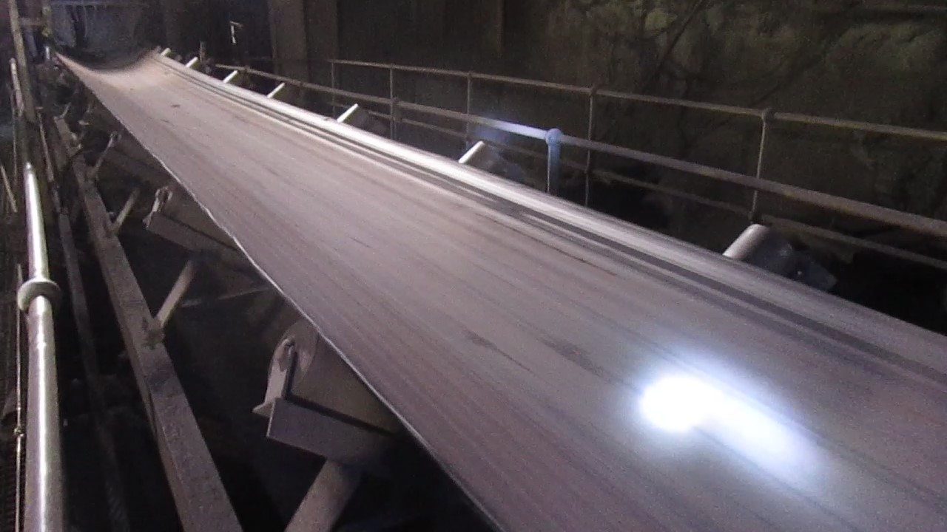
Figure 44 - U4 Conveyor - Tripper Car evidence - UGU4-REF-009 / FND-021
Photographic evidence assessment - UGU4-REF-009
Observation | Engineering assessment | Recommended action
The belt is visibly laterally displaced relative to the carrying-idler/support geometry. | Direct evidence of belt mistracking. No measured lateral offset should be derived from the photograph alone. | Realign/adjust the relevant tail-pulley/tracking geometry and verify belt centring under representative load through the full tripper travel.

16.4.2.2 Photographic Evidence Sheet
Photo ID | UGU4-REF-007
Finding ID | FND-021
Asset | U4 Conveyor - Tripper Car
Component / location | U4 Tripper Car conveyor-side area
View / direction | One-side solid-product accumulation view
Date / time | July 2026 (inspection period)
Caption | Concentrated lump/solid-product spillage accumulated along one side of the U4 Tripper Car conveyor path.
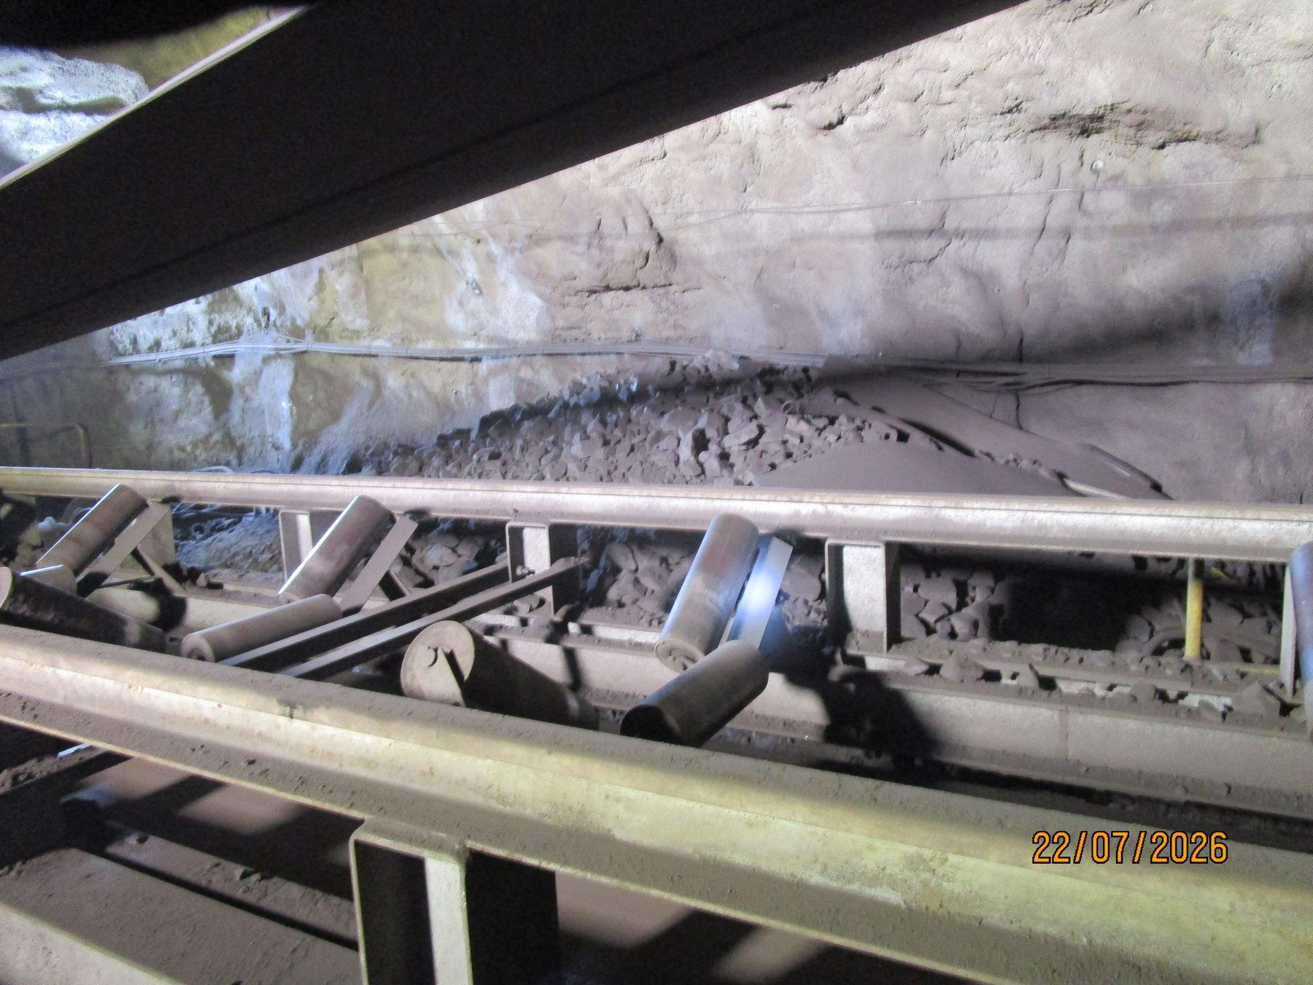
Figure 45 - U4 Conveyor - Tripper Car evidence - UGU4-REF-007 / FND-021
Photographic evidence assessment - UGU4-REF-007
Observation | Engineering assessment | Recommended action
Significant lump/solid product is visibly accumulated predominantly along one side of the tripper/conveyor area. | Direct consequence evidence consistent with the visually verified mistracking condition. The still shows the accumulated result, not the instant of material leaving the belt. | Correct/verify tracking and then confirm whether one-side product loss has ceased through representative tripper positions.

16.4.2.3 Photographic Evidence Sheet
Photo ID | UGU4-REF-011
Finding ID | FND-021
Asset | U4 Conveyor - Tripper Car
Component / location | U4 Tripper Car cleaner arrangement
View / direction | Custom transverse cleaner/scraper view
Date / time | July 2026 (inspection period)
Caption | U4 Tripper Car custom transverse cleaner/scraper arrangement.
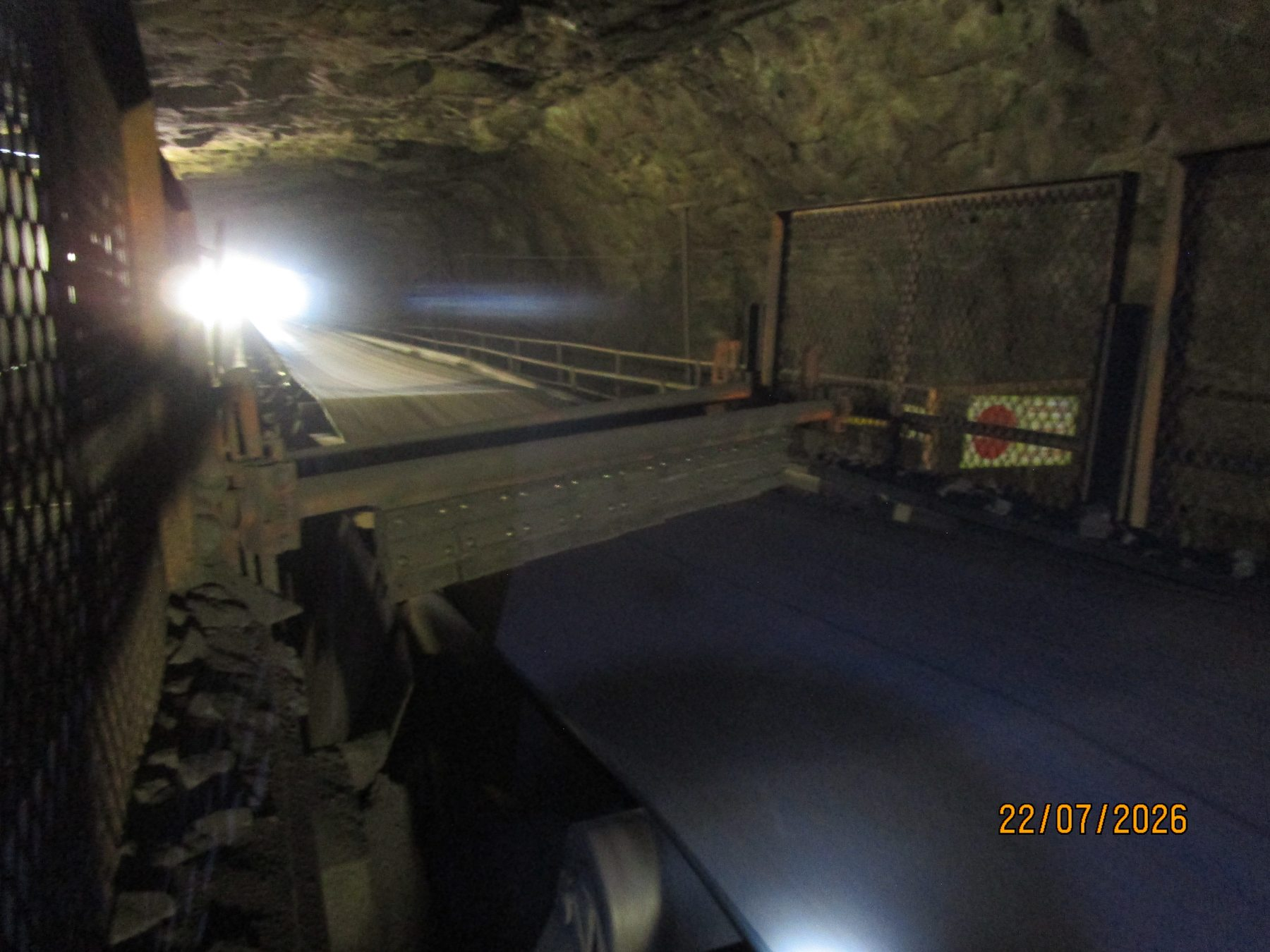
Figure 46 - U4 Conveyor - Tripper Car evidence - UGU4-REF-011 / FND-021
Photographic evidence assessment - UGU4-REF-011
Observation | Engineering assessment | Recommended action
A distinct transverse cleaner/scraper arrangement with dedicated support structure is visible across the belt path. | Direct evidence that the U4 cleaner arrangement differs materially from the conventional cleaner configurations observed elsewhere. | Do not automatically apply the CV09 cleaner standardisation concept to U4; treat U4 as a separate applicability/design case.

16.5 Underground - Silos / Feeders

16.5.1 U5A Conveyor
Location / system | Underground silos/feeders
Observed condition | Extensive/widespread dry-fines accumulation with large mounds and longitudinal deposits beneath/alongside the conveyor.
Primary evidence | UG5A-REF-002; REF-006 or -007; REF-004.
Mechanism / cause assessment | REF-004 strongly supports return-side carryback geometry; carryback should not be asserted as the sole source of every surrounding deposit.
Evidence qualification / limitation | None additional beyond Section 5 and Section 21 limitations.
Working action / next step | Prioritise cleaner/return-side source-control review and recurring accumulation reduction; retain confined-access implications for maintenance/cleaning.
Condition / severity / priority | [TO BE RATED] | [TO BE CLASSIFIED] | [TO BE ASSIGNED]

16.5.1.1 Photographic Evidence Sheet
Photo ID | UG5A-REF-002
Finding ID | FND-022
Asset | U5A Conveyor
Component / location | U5A conveyor-side route
View / direction | Large fines-mound severity view
Date / time | July 2026 (inspection period)
Caption | Large U5A fines mound beneath/alongside the conveyor.
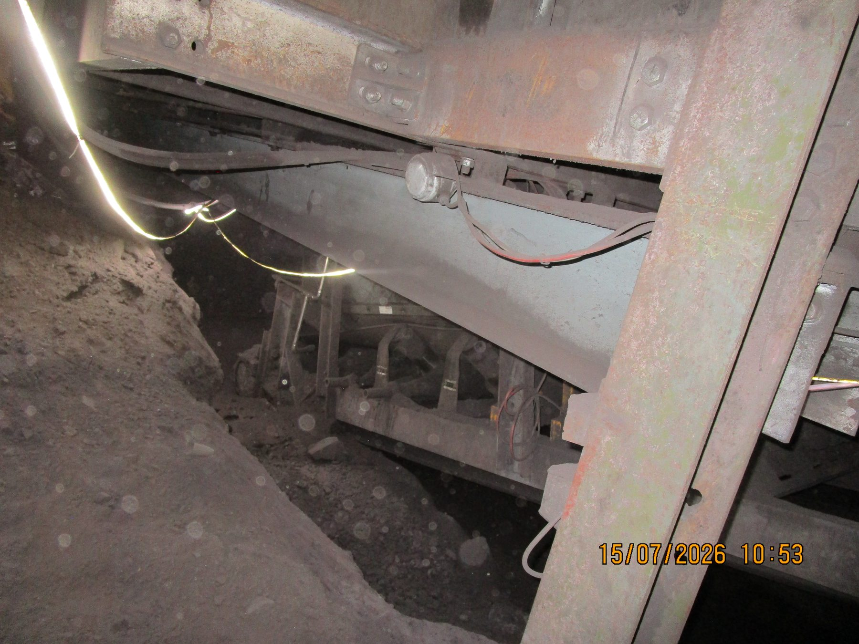
Figure 47 - U5A Conveyor evidence - UG5A-REF-002 / FND-022
Photographic evidence assessment - UG5A-REF-002
Observation | Engineering assessment | Recommended action
A very large dry-fines mound is visibly accumulated beneath/alongside the U5A conveyor. | Direct evidence supporting the extensive/widespread U5A classification. | Prioritise cleaner/return-side source-control review and plan recovery of accumulated material after the recurring mechanism is addressed.

16.5.1.2 Photographic Evidence Sheet
Photo ID | UG5A-REF-006
Finding ID | FND-022
Asset | U5A Conveyor
Component / location | U5A longitudinal conveyor-side route
View / direction | Wider longitudinal extent view
Date / time | July 2026 (inspection period)
Caption | U5A longitudinal fines accumulation extending along the confined conveyor-side route.
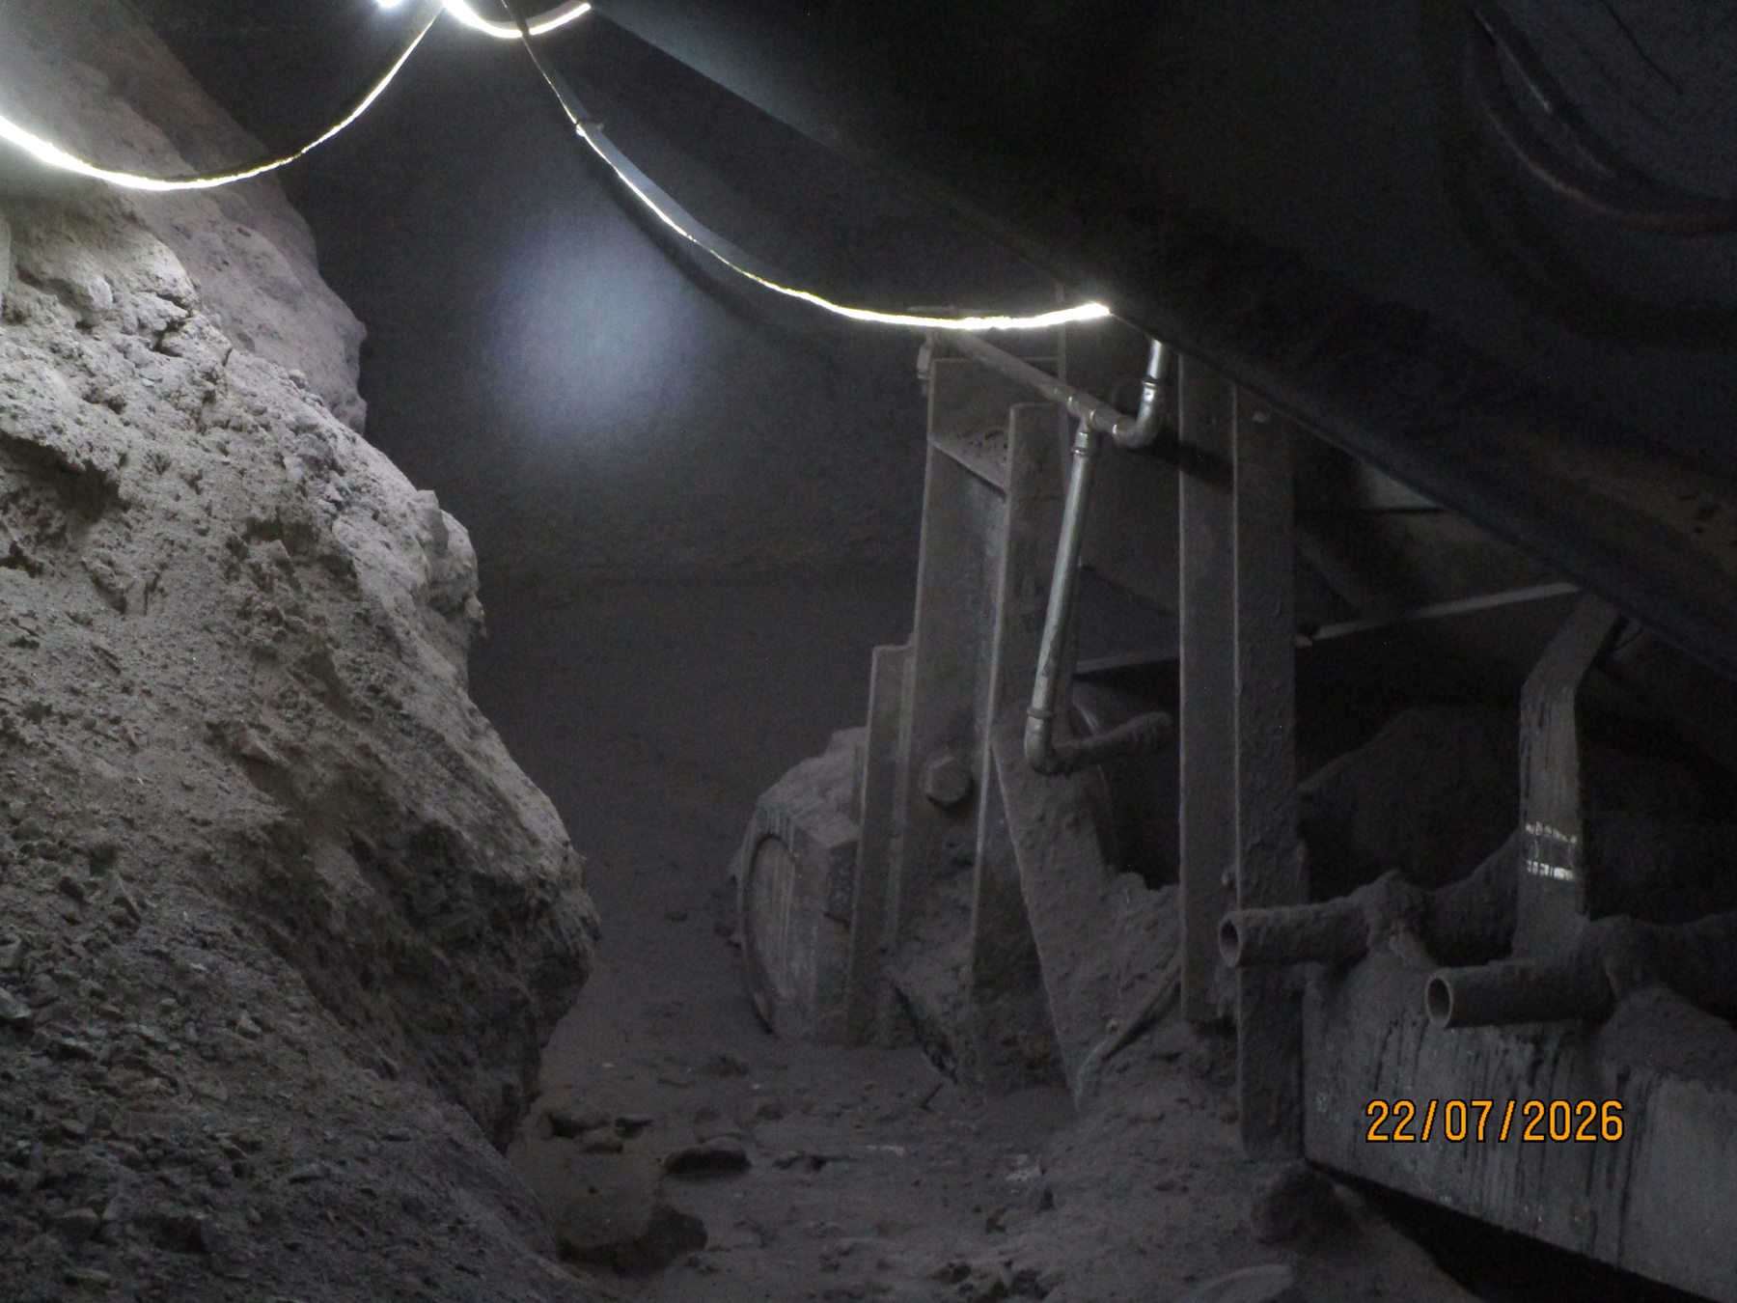
Figure 48 - U5A Conveyor evidence - UG5A-REF-006 / FND-022
Photographic evidence assessment - UG5A-REF-006
Observation | Engineering assessment | Recommended action
Fines are visibly accumulated continuously along a substantial length of the conveyor-side route. | Direct evidence that the U5A condition is widespread rather than an isolated local mound. | Treat U5A as a priority underground carryback/source-control location and trend recurrence after corrective maintenance.

16.5.2 U5B Conveyor
Location / system | Underground silos/feeders
Observed condition | Dry-fines accumulation at several local points; some individual piles are sizeable but the set is not continuously/widely accumulated like U5A.
Primary evidence | UG5B-REF-001 or -005; optional REF-003/-004 for return-side geometry.
Mechanism / cause assessment | Local return-side fines are consistent with carryback; overall extent remains trace-to-localised.
Evidence qualification / limitation | Retain overall trace-to-localised classification despite sizeable individual local deposits.
Working action / next step | Routine cleaner/return-side inspection and housekeeping; trend local recurrence and compare with U5A source-control measures.
Condition / severity / priority | [TO BE RATED] | [TO BE CLASSIFIED] | [TO BE ASSIGNED]

16.5.2.1 Photographic Evidence Sheet
Photo ID | UG5B-REF-001
Finding ID | FND-023
Asset | U5B Conveyor
Component / location | U5B conveyor-side area
View / direction | Local deposit severity view
Date / time | July 2026 (inspection period)
Caption | Sizeable local dry-fines accumulation adjacent to U5B.
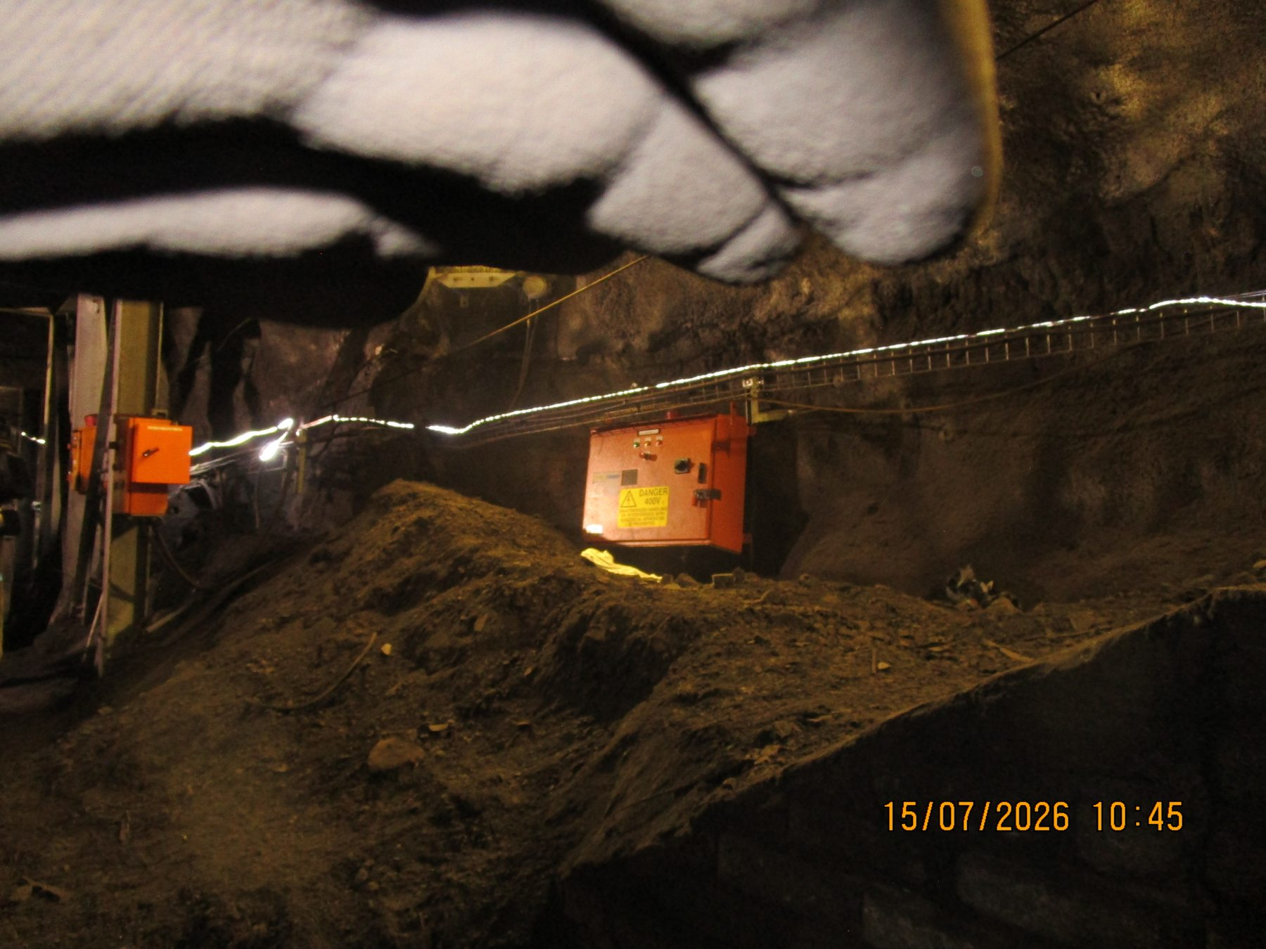
Figure 49 - U5B Conveyor evidence - UG5B-REF-001 / FND-023
Photographic evidence assessment - UG5B-REF-001
Observation | Engineering assessment | Recommended action
A sizeable local fines deposit is visibly present adjacent to the conveyor. | Direct evidence of a substantial local deposit while the wider U5B set remains trace-to-localised overall. | Remove local deposits and inspect return-side cleaner/source condition; trend recurrence without reclassifying the whole asset as widespread.

16.5.2.2 Photographic Evidence Sheet
Photo ID | UG5B-REF-003
Finding ID | FND-023
Asset | U5B Conveyor
Component / location | U5B return-belt / support region
View / direction | Return-side geometry view
Date / time | July 2026 (inspection period)
Caption | U5B fines accumulation immediately below the return-belt/support region.
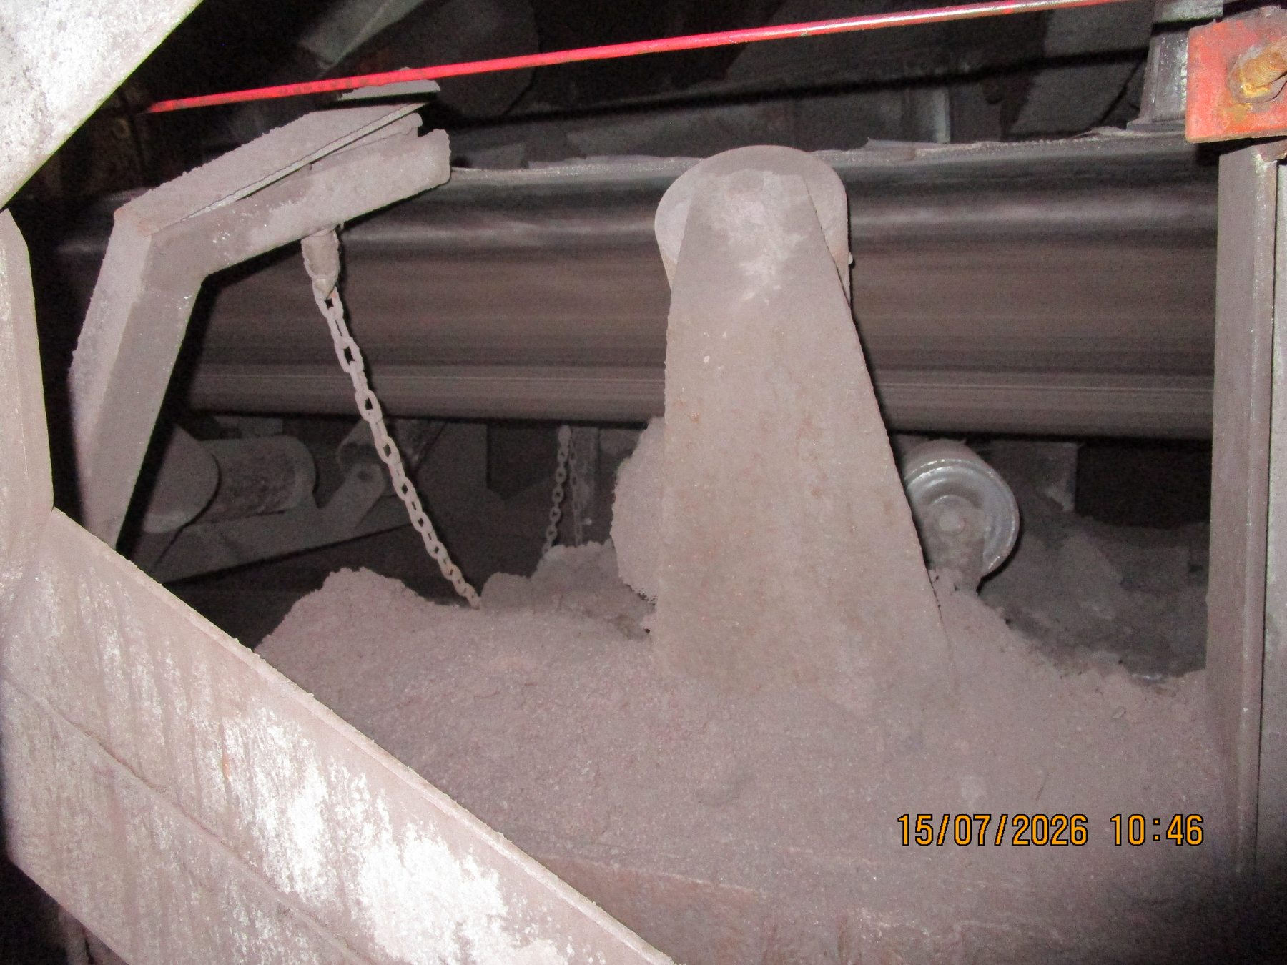
Figure 50 - U5B Conveyor evidence - UG5B-REF-003 / FND-023
Photographic evidence assessment - UG5B-REF-003
Observation | Engineering assessment | Recommended action
Fines are visibly accumulated directly beneath the return-belt/support geometry. | Direct evidence strongly consistent with the recorded return-side carryback mechanism, while not proving the source of every surrounding deposit. | Verify cleaner/contact condition and maintain routine return-side housekeeping and trend monitoring.

17 Summary of Findings
Table 19 - Consolidated findings summary
Scope / asset | Finding | Evidence basis | Working response
Systemic | Recurring fines carryback across surface and underground conveyor ecosystem | Direct/supporting across multiple assets | Source control / cleaner effectiveness
CV06 | Displaced cleaner support bush + missing blades | Direct | Restore cleaner; review support/maintenance
CV09 | Cleaner area outside effective containment; wet fallout active | Direct | Pilot contained/self-tensioning cleaner/chute modification
Sample 2/3 | Product size/volume high relative to narrow belt; containment loss | Direct | Feed study + capacity/tracking verification + side containment
Sample 3 | Lateral offset/mistracking | Direct/supporting | Alignment/tension/live-tracking verification
L3 | Tail-end offset | Supporting/source-recorded | Quantify and verify causal spillage link
U4 | Mistracking + one-side product loss; tail-pulley misalignment source-recorded | Direct + source-recorded | Realign and verify full tripper travel
Screens | Active water loss of containment; severe corrosion; cut/damaged supports | Direct | Safe-shutdown leak investigation + structural assessment
L1 | Extensive spillage; structural deterioration; previous/intermittent belt contact | Direct | Structural assessment/repair + tracking monitoring
Housekeeping / trips | Reactive housekeeping and event-driven unloading add secondary spillage handling | Source-recorded | Confirm procedures; prioritise recurring source control

18 Inspection Observation and Evidence Log
The complete file-level register is maintained in Report-Working/evidence_index.md. This section is intentionally a report-level summary rather than a duplicate of all 197 media files.
Table 20 - Inspection observation and evidence log
Observation group | Primary evidence examples | Classification | Report use
CV06 cleaner failure | CV06-REF-004/-005 | Direct | Asset finding + maintenance example
CV09 wet carryback / cleaner containment | CV09-REF-002/-003; videos -006/-008 | Direct / supporting | Primary cleaner design example
Sample 3 tracking / containment | Sample3-REF-013; -005/-006; -002/-012 | Direct / supporting | Sample conveyor engineering case
Screens water / supports | Screen videos -016/-017; photos -004/-008; -006/-010 | Direct | Water containment + structural finding
L1 structure / contact | L1-REF-007; -003/-005; -008; -013 | Direct | Structural + tracking consequence
U4 mistracking / product loss | UGU4-REF-009; -007; video -010 | Direct + source-recorded alignment | Alignment/tripper case
U5A fines | UG5A-REF-002; -006/-007; -004 | Direct/supporting | Underground systemic carryback example

19 Consolidated Engineering Assessment

19.1 Confirmed / Directly Supported Mechanisms
- Fines carryback occurs across multiple underground and surface conveyor sections and is progressively redistributed from the return belt onto conveyor structures and surrounding areas.
- CV06 had a non-functional cleaner condition, including a displaced support bush and missing scraper blades.
- CV09 has a cleaner outside the effective discharge containment; removed wet carryback can become spillage while residual carryback continues downstream.
- Sample Conveyors 2 and 3 have a product-size/product-volume relationship that challenges the practical containment capability of the narrow belt arrangement; Sample Conveyor 3 additionally exhibits visually supported mistracking.
- U4 belt mistracking and associated one-side lateral product loss are visually confirmed; the recorded tail-pulley misalignment remains the working upstream mechanical cause pending quantitative verification.
- Screen process water escapes during normal operation and contributes to wet-fines accumulation and a corrosive structural environment.
- Screen support members identified in the inspection context as load-bearing are physically cut/damaged.
- L1 shows direct physical evidence of previous/intermittent belt-to-structure contact and major structural corrosion/deterioration.
- Housekeeping repeatedly removes the consequence of recurring spillage while source mechanisms remain active. Trip/restart clearing is a separate event-driven spillage mechanism.

19.2 Probable / Working Causes Requiring Verification
- A common cleaner/chute design limitation may exist at multiple conveyors that were not directly accessible; this remains an engineering inference pending local verification.
- The absence of self-tensioning in the conventional cleaner arrangement is a probable contributor to reduced contact pressure as wear elements reduce in thickness.
- CV06 support-bush displacement is probably influenced by housing design, but the failure mechanism has not been independently tested.
- Sample-conveyor feed control likely requires redesign; the actual control point and metering mechanism remain unknown.
- At Sample Conveyor 3, head/tail alignment, belt tensioning and/or trapped spillage may contribute to mistracking; these remain hypotheses pending live inspection.
- L3 shows significant offset, but the root cause and causal link to solid-product spillage remain unresolved.
- The equipment-level cause of screen-water escape remains unresolved; the reason screen supports were cut remains unresolved.

19.3 Systemic Versus Local Causes
Systemic working causes are ineffective or degraded belt-cleaner performance, variable cleaner maintenance condition, incomplete containment at some discharge points and recurring fines carryback throughout the conveyor ecosystem. Local/asset-specific causes include the CV09 cleaner location, CV06 missing blades/displaced bush, U4 alignment/mistracking, Sample Conveyor 3 mistracking and limited belt width, screen-water loss of containment, and L1 belt-contact/structural condition. Structural deterioration is both a consequence of long-term spillage/moisture exposure and an independent engineering concern requiring dedicated assessment.

20 Recommendations
Recommendation status
The recommendations below are working engineering concepts derived from the consolidated evidence. They are not fabrication drawings, final design details or substitutes for South32 operational risk decisions and competent-person approvals.

20.1 CV09 Pilot Belt-Cleaner / Chute Modification
- Use CV09 as the preferred pilot location for an improved cleaner arrangement.
- Extend/revise the discharge-chute enclosure so the cleaner operates inside the effective containment envelope and removed wet fines report to the CV09 fines-discharge stream.
- Use a spring-loaded/self-tensioning cleaner concept to maintain positive contact as wear elements reduce in thickness.
- Provide positive wear/travel limits to prevent over-travel after allowable wear is reached.
- Evaluate whether primary and secondary cleaner stages are required for wet/sticky service.
- Retain safe maintenance access and test effectiveness before wider standardisation.

20.2 Wider Cleaner Standardisation
- After a successful CV09 pilot, survey cleaner presence, physical space, chute geometry, material condition and maintenance access at each applicable discharge.
- Do not automatically apply the common design to U4 because its cleaner/discharge arrangement is materially different.
- Develop a common inspection/replacement standard covering blade condition, contact pressure, support hardware and wear limits if existing mine requirements are absent or inconsistent.

20.3 Sample Conveyors 2 and 3
- Inspect and quantify the actual feed-control arrangement; determine how incoming sample-product volume can be throttled/metered.
- Measure representative product size relative to usable belt width/capacity.
- Inspect head/tail alignment, belt tension and live tracking, particularly Sample Conveyor 3 and as a verification item on Sample Conveyor 2.
- Remove trapped accumulated product before tracking assessment.
- Develop a fixed side-support / flexible rubber-skirt containment system as secondary control. Current approx. 250 mm height and 5-10 mm clearance values remain preliminary only.
- Finalise side-containment geometry only after feed and tracking issues are evaluated/corrected.

20.4 Belt Tracking / Alignment
- L3: quantify tail-end offset and determine whether it is causing current product loss before assigning a root cause.
- U4: realign the tail pulley using verified adjustment provisions, then confirm centred tracking through full tripper travel under representative operation.
- Use fixed/repeatable reference points so post-adjustment condition can be trended.

20.5 Screen Water Containment and Structural Supports
- Perform a close safe-shutdown inspection to identify the actual water escape path and mechanism.
- Modify screen/chute containment only after the actual loss mechanism is confirmed.
- Obtain formal structural assessment of cut/damaged/corroded screen supports and define repair/replacement requirements.
- If support geometry changes for installation clearance, quantify the clearance and obtain structural calculation/approval before implementation.

20.6 L1 Structural Condition
- Obtain structural assessment and repair definition for concrete/steel deterioration and affected support members.
- Retain belt-tracking monitoring because wear slots are consistent with previous/intermittent contact even though the captured belt was clear.
- Address recurring fines/moisture accumulation around support interfaces as part of corrosion control.

20.7 Housekeeping and Trip / Restart Handling
- Prioritise source-control improvements so housekeeping is not the principal recurring-carryback control.
- Confirm the mine housekeeping/recovered-product reintroduction procedure, responsibilities and normal clearing frequency.
- Confirm the written trip/restart belt-unloading procedure and consider defined temporary containment/laydown locations where this would reduce uncontrolled secondary deposits.

21 Conclusion
The completed contextual and visual-evidence review confirms that spillage across the inspected Wessels Mine areas is multi-mechanism. Recurring fines carryback is the dominant cross-system theme, while specific local conditions - cleaner maintenance/design deficiencies, inadequate discharge containment, product loading versus belt width, belt mistracking, process-water loss of containment and structural deterioration - materially increase spillage at particular assets.
The evidence base is sufficiently developed to support a first formal report draft, but several recommendations still require targeted measurement, shutdown inspection, structural assessment or detailed design before implementation. The most useful immediate engineering development steps are the CV09 pilot cleaner/chute concept, Sample Conveyor feed/tracking/side-containment verification, U4/L3 alignment verification, screen leak-source investigation and structural assessments for the screen supports and L1.

22 Technical Review and Report Issue Sign-off
Table 21 - Technical review and issue sign-off
Review item | Status / requirement | Responsible role | Evidence / sign-off
Evidence traceability | Complete inventory/reconciliation and visual review; final report layout selection pending | ISS | evidence_index.md + Batch A-F review files
Engineering review | Required before issue | [REVIEWER] | [SIGN / DATE]
Structural recommendations | Require competent structural authority review where adopted | South32 / appointed structural engineer | [RECORD]
Mechanical modifications | Require detailed engineering/site verification before fabrication/installation | Mechanical / Conveyor Engineering | [RECORD]
Final issue approval | Required | [APPROVER] | [SIGN / DATE]

Appendix A - Photographic Register and Evidence Selection
The repository originals remain the master evidence. The table below identifies the preferred first-draft report figures only; the full 197-media register remains in Report-Working/evidence_index.md. Final image selection may be reduced further during layout to avoid unnecessary duplication.
Table A1 - First-draft photographic figure plan
Asset / group | First-draft evidence candidate(s) | Intended report purpose
W10 | W10-REF-002; W10-REF-010 or -011 | Spillage severity + restricted tunnel context
CV01 | CV01-REF-001; REF-003 or -004 | Damaged roller + wet fines/slurry
CV02 | CV02-REF-001; REF-003 | Mixed dry spillage + return-side accumulation
CV03 | Optional REF-002 or -003 | Clean comparator only if useful
CV04 | REF-002; REF-005 | Wet slurry + extent
CV06 | REF-004; REF-005 | Displaced bush + missing blades
CV09 | REF-003; REF-002; video REF-006; optional video REF-008 | Cleaner arrangement + wet consequence + active fallout
CV14 | REF-002 | Localised carryback mound
CV15 | REF-003; REF-004 or -006; optional REF-008 | E-3181 location + widespread fines
Screens | Video REF-016 or -017; photo REF-004/-008; photo REF-006/-010 | Water escape + corrosion + support damage
L1 | REF-007; REF-003/-005; REF-008; REF-013; optional REF-017 | Belt-contact evidence + structural deterioration + severity
L2 | Normally none; optional REF-004.jpg or REF-005.jpg | Clean comparator
L3 | REF-001; REF-007; optional REF-008 | Tail-end offset + fines
L4 | REF-003 or -004; optional REF-007/-008 | Localised accumulation + operating context
Sample 1 | REF-011; REF-008; REF-005/-006; REF-007/-010 | Widespread accumulation + adhered deposits
Sample 2 | REF-004; REF-006/-007; REF-001/-003 | Product size versus belt width + containment loss
Sample 3 | REF-013; REF-005/-006; REF-002; REF-012 | Mistracking + product loading + spillage
Crusher | UGCrusher-REF-001; REF-002/-003 | Mixed accumulation + local water
UC05-UC01 | REF-006/-008; REF-015/-016; REF-005; optional REF-007 | Distributed fines + local severity + comparator
U3 | UGU3-REF-007; REF-004/-005 | Direct conveyor-adjacent accumulation
U4 | REF-009; REF-007; optional REF-006; video REF-010; REF-011/-012 | Mistracking + one-side product + alignment context + custom cleaner
U5A | UG5A-REF-002; REF-006/-007; REF-004 | Widespread fines + return-side geometry
U5B | UG5B-REF-001/-005; optional REF-003/-004 | Localised fines + return-side geometry
Image handling
Do not embed full-resolution repository originals directly into the final report. Create report-ready copies only after the final figure set is confirmed. Preserve the original filenames / canonical evidence IDs for traceability.

Appendix B - Spillage Audit Checklist
Table B1 - Spillage audit checklist
Item | Inspection check | Result | Observation / limitation | Evidence ref
1 | Asset/location confirmed | [PASS / FAIL / N/A] | [OBSERVATION] | [EVIDENCE]
2 | Spillage type identified | [PASS / FAIL / N/A] | [OBSERVATION] | [EVIDENCE]
3 | Spillage location identified | [PASS / FAIL / N/A] | [OBSERVATION] | [EVIDENCE]
4 | Qualitative extent recorded | [PASS / FAIL / N/A] | [OBSERVATION] | [EVIDENCE]
5 | Water/wet fines considered | [PASS / FAIL / N/A] | [OBSERVATION] | [EVIDENCE]
6 | Carryback/return-side condition considered | [PASS / FAIL / N/A] | [OBSERVATION] | [EVIDENCE]
7 | Cleaner/scraper condition considered | [PASS / FAIL / N/A] | [OBSERVATION] | [EVIDENCE]
8 | Transfer/chute containment considered | [PASS / FAIL / N/A] | [OBSERVATION] | [EVIDENCE]
9 | Belt tracking/alignment considered | [PASS / FAIL / N/A] | [OBSERVATION] | [EVIDENCE]
10 | Structural condition considered | [PASS / FAIL / N/A] | [OBSERVATION] | [EVIDENCE]
11 | Access/housekeeping constraint considered | [PASS / FAIL / N/A] | [OBSERVATION] | [EVIDENCE]
12 | Evidence reference recorded | [PASS / FAIL / N/A] | [OBSERVATION] | [EVIDENCE]
13 | Observation separated from interpretation | [PASS / FAIL / N/A] | [OBSERVATION] | [EVIDENCE]
14 | Root cause qualified where unverified | [PASS / FAIL / N/A] | [OBSERVATION] | [EVIDENCE]
15 | Recommended action tied to evidence | [PASS / FAIL / N/A] | [OBSERVATION] | [EVIDENCE]

Appendix C - Measurements and Dimensional Records
Current audit conclusions are primarily qualitative. The table below records the measurements required to close the principal design/verification gaps. Populate only when measured values, datum/reference and method are available.
Table C1 - Targeted measurement requirements
Asset | Measurement required | Engineering purpose
CV09 | Chute/cleaner envelope dimensions; belt-to-cleaner geometry; maintenance access | Detailed pilot design
Sample 2 | Usable belt width; representative lump size; feed geometry/rate; pulley alignment/tracking | Capacity/feed/containment design
Sample 3 | Usable belt width; representative lump size; feed geometry/rate; head/tail alignment; live tracking | Capacity/feed/containment + mistracking
L3 | Tail pulley/belt offset relative to fixed datum; alignment/tension parameters | Confirm cause and significance
U4 | Tail pulley alignment relative to tripper frame; belt centring through full travel | As-found/as-left verification
Screens | Leak-source geometry/clearance; support dimensions if repair geometry changes | Containment + structural design
L1 | Affected concrete/steel member dimensions and section loss as required by structural engineer | Structural assessment/repair

Appendix D - Video Evidence Register
Table D1 - Video evidence register
Canonical ID | Repository filename | Asset | Report use
CV09-REF-006 | Cv09-Ref-006.mp4 | CV09 | Direct dynamic evidence of active wet-material fallout beneath conveyor/transfer area
CV09-REF-007 | Cv09-Ref-007.mp4 | CV09 | Supporting walk-through / cleaner-area context
CV09-REF-008 | Cv09-Ref-008.mp4 | CV09 | Close cleaner-area condition / wet-fines build-up
Screen-REF-015 | Screen-REF-015.mp4 | Screens | Active wetting/runoff context
Screen-REF-016 | Screen-REF-016.mp4 | Screens | Direct active process-water spray loss of containment
Screen-REF-017 | Screen-REF-017.mp4 | Screens | Strong direct wider water spray/runoff evidence
LoadoutStationL2-REF-005 (video) | LoadoutStationL2-REF-005.mp4 | L2 | Clean/no-significant-spillage captured operating/inspection context
UGU4-REF-010 | UGU4-REF-010.MP4 | U4 Tripper Car | Supporting running tail-pulley/belt alignment condition

Appendix E - Drawings, Schematics and Conceptual Engineering References
Table E1 - Drawings and schematics register
Reference ID | Description | Status / intended use
SPILL-REF-001 | Overall combined-product process and inspected scope layout | To be created / inserted
SPILL-REF-002 | CV09 existing cleaner/chute relationship | To be created from reviewed evidence geometry
SPILL-REF-003 | CV09 proposed contained self-tensioning cleaner pilot concept | Conceptual - not for fabrication
SPILL-REF-004 | Sample Conveyor existing narrow-belt loading/containment context | To be created from reviewed Sample 2/3 evidence
SPILL-REF-005 | Sample Conveyor side-support / flexible rubber-skirt concept | Conceptual - preliminary dimensions to be verified
SPILL-REF-006 | U4 Tripper Car tracking/alignment explanatory arrangement | Optional contextual illustration

Appendix F - Supporting Documentation and Source Records
Table F1 - Supporting documentation register
Document / record | Repository / source | Purpose / status
Running_Report_Contextual_Spillage_NotesV3.7.docx | Context/ | Primary consolidated engineering drafting source; includes complete visual-review integration
Running_Report_Contextual_Spillage_Questionnaire_ResponseV1.docx | Context/Questionaires/ | Asset baseline source
Running_Report_Contextual_Spillage_Questionnaire_ResponseV2.docx | Context/Questionaires/ | Mechanism/root-cause/control source
evidence_index.md | Report-Working/ | Complete evidence inventory, review status and first-draft figure candidates
evidence_visual_review_batch_A.md | Report-Working/ | CV06 / CV09 / U4 review
evidence_visual_review_batch_B.md | Report-Working/ | Sample 2 / Sample 3 / L3 review
evidence_visual_review_batch_C.md | Report-Working/ | Screens / L1 review
evidence_visual_review_batch_D.md | Report-Working/ | W10 / CV01 / CV02 / CV03 / CV04 / CV14 / CV15 review
evidence_visual_review_batch_E.md | Report-Working/ | L2 / L4 / Sample 1 review
evidence_visual_review_batch_F.md | Report-Working/ | Crusher / UC05-UC01 / U3 / U5A / U5B review
Evidence originals | Evidence/ | Master photos/videos retained at original resolution
V0.1 draft development status
This V0.1 report contains the consolidated engineering narrative and selected Section 16 photographic evidence sheets. The next development pass should finalise ratings/priorities, refine figure/table registers, add selected conceptual illustrations, confirm controlled metadata/sign-off details and complete the planned colour/style polish before formal issue.

